**Water Resource Management**

**Options for the Orinoquía**

The Orinoquía Water Futures Model

**March 22nd, 2024**

**The University of Massachusetts**

**Alianzas para la Sostenibilidad**

**La Universidad de los Llanos**

**Resolute Development Solutions**

**DELIVERABLE 4**

**Table of Contents**

Introduction 1

Resilience by Design 2

Project Design and Objectives 3

the Orinoquía 4

Water 5

Climate 10

Livestock and Agriculture 12

Cattle (beef and dairy) 12

Pigs and Chicken 14

Rice 15

Oil Palm 17

Other crops 19

Development Planning 20

the orinoquÍa water futures (OWF) model 22

Introduction 22

An OWF overview 22

Study Site: The Meta River Basin 24

Weather Generator Model 26

Material and methods 26

Data and data filling 27

Stochastic scenarios using the HMM 35

The Hydrology Model 37

A GR2M Model Construction 39

Hydrology Model Results 42

Long-term water balance 48

Water Demand Models 50

Dispatch orders 51

Municipalities to watersheds 53

Freshwater: urban and rural 54

Livestock: cattle, pigs and chicken 57

Agriculture: rice and oil palm 60

Minimum flow requirement 64

The OWF Infrastructure Model 65

Hydro-system infrastructure 65

Water resource allocation 66

A Climate Stress Test System 70

The RCPs 70

Setting the bounds 71

The Stress Test 72

water demand scenarios 74

Introduction 74

A Stakeholder Engagement Process 74

An Opinion Survey 77

Water Demand Scenarios 83

System performance metrics 84

Scenario I. Climate Change 86

Scenario II. Unlimited Demand Expansion 86

Scenario III. Demand Sensitivity analysis 91

Scenario IV. Selected Future 91

owf model Results 92

Results: Climate Stress Test 92

Response to changes in precipitation 92

Results: Water Demand Scenarios 98

Scenario I. Climate Change 98

Scenario II. Unlimited Demand Expansion 100

Scenario III. Demand Sensitivity 103

Scenario IV. Selected Future 104

Conclusions 107

References 109

**List of Acronyms**

|  |  |
| --- | --- |
| ALISOS | Partnerships for Sustainability  (*Alianzas para la Sostenibilidad*) |
| BIC | Bayesian Information Criterion |
| CAR | Regional Autonomous Corporation  (*Corporación Autónoma Regional*) |
| CIAT | Tropical Agriculture Research Center  (*Centro Internacional de Agricultura Tropical*) |
| CRDA | Regional Centers for Environmental Dialogue  (*Centro Regional de Dialogo Ambiental*) |
| CNA | National Water Council  (*Consejo Nacional del Agua*) |
| CONPES | National Council of Economic and Social Policy  (*Consejo Nacional de Política Económica y Social*) |
| CORMACARENA | Corporation for the Sustainable Development of the Special Management Area La Macarena  (*Corporación para el Desarrollo Sostenible del Area de Manejo Especial La Macarena*) |
| CORPORINOQUIA | Regional Autonomous Corporation of the Orinoquia  (*Corporación Autónoma Regional de la Orinoquía*) |
| DANE | National Administrative Department of Statistics  (*Departamento Administrativo Nacional de Estadística*) |
| DDM | Deficit and Demand Management |
| DEM | Digital Elevation Model |
| DNP | Department of National Planning  (*Departamento Nacional de Planeación*) |
| ENSO | El Nino-Southern Oscillation |
| ETO | Reference Evapotranspiration |
| FAO | Food and Agriculture Organization of the United Nations |
| GCM | Global Climate Model |
| GR2M | Genie Rural 2 Mensuel |
| GRASS | Geographic Resource Analysis Support System Software |
| HMM | Hidden Markov Model |
| HMMTool | Hidden Markov Model Tool |
| IDEAM | Institute of Hydrology and Environmental Studies  *(Instituto de Hidrología, Meteorología y Estudios Ambientales)* |
| IDW | Inverse Distance Weighting |
| IUA | Colombian Water Use Index  *Índice de Uso del Agua en Colombia* |
| KNN | k Nearest Neighbor |
| LP | Linear Programming |
| MAE | Mean Absolute Error |
| MAVDT | Ministry of Environment, Housing and Territorial Development (*Ministerio de Ambiente, Vivienda y Desarrollo Territorial*) |
| MADS | Ministry of Environment and Sustainable Development  (*Ministerio de Ambiente y Desarrollo Sostenible*) |
| MME | Ministry of Mines and Energy  (*Ministerio de Minas y Energía)* |
| MADR | Ministry of Agriculture and Rural Development  *(Ministerio de Agricultura y Desarrollo Rural)* |
| MSPS | Ministry of Health and Social Protection  *(Ministerio de Salud y Protección Social)* |
| MV | Ministry of Housing  *(Ministerio de Vivienda)* |
| MCAT | Monte Carlo Analysis Toolbox |
| MOTRO | Regional Land Use Planning Model for the Orinoco  (*Modelo de Ordenamiento Territorial Regional para la Orinoquía)* |
| PNN | National Natural Parks  (*Parques Nacionales Naturales*) |
| NSE | Nash–Sutcliffe Efficiency |
| OWF | Orinoquía Water Futures |
| PGAR | Regional Environmental Management Plan  (*Plano de Gestión Regional Ambiental*) |
| PNGIRH | National Policy for the Integrated Management of Water Resources  *(Política Nacional para la Gestión Integral del Recurso Hídrico*) |
| PFZ | Potentially Floodable Zones |
| POMCAS | Watershed Management Plans  *(Planes de Ordenación y Manejo de Cuencas)* |
| PRICO | Comprehensive Regional Climate Change Plan for the Orinoquía (*Plano Regional Integral de Cambio Climatico para la Orinoquía)* |
| PYWR | Generalized network resource allocation model written in Python |
| RbD | Resilience by Design |
| RCP | Representative Concentration Pathways |
| RMSE | Root-Mean-Square Error |
| SIPRA | Information System for Agricultural Rural Planning  *Sistema de Información para la Planificación Rural Agrícola* |
| SIRH | Colombian Water Resources Information System  (*Sistema de Informacíon de Recursos Hidricos*) |
| SMT80 | Soil Moisture Threshold 80 percent |
| SPS | Silvo-Pastoral Systems |
| TD | Transdiscipline |
| TWG | Technical Working Group |
| UDE | Unlimited Demand Expansion |
| UMASS | University of Massachusetts, Amherst |
| UNILLANOS | The University of the Llanos  *(Universidad de los Llanos)* |
| WAPABA | Monthly Water Partition Balance Model |
| WB | World Bank |

# Introduction

Even in a seemingly water-rich country as Colombia—ranked 13th in the world for internal renewable freshwater resources per capita[1]—a combination of climate change and increasing water demand may create unforeseen conflicts as localized water issues become more frequent.

Before the disruption becomes manifest, water system management must shift away from simple supply metrics—how much water and for whom—to designing and managing for resilience, which, simply put, is the ability of a water system to maintain its function and services under stress and disturbance.

Planning for, and investing in, water system resilience will improve our ability to forecast climate disruption and manage risks. It will enable adaptation to incremental change and speed recovery from the impact of increasingly extreme events.

The work and results reported herein takes a step in that direction by incorporating resilience into a water system modeling framework for the Orinoquía of Colombia, a region that in the foreseeable future is expected to experience the impacts of climate change while seeing an increase in water demand due to economic development.

Agricultural development for the Orinoquía region remains a crucial objective of Colombia’s national planning (DNP 2018), as well as continued oil and gas exploration—even though there is a commitment to an energy transition—both of which hold the potential to threaten the balance between economic growth and the preservation of natural systems. Especially when agricultural commodities and food production can use more than 80 of available water worldwide (UNESCO 2022, USDA 2021[2])

This while Colombia's National Development Plan: 2022-2026 (DNP 2022) has regional water planning as one of its five axes, creating Regional Water Councils (RWC) with the objective to “...*strengthen multilevel, differential, inclusive and fair water governance and regional planning around water, seeking the consolidation of functional territories with a focus on adaptability to climate change and risk management*"[3].

The hope is that the analysis in this document deepens the understanding of these issues and helps, in some small part, to balance competing goals and support a better and brighter future for the unique region that is the Orinoquía.

## Resilience by Design

Resilience by Design (RbD), developed at the University of Massachusetts, builds on the Decision Scaling*[4]* approach (Brown et al. 2012; Ray and Brown, 2015) and is a participatory planning, decision and investment evaluation process centered on a system analytics and decision-support modeling platform (Brown et al., 2020)[5].

RbD responds to the growing demand for approaches to diagnose, design and manage water systems for resilience. The RbD approach integrates, as needed, hydrologic, economic and systems modelling, aligned with local objectives and constraints identified through stakeholder engagement and carried out in close partnership with local institutions.In this manner, RbD uses a transdisciplinary (TD)[6] approach to overcome the barriers inherent within a complex social, cultural, and ecological system.

RbD has been successfully applied in the Mexico City water system and its main supply basins (see Freeman et al. 2020), for three principal river basins in Tanzania, and in partnership with the San Francisco Public Utilities Commission (see Francois et al. 2021)[7]. RbD delivers three key development results: (1) an informed and mobilized multi-stakeholder collective seeking resilient water system outcomes; (2) a suite of water system analytics that improve the understanding of water resource management; and (3) a platform that can be used to structure and guide future investments that will ensure water system function under stress.

## Project Design and Objectives

In this exercise the RbD approach is employed to improve the knowledge available to understand, design and encourage the adoption of climate smart agricultural practices in support of sustainable development for the Orinoquía.

The project uses water as a master variable to evaluate the environmental and economic impacts of possible future scenarios for the Orinoquía region as the population grows and demand for agricultural production and other economic activities increase.

This work charts a path forward based on quantitative modeling and a participatory planning effort that brings together stakeholders from all corners of the region to engage in debate and planning. The transdisciplinarity of the RbD approach identifies and explains water risk created over time by multiple actors seeking immediate solutions to complex problems (see Tellman et al. 2018).

Together, the project team at the University of Massachusetts, Department of Civil and Environmental Engineering, Hydrosystems Research Group (UMASS), Alianzas para la Sostenibilidad (ALISOS www.alisos.net) and the Universidad de los Llanos (UNILLANOS) built a water system model for the Orinoquía, called the Orinoquía Water Futures (OWF) model, designed to be the basis for on-going contributions to policy analysis and development design for the region.

Over the course of the project, the team held more than 40 stakeholder workshops and meetings, connecting with 300+ local stakeholders representing public and private stakeholders as well as civil society, creating an interest in and commitment to model results, as well as an understanding of the potential for future analysis of emerging development issues.

The combination of modeling and stakeholders’ engagement has, hopefully, created a vested community of interest in the region that can serve as the foundation for future discussion and debate.

# the Orinoquía

At first glance, the Orinoquía region appears to be a flat, uniform plains in the eastern Colombia. It is far from that. It is a unique region comprised of multiple ecosystems matched by a deep cultural heritage and blessed with a promising future (Becerra et al. 2009).

The four departments of the Orinoquía comprise Arauca, Casanare, Meta and Vichada (**Figure 1**), and has four key sub-systems; the Piedmonte (3.7 million ha); the Altillanura (4.2 million ha); the Flooded Savannas (6 million ha) and the Serrania (7 million ha). Each system with different character, potential and limitations.

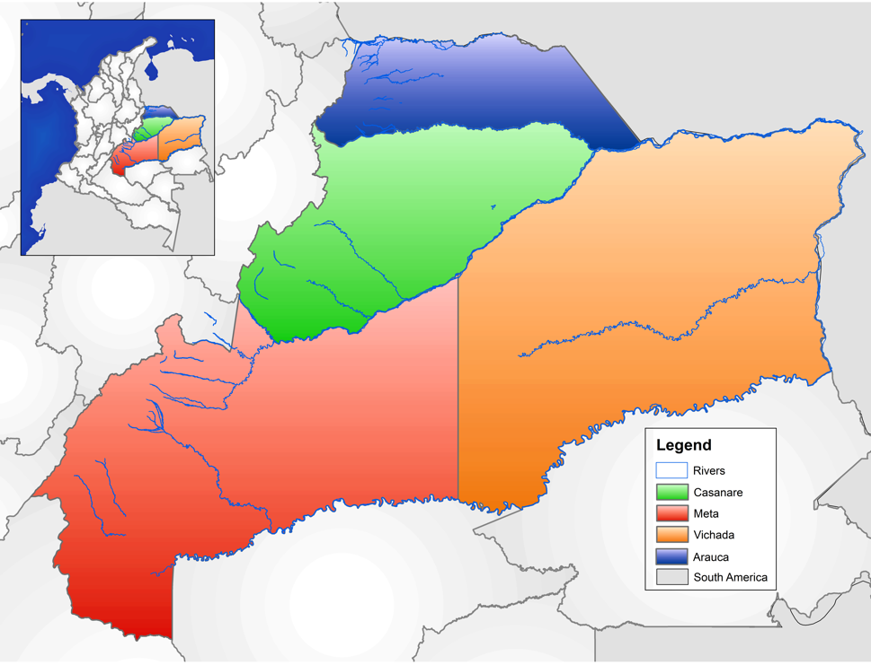

*Figure 1. The four Departments of the Orinoquía*

Furthermore, the 36 distinct ecosystems found in the Orinoquía span dense forests, gallery forests, wetlands, and the dominant tropical grassland savannas, which are considered one of the most important reservoirs of biodiversity in the Neotropics (Gassón 2002, Lasso et al. 2010).

The region is home to more than 1.5 million people, divided roughly as 1 million urban residents and 500,000 rural, with in-migration and population growth expected to drive that number up to nearly 2.25 million by 2035[8]. In Vichada, almost 40 percent of the population are indigenous or afro-descendent populations (in Arauca and Casanare the number is around 2%) (Becerra et al., 2009).

The research and results presented in this document focus on the water system, so the discussion below is intended to provide enough of a background for the reader to understand the goals of the research, the logic of the models, and the basis for the scenarios. The selected documents referenced herein (and they are only a sample) provide much deeper examinations of specific issues, and are well worth reading on their own.

The rest of this chapter provides a brief look at some general water issues for the region, a review of the regional climate and possible upcoming changes, a summary of livestock and agricultural systems, and a high-level look at some of the development planning and discussions that have taken place over the past decade

## Water

Water planning and administration in Colombia is executed at four levels. The first, and largest, are Macro-Basins, of which there are five (the Orinoco River Basin[9] is one). The CARs are the environmental authority for the management of these basins in coordination with the National Natural Parks (PNN). Then there are Hydrographic Zones, of which there are 41 and the national water monitoring program led by IDEAM, is managed at this hydrographic zone level (**Figure 2**).

Below there are Hydrographic Subzones of which there are 312 (IDEAM 2013). These subzones are defined as basins with drainage areas greater than 500 km2 within a hydrographic zone that are direct tributaries of the main river.

The planning and management instrument for these subzones are the *Planes de Ordenación y Manejo de Cuencas* (POMCAS). And finally, there are the Micro-watersheds, which are aquifer systems and wetland complexes that are managed through local workings groups, in coordination with higher planning authorities.



*Figure 2. Major HydroZones of Colombia (left), principal Sub-hydrozones (middle) and study region of Meta-Casanare in The Orinoquia (right). Source data: IDEAM.*

Colombia's MADS defines the policies and regulations for environmental planning and water management, and the Regional Autonomous Corporations (CAR)[10] administer the watersheds and the natural resources within them.[11] The implementation of water policies and regulations is done through the National Policy for the Integrated Management of Water Resources (PNGIRH), adopted in 2010 (MAVDT 2010), which establishes the strategic objectives, priority programs and instruments for the sustainability of water resources. The PNGIRH has a timeline of 12 years, the most recent of which expired in 2022, but, while under review, and until a new policy is published, it remains the law of the land.

In addition, a National Water Council (CNA) was created in 2017 to coordinate plans and programs for the implementation of the PNGIRH. The CNA a coordinated effort of the Ministry of Environment and Sustainable Development (MADS), the DNP, the Institute of Hydrology, Meteorology and Environmental Studies (IDEAM), and the Ministries of Mines and Energy (MME), Agriculture and Rural Development (MADR), Health and Social Protection (MSPS), and Housing (MV) participate. **Table 1** summarizes the instruments, stakeholder participation forums and definition for water management programs and policies.

*Table 1. Water governance****:*** *planning and management instruments for basins and aquifers.*

|  |  |  |
| --- | --- | --- |
| Instruments for planning and management of watersheds and aquifers | Multi-stakeholder participation forums | Definition |
| Strategic Plans for Macro-basins  (National scale 1:500,000) | Regional Environmental Councils | Inter-institutional and intersectoral coordination of actors in the macro-basin (National Decree 050 of 2018). |
| Watershed Management and Management Plans  (Regional scale 1:25,000) | Basin Level Councils | Consultative and representative body of all stakeholders living and developing activities within the watershed. (Sole Regulatory Decree 1076 of 2015). |
| Environmental Management Plans (Local scale 1:10,000) | Working Groups | Participation in planning and management of micro basins and aquifers. |

Decree 1076 of 2015 compiles all the regulations issued by the National Government for executing the laws of the Environmental sector. In ARTICLE 2.2.3.2.7.6. The following order of priorities is established to grant consumptive water rights.

* + - 1. Use for human, collective, or community consumption, whether urban or rural;
      2. Use for individual household needs;
      3. Community agricultural uses, including aquaculture and fishing;
      4. Individual agricultural uses, including aquaculture and fishing;
      5. Hydroelectric power generation;
      6. Industrial or manufacturing uses;
      7. Community recreational uses; and then
      8. Individual recreational uses.

In 2013 Corporinoquia[12] listed 744 formal water users with 566 taking surface water and 146 from underground sources (wells) in the Orinoquía.[13] These users combined for a licensed 10.1 million m3/s, with 8.9 million from surface water, of which approximately 75% came from the rivers Upia, Humea, Cravo Sur, Cusiana y Tocaría.

This area uses more than 55 percent of its water for agricultural activities, 16 percent for energy generation and 14 percent for aquaculture. In the Orinoco hydrographic area, the volume of water that does not return to the basin due to the activity of one of the sectors (blue water footprint) is distributed 84 percent in agricultural activity, 11 percent in livestock activity and 1 percent in fish farming, construction, energy, and domestic use (IDEAM, 2023).

There appears to be almost an excess of water in the region. The Orinoquía has five of the eleven Colombian rivers with a flow of more than 1,000 m3/second, and of the total Potentially Floodable Zones (PFZ)—defined as areas that are saturated or flooded for part of the year—in Colombia, 56.3 percent are found in the Orinoco Basin (many in the so-called flooded savannas).[14] The hydrographic sub-zone with the largest Potentially Floodable Zone (PFZ) area with respect to the total IPZ area of the country is Meta River Basin, with 19.6% At the departmental level, IDEAM (2023) states that "*Casanare, Vichada and Meta are the departments with the largest area of potentially floodable zones, with 35,262 km2 (18.5 % of the national total), 31,899 km2 (16.7%), 17,060 km2 (9.0%), respectively*". The PFZs, however, are not immune to human intervention through urbanized areas or areas dedicated to agricultural production. Between 2012 and 2018, PFZs in Orinoquía lost natural cover of 9,459 km2 (9 %) with the department of Casanare particularly affected (IDEAM, 2023).

In addition, the FAO (2013) describes a water shortage as: "*The lack of water, or low levels of water supply, at a given time and place; this is the result of insufficient water resources, absence of infrastructure, inadequate maintenance of these, due to low water levels as a result of seasonal or annual differences in climate, or due to many other hydrological and hydrogeological factors.*"

And a recent National Water Study (ENA 2022), using a vulnerability index for water supply, suggests that in the Orinoco hydrographic area, 79% of the basins have low vulnerability in an average year, and 67% have low vulnerability. In 2023 IDEAM created an index from 1 to 5[15] to track the relationship between water demand and supply while providing indicators of the historic ability of hydrographic subzones to sustain the volumes of water required for the Orinoco hydrographic area, noting that most of the subzones have had the water necessary to meet the demand in an average year.

In a dry year, however, there are 13 subzones that have a moderate water use index, 5 that have a high water use index, and 1 that has a very high water use index. This indicates that in a drought there may be difficulties in meeting water requirements, and for the period from 1985 to 2020, IDEAM identified the Meta River Basin as one of the hydrographic zones with a drought frequency that exceeds the national average by 30 percent.

Indeed, drought events are frequent throughout the Orinoquía, and annual periodic drought is a defining factor in the region’s ecosystems (Castellanos 2015). IDEAM has shown that the highest number of drought events in the country are concentrated in the four departments, including some high and very high registers. Indeed, Vichada exceeds the national average of drought events in all departments by 29 percent, followed by Meta and Casanare, by 26 percent, and finally Arauca, which has 23 percent more drought events than the other departments, which opens the door to water conflicts.

The cause of conflicts over water is often the lack of supply to meet a given demand for any given actor (Gleick and Iceland 2018). This may be a result of overall water availability as well as restricted access or poor quality. In other words, the appropriation of water by an actor while leaving another actor water-scarce (Robbins 2004, Martínez-Alier et al., 2010 Rincón-Ruiz, A. et al., 2019). Water-related conflicts can range from a neighborly dispute to a full-scale international altercation.[16]

According to IDEAM (2023), nine subzones of the Orinoco hydrographic area face high or very high pressures, and therefore have a greater potential for conflict, eight of which are part of the Meta hydrographic zone,[17] with the remaining zone being the Banadía.[18]

The Ministry of Environment (MADS 2014) has established three types of water conflict that may arise, including: water resource use conflicts, which focus on the availability and quality of the resource: land use conflicts, which refer to disagreements between land users due to the over or under use of the land of the area, zone or hydrographic subzone; and conflicts due to loss of coverage in strategic ecosystems, in which the conservation of biodiversity or other ecosystem services are threatened, diminished or affected.

UNILLANOS in collaboration with local and regional experts, identified the following list as potential sources of conflict over water, suggesting that conflicts result from inequitable distribution and damage and changes in water quality, rather than from water scarcity. Some examples of these conflicts can include the following:

* Unilateral and arbitrary decisions by governmental agents that hand over public water services to private third parties.
* Pollution of rivers, natural reservoirs and aquifers.
* Changes in water courses and flows that ration or cut off access and sometimes cause flooding.
* Competition in demand and use for agriculture, livestock and urban use.
* Speculation and hoarding by companies and concessions.
* Inadequate and poor construction. (Arias-Castellanos 2015 pg.145)[19]

Furthermore, UNILLANOS identify the emerging need for attention to hydropolitics in the region to regulate water availability and access (Caro-Caro et al. (eds), 2015).

In response, the MADS created Regional Centers for Environmental Dialogue (CRDA) in each of five main Macro Basins (MADS, 2018), which act as independent spaces for facilitation, articulation, participation, cooperation and reflection in the identification, prioritization and discussion of environmental conflicts at the regional level and.

Finally, while the Orinoquía has always been seen through the lens of water availability, and even excess, a recent report card from the World Wildlife Foundation (WWF 2016) gave most of the Meta Basin a “C” grade[20] with even a “D” for the Upper Meta, and Universidad de los Llanos (UNILLANOS), in its publication “*Vision de Visiones*” for the Orinoquía has highlighted emerging threats to the resilience and access to the water system (Caro-Caro et al., 2015), raising the specter of future problems.

## Climate

There is increasing evidence of the negative impacts of climate change on hydrological systems and its knock-on effects in agricultural production, which may limit the potential expansion of agriculture in the Orinoquía. The effects, however, are more consistent for temperature than precipitation, and are not all in complete agreement.

In the IPCC general circulation models (GCM) increases in mean temperature occur gradually over time. In the first few decades, through 2040, the 4 Representative Concentration Pathways (RCPs) project similar temperature increases, after which they diverge.

For the period 2041-2070 the magnitude of the changes in the average temperature for Colombia, compared to the reference period of 1976-2005, are projected to see an increase of approximately 1.0 to 1.5°C in RCP2.6 and 1.5 to 2.0°C in RCP8.5. Then in 2071-2100 RCP2.6 flattens to a steady level of 1.0°C, while RCP8.5 continues to see temperature increase to 2.0°C to 3.5°C for the whole country. Thus, there is consistent indication in the model simulations of warming and the possibility of warming that is significant.

In the Colombia’s Third National Communication on Climate Change (IDEAM 2017), a multi-model ensemble used to project changes in precipitation and temperature at the national level, estimates that by the year 2040 the average national increase in temperature could be 0.9degrees and could increase up to 2.4 degrees over the longer term.[21]

The Comprehensive Regional Climate Change Plan for the Orinoquía (PRICO) (Castillo, 2018), prepared in collaboration with the Universidad de Los Andes and the Tropical Agriculture Research Center (CIAT), presents climate change projections up to 2100, where the annual maximum temperature is projected to increase in the region between 0.8 to 1.9°C and the minimum between 0.3 to 1.8°C, under the RCP 4.5 scenario (the so-called realistic scenario), with higher rates increase in the departments of Vichada and Arauca. Compared with climate change scenarios at the national level, the departments of Arauca and Vichada are projected to have the highest temperature increases in the country (IDEAM, 2017), with regional temperature increase for the pessimistic scenario (RCP 8.5) possibly reaching 2.4°C.

In contrast, the RCPs project continued trend reflecting the historical precipitation from the reference period of 1975-2005 and do not indicate any clear signal of future changes in regional precipitation. Pabón Caicedo (2012), however, shows a possible increase in precipitation at the regional level, while Arrieta-Castro (2020) states that climate change will increase variability in river flows in the Meta River. Florian et al. (2022) evaluated the capacity of the Regional Climate Models included in the regional scale reduction experiment (CORDEX-CORE),[22] to represent the monthly precipitation and evaporation in the Meta River and found significant imprecision.

In general, the projected changes for total precipitation in the PRICO are modest, fluctuating between -5 to +5 percent under the RCP 4.5 emissions scenario, with more significant increases towards the region's south and decreasing towards the northeast of Vichada and east Arauca. In these models, precipitation is also projected to decrease towards the end of rainy season, between September-November, especially in Arauca and northern Vichada. This projection is potentially significant for agriculture since it could cause the rainy season to end earlier than usual and force prolonged dry seasons. Under the pessimistic emissions scenario (RCP 8.5), the decrease in precipitation could be as high as 25% between September and November. In contrast, rainfall may increase in the wet months (May to July) and causing more frequent extreme rain events in certain areas.

## Livestock and Agriculture

The potential negative environmental and hydrological impacts of land use change due to agricultural expansion in the Orinoquía, is receiving increasing attention (González 2005, Pimentel et al. 2021, Ramírez-Contreras et al. 2021).

The following sub-section discusses the key water consuming livestock and agricultural activities: cattle (beef and dairy), pigs, poultry, oil palm, and rice. There are other land use activities, emerging in the region, but they are largely rainfed and therefore do not contribute to consumptive water and as such are not yet in consideration in the model.

### Cattle (beef and dairy)

Cattle arrived at Colombia in 1525 from the Orinoco region through what are now the departments of Norte de Santander and Arauca and have been an integral part of the landscape ever since (Palacio et al, 2001). From milk production in the mountains to extensive beef production in the eastern plains, cattle production in Colombia today is as diverse as the country itself (Bustamante and Rojas-Salazar 2018).

The cattle herd in Colombia is approximately 29.3 million head, with approximately 6 million found in the Orinoquia, and Department herds distributed as follows: Vichada 250 thousand, Arauca 1.3 million, Casanare 2.2 million, and Meta 2.2 million.[23] The population is distributed over approximately 50,000 farms, with 26,000 farms having herds of less than 50 head. Ranching in the region has historically driven conversion of the predominant gallery forest to pasture, which is now the main land use throughout the region (Molina-Benavides 2021) with more than 50% of land use in the region also comprising natural savannahs (although there has been a loss of approximately 13% in that ecosystem) and an additional 15% in mixed pasture and crop use (Vargas, Valencia and Villegas 2022).

Growth of the cattle herd over the past 20 years has been steady (**Figure 3**). In 2004 the total herd stood at 3.8 million and is now 6.1 million.[24] This is a total herd growth in all 4 departments of 2.2 million in 20 years (approximately 60%), or a cumulative growth rate of approximately 2.5 %. This rate, varies greatly by Municipalities and Department, ranging as low as zero and as high as 5%.[25]

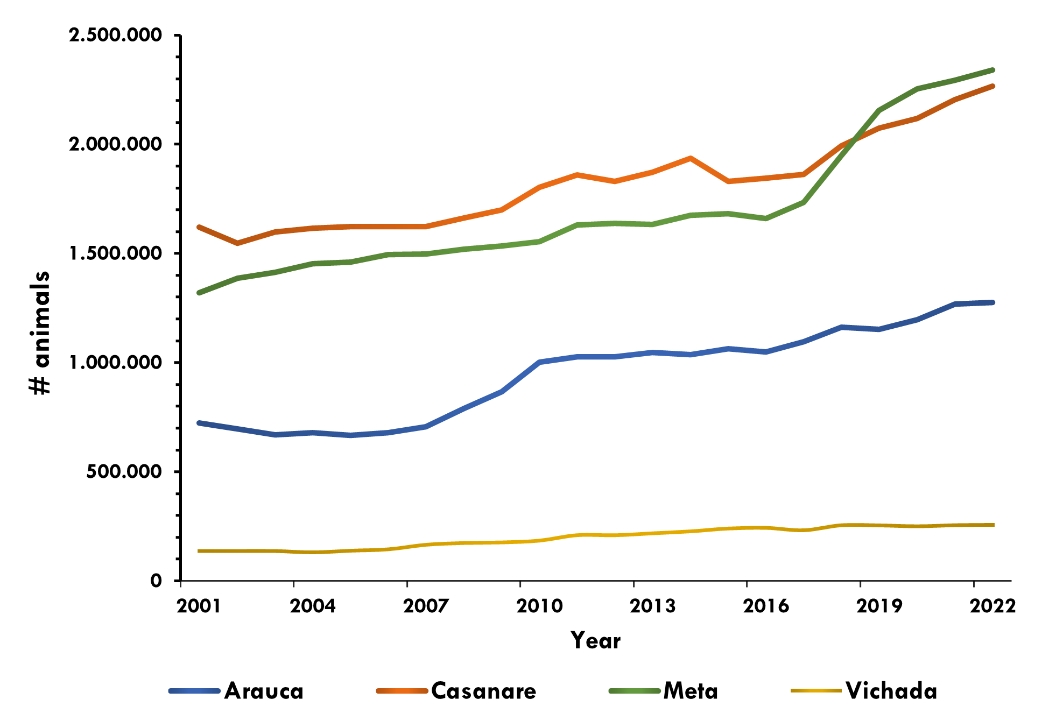

*Figure 3. Growth in total cattle herd (# animals) for the four departments of the Orinoquía from 2004 to 2023. (Source: ICA)*

Bravo (2021) describes an increase in the national herd from just under 23 million to the current 28 million between 2016 and 2019, and suggests that the potential for significant additional growth remains a possibility. Land area appears to not be a limiting factor since approximately 27 million hectares of the 40 million designated as agricultural frontier in Colombia are estimated to be suitable for beef and dairy production (of these, 17 million hectares are considered high and medium suitability for beef and 12 million hectares are categorized as high and medium suitability for dairy).

Large parts of the region, however, have difficult production conditions with poor soils or suffer either drought or floods, which may constrain overall expansion. The department of Meta is considered the most drought-prone department in the country (IDEAM, 2023), while the flooded savannahs make up large parts of Casanare and Arauca, and Vichada has extensive regions with poor soils. The maximum carrying capacity for the regions therefore ranges from approximately 1 ha/head in the Piedmont, to 3 ha/head in the Altillanura, and down to 7 ha/head in the flooded savannah and throughout many parts of Vichada (and in many cases a much lower carrying capacity is not uncommon).

A feature of the national cattle herd in Colombia is that a high proportion of the herd (40 %) is designated as dual-purpose where the production is for both beef and dairy, which affects productivity for both activities. The remainder is 35 percent cow-calf, 20 percent fattening and 6 percent specialized dairy (FEDEGAN 2018).

### Pigs and Chicken

The population of pigs (**Figure 4**) and chicken in the Orinoquía is increasing and while a relatively minor consumer of water at the current moment, these activities could become a significant source of water demand when including the slaughter phase of the value chain. It appears that a large population growth in the department of Meta (from 150,0000 in 2021 to 850,000 in 2022) creates significant recent regional increase.

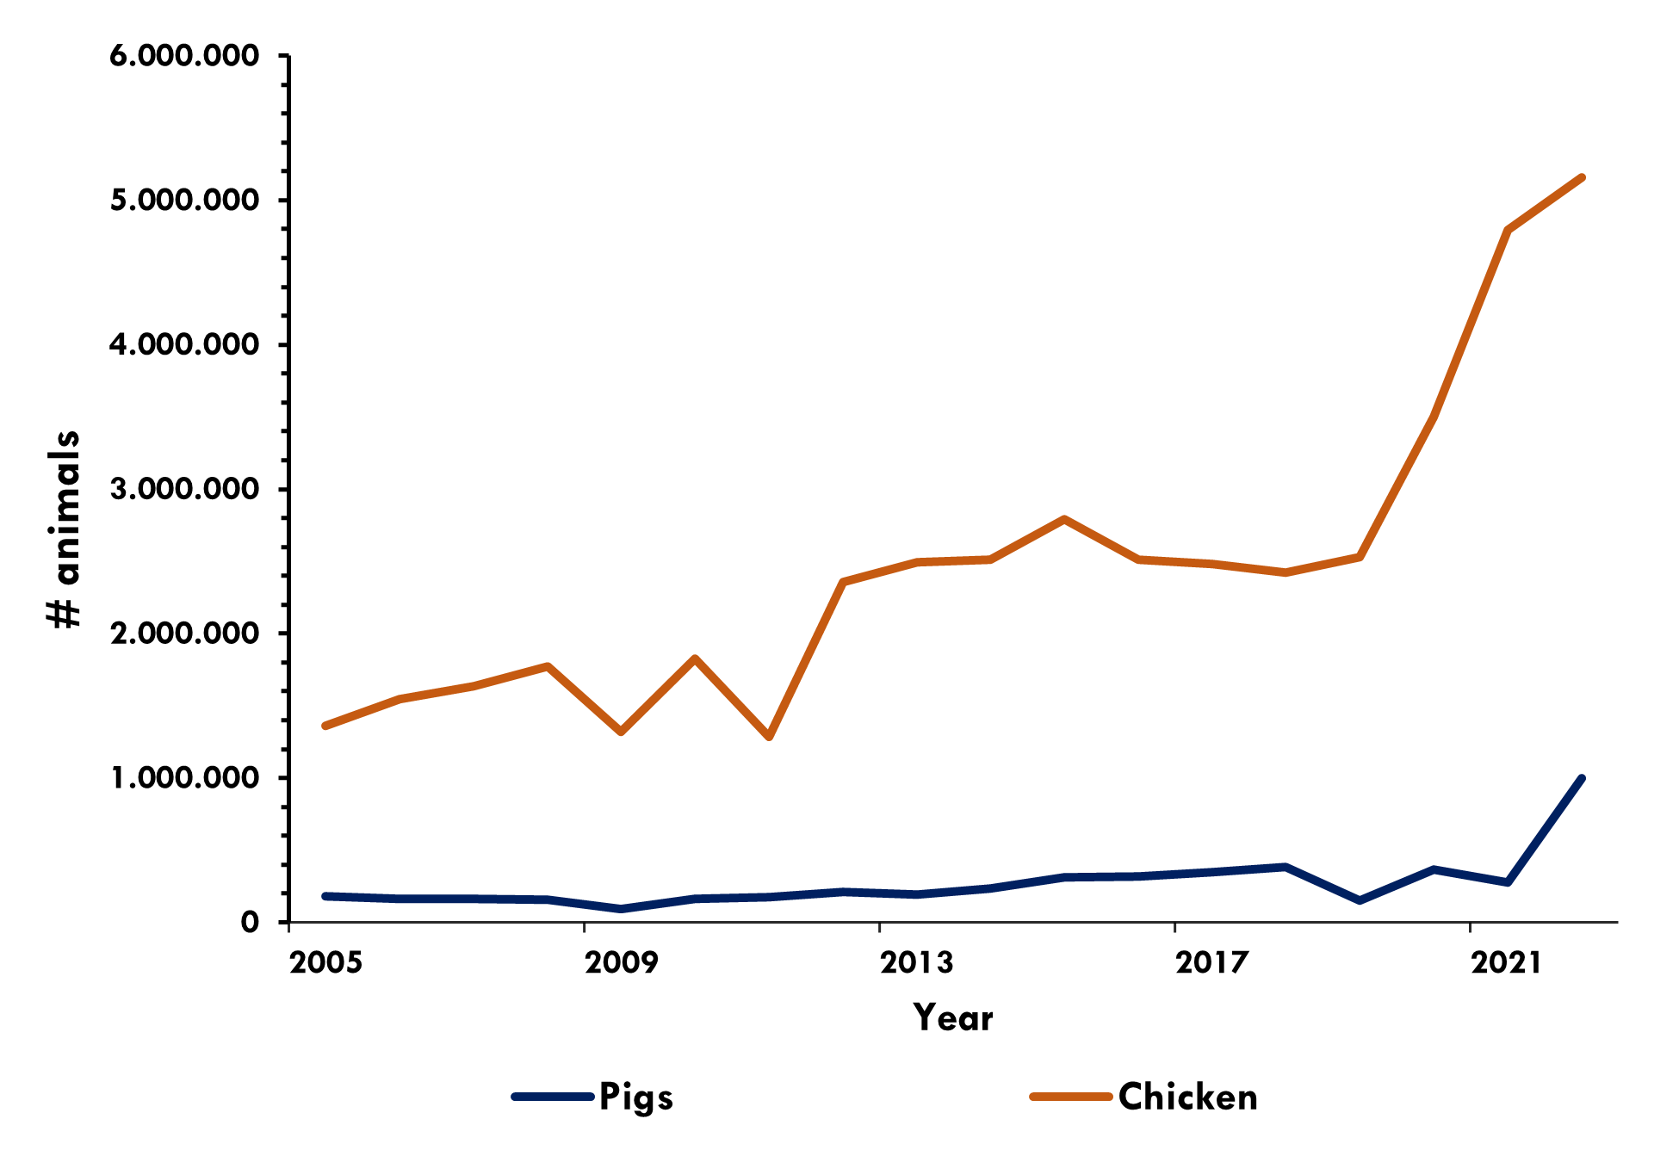

*Figure 4. Pig and chicken population (2005- 2022) in the Orinoquía 2005 to 2023.*

The chicken population in the four departments of the Orinoquía has increased from 1.3 million in 2005 to 6 million in 2023, with significant jumps of approximately 1 million per year between 2019 and 2021, and then an increase of 0.5 million for both 2022 and 2023.

With a growing demand for protein in Colombia and a particular preference for chicken by consumers (cost effective) there is no reason to expect a decline in the population. The other two departments of the Meta River Basin both have significantly larger populations (Boyacá 5 million and Cundinamarca 38 million) because they have suitable climatic conditions and better access to the eight million strong market of Bogotá.[26]

### Rice

Rice is a water-hungry crop. Accounting for evapotranspiration, seepage and percolation, it can take up to 2,500 liters of water to produce 1 kg of rice, which is up to 3 times more than other cereals.[27] However, the recognition of regional and global water shortages has led to the development of alternative irrigation technologies beyond continuous flooding (CF) as well as the dryland crop varieties that are better suited to rainfed production.

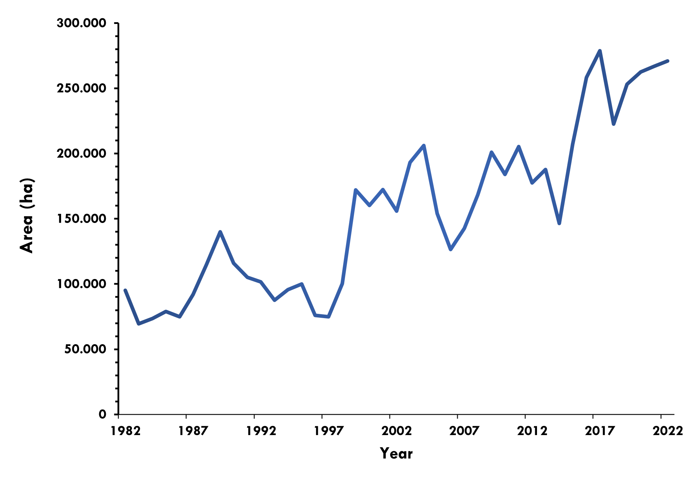

*Figure 5. Total area of rice production (ha) in the Orinoquía (Zona Llanos) from 1982 to 2022.*

Rice production in the Orinoquía has grown unsteadily. The expansion in production area can be largely attributed to the changes in the area of dryland rice production, because as shown below in **Figure 6**, the irrigated rice area has remained relatively stable for the past decade (Fedearroz, 2022).

There is also intra-annual variation since rice is grown in two seasons. Casanare and Meta plant more than 80% of dry rice and 20% of irrigated rice in the first semester to take advantage of the rainy season. Since 2010, Casanare has been the largest producer in the region mainly due to the impact of the improved road between Villanueva and Yopal which has created favorable access and growth in municipalities such as Aguazul and Yopal, as well as the installation of processing facilities such as Arroz Diana.

Rice production is sensitive to changes in input costs (including competition for land) and international markets. Climatic factors have also impacted planting areas. According to FEDEGAN (2017), climatic phenomena have occurred between September 2009 and April 2010 (El Niño), October 2010 and June 2011 (La Niña), October 2011 and March 2012 (La Niña), in 2014 (El Niño) and between 2015 and 2016 (El Niño), all of which affect rice production and profitability. Also, rice production, especially near the flooded savannahs can be affected by floods as well as droughts.

#### Rainfed vs Irrigated

The distribution of rice planting areas includes both irrigated and rainfed systems (rainfed rice). In both system, rice is grown with controlled levels of water but rainfed depends solely on precipitation.

The irrigated system, however, while providing a more consistent access to water, requires investments in irrigation canals and water intake systems making for a higher financial investment but returning more consistent benefits.

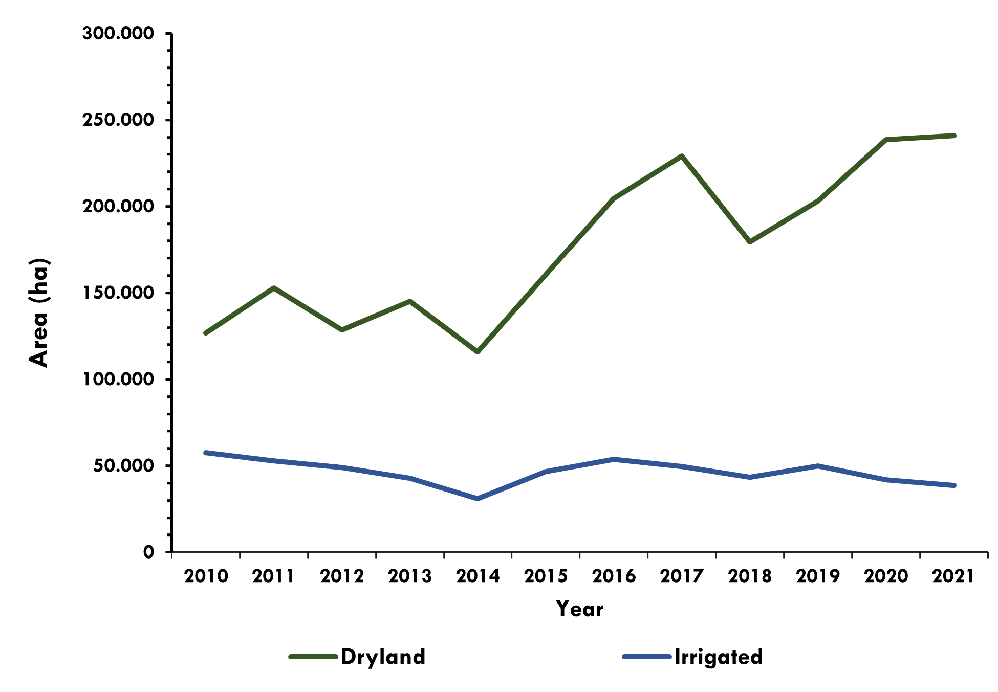

*Figure 6. Area of rice production (ha) in Orinoquía 2010 to 2021 by system (dryland/rainfed and irrigated)*

In the rainfed system, the available water depends only on the rainfall regime, which increases uncertainty, but it is less expensive and more flexible (with no fixed costs one can choose to not plant if weather projections indicate a poor crop).

The trends in these two production options are distinct, with irrigated rice having a steady and relatively unchanging area planted while dryland rice area is steadily increasing, albeit with significant annual fluctuation.

### Oil Palm

Oil palm is a significant global commodity which first appeared on the Colombian landscape in the early 1960s and has emerged as a lucrative alternative, in part due to government incentives (Vargas et al. 2015).[28]

Indeed, oil palm (Palma Africana) has been touted as one of the products with the highest potential to drive additional economic growth in the region. Oil palm will likely continue expanding (Castiblanco et al. 2013), albeit at an increasingly slow rate. Production area has increased dramatically over the past decades from approximately 5,000 ha in 1980 to 265,000 ha in 2020.

The expansion of African palm cultivation became important due to a national policy that sought to substitute vegetable oil imports (Perfetti et al., 2013). In the region, there is evidence of significant growth since 2009 and a difference in areas between the two departments of Meta and Casanare, as shown in **Figure 7**.

In addition to government support and increasing market access, forced displacement and land dispossession are thought to be factors in oil palm expansion. The armed conflict drove land dispossession and led to an opportunity for large scale land purchases (Osorio, 2015; Mesa, 2017).

The oil palm agroindustry has now long been considered one of the crops with the greatest growth potential in the country (CONPES, 2007) and has been the recipient of Government support including support directed at establishing a small farming contract system between processer and farmer with less than 20 ha.[29]

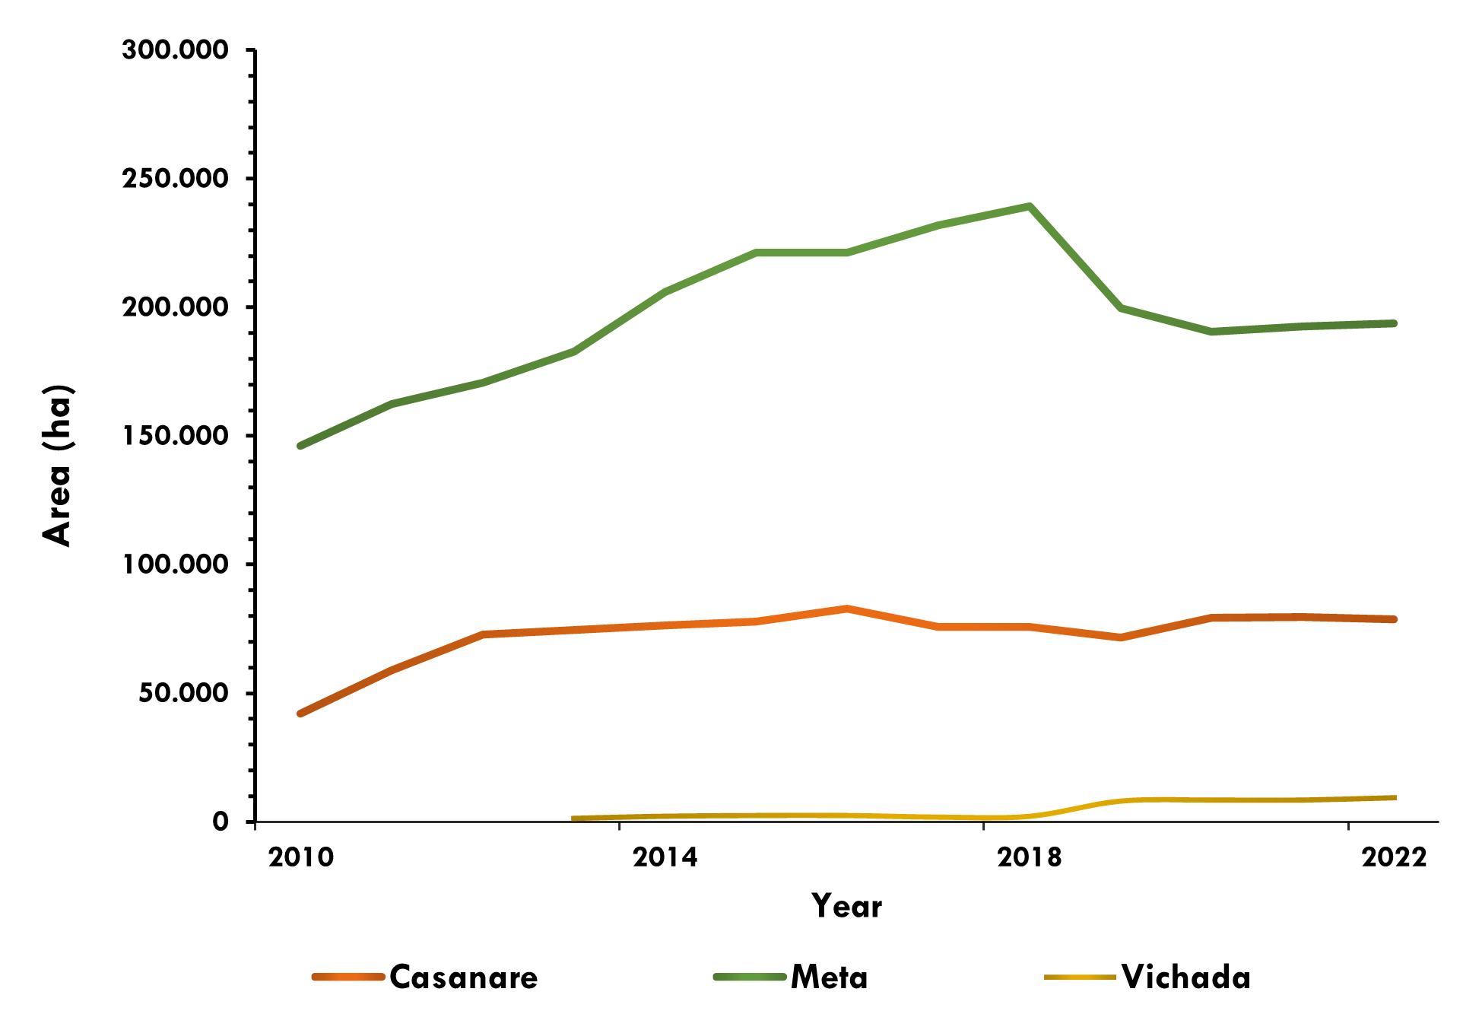

*Figure 7. Growth of area (ha)under Oil Palm cultivation in Casanare, Meta and Vichada from 2010 to 2022.*

But the expansion may be cooling slightly as oil palm finds it limits in available land and water while also facing problems of disease like Bud Rot (*Phytophthora palmivora*), which first appeared in Colombia in the 1960s but has recently become more widespread affecting up to 70,000 ha in some regions (Torres et al. 2010, Torres et al. 2015). Indeed, Rozo (2014) suggests that it is unlikely that the sector will ever meet its professed target of 3 million ha and potentially will not reach 1 million ha (the current national total area is approximately 450,000 ha)

Furthermore, water consumption in oil palm, however, has always been an issue of concern worldwide, from both social and production perspectives (ECOTON 2020). It is estimated that oil palm consumes up to 34,000 liters of water per hectare per day, with a potentially larger footprint when considering grey and green water as well as blue.[30]

Kospa et al (2017) estimate that the water footprint of oil palm production in a selected study company in Indonesia is 981 m3/ton, of which 820 m3 is green water, whereas the processing of crude oil requires 3,819 m3/ton.

The effect of irrigation in oil palm, however, has been shown to increase yields in a range of 5 percent to 140 percent over non-irrigated fields depending on the local conditions (Mejia, 2000).

Safitri et al. (2019) estimate that oil palm water consumption ranges between 3.07–3.73 mm/day and that the total water footprint ranged between 0.56 and 1.14 m3/kg for depending on plant age, soil types and other conditions.

**Rice and oil palm areas**

Below is a comparison of rice and oil palm area and distribution between Departments. In Casanare rice is planted on 195,000 ha while oil palm covers 79,000. In Meta, the opposite is almost the case; there are 194,000 ha in oil palm and 85,000 in rice (**Figure 8**). Arauca and Vichada have much less, or none, of both. In Arauca there are approximately 21,000 ha of rice and no oil palm, while in Vichada there are 9,000 ha of oil palm and 500 ha of rice. There is a total regional estimated area of 300,000 ha of rice and 280,000 ha of oil palm.

Overall, Rice production is the dominant annual crop covering up 59 percent of agricultural area in the region and, with the exception of oil palm, which is a perennial, is the only crop for which irrigation is a common practice. Even in rice, continuously flooded irrigated rice only occurs in 20 to 30 percent of the productive area. The remainder is rainfed, dryland, rice (*arroz secano*).

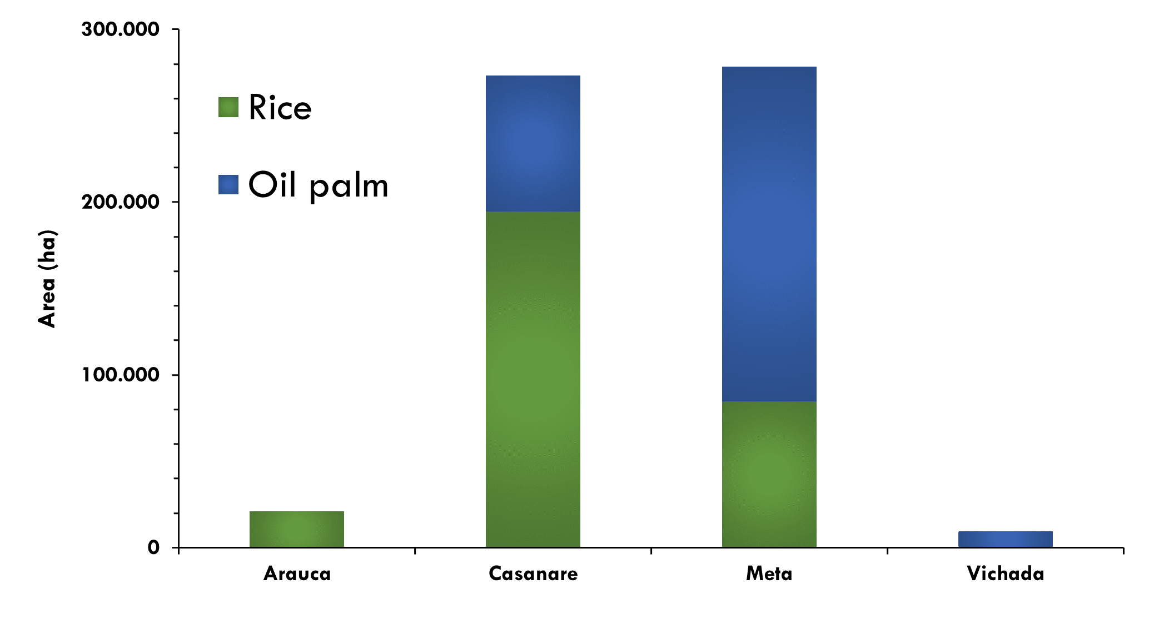

*Figure 8. Rice and Oil Palm production areas in the four Departments of the Orinoquía.*

### Other crops

Five key agricultural products are expected to influence the region's future: livestock, palm oil, forestry, rice, and soy beans (DNP 2014, Williams et al. 2020). At a smaller scale, cashew cultivation has also become relevant (Owen and Román, 1996), especially in Vichada, and cocoa crops are gradually expanding in Arauca and Meta (although it is said that cocoa has been produced in Arauca for at least 200 years).

The estimated regional area for corn is 106,000 ha[31] with Meta contributing 89,000 of those ha. Plantain is the next regional crop with 71,000 ha of which Arauca contributes 36,000 ha and Meta 29,000. Soy also covers 70,000 ha, all of which, bar a few hundred ha, are in Meta. Cocoa covers a total of 36,000 of which 21,000 are in Arauca and 12,000 are in Meta. And finally, cashew is an emerging crop in Vichada with nearly 9,000 ha **(Figure 9**).

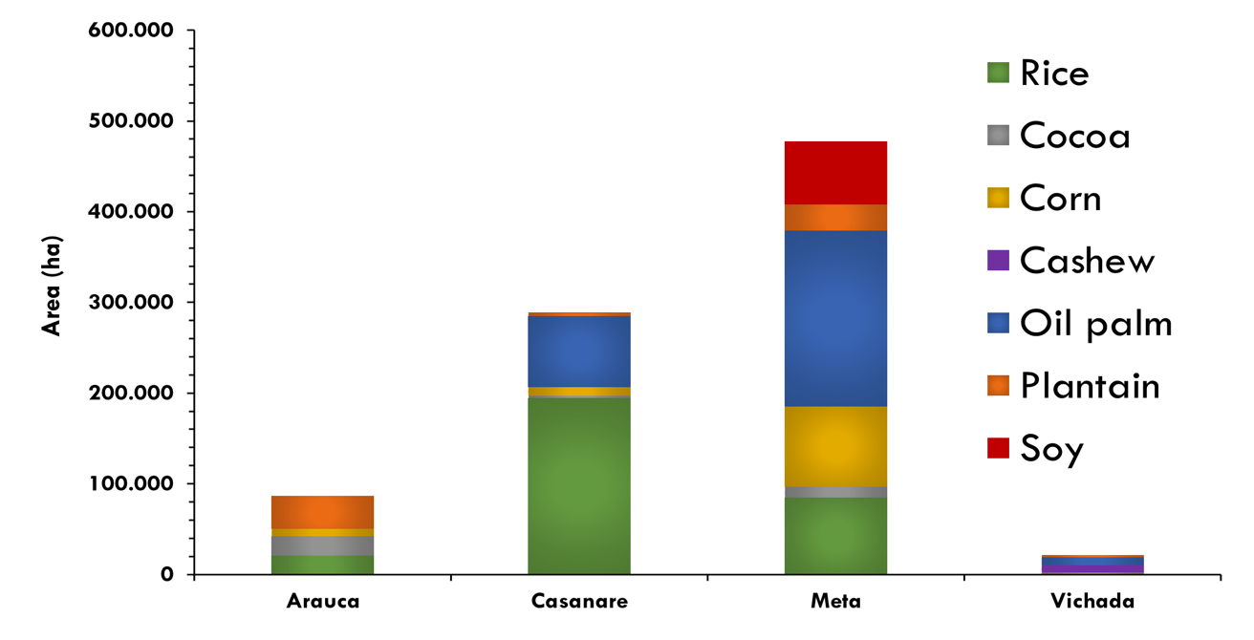

*Figure 9. Distribution of other crops of significance in the region as compared in scale to rice and oil palm.*

## Development Planning

As warranted for a region holding such promise for economic development, there is now a rich collection of planning documents for the Orinoquía. As far back as 2009 the trade-offs between agricultural development, mainly in rice and palm, and environmental management had begun to manifest itself, although pasture still covered nearly 90 percent of the productive land. Becerra et al. (2009), in a study on the environment and economics of the region, recommend that the development in the Orinoquía pay close attention to the abundant natural resources, in particular the water systems, and make note of the unique difficulties inherent in strongly seasonal systems like those experienced in the flooded savannas of Casanare and Arauca.

In 2011, the Department of National Planning (DNP) put out a vision for the development of Arauca seeking a sustainable future (DNP 2011 pg 163)[32], abridged and translated here as:

“*The Department of Arauca will be a border region that builds peace, that will have "seeded" the oil bonanza to improve the quality of life of its inhabitants and the sustainable management of its territory, based on the strength of its institutions, on the basis of a high ethical sense of public affairs and a strong alliance between the public, private and academic sectors*…”

Aspirational visions for the future of all the departments in the Orinoquía published a decade or so ago lay out a similar scenario, whereby a positive economic future is created in balance with the natural ecosystems.[33]

The Regional Environmental Management Plan (PGAR): 2013-2025 (Corporinoquia, 2103) identifies the Orinoquía as the last agricultural frontier of Colombia and, importantly, included the departments of Boyacá and Cundinamarca within its purview.[34] The PGAR lays out a comprehensive review of the legislation regulating environmental and development issues nationally and regionally, and includes a review of water supply and demand for the region, among many other topics.

In 2015, UNILLANOS published a definitive report called Vision of Visions (*Visión de Visiones)* (Caro-Caro, et al. 2015) that provides an excellent overview of the historical planning process of the Orinoquía dating back to 1961 and going through to a current discussion of the local visions of development. This report also identifies water as a strategic resource for the region.

Other important recent advances in planning for the future of the Orinoquía include Cormacarena (2019) that outlines and environmental plan for the region, The MADR (2021) with a focus on managing climate change by the agricultural sector, the Regional Land Use Planning Model for the Orinoco (MOTRO) by DNP (2021), which lays out a very thorough ecological, social and economic overview of the region, and the National Water Study from the Ministry of Environment and Sustainable Development (MADS,2022), which is discussed in more detail below, among others.

# the orinoquÍa water futures (OWF) model

## Introduction

The OWF is an integrated water system modeling platform that incorporates a number on individual models into a system and allows them to run simultaneously to create projections about the future condition of the water system in the Orinoquía.

### An OWF overview

At its most basic the water system model projects how much water will enter the system through tributary rivers, how it moves through the system, and how much is taken out by water users. Climate stresses and changes in water demand affect the system and the model simulates the system’s responses to these changes with the results providing information to assess the ability of the system to meet future water needs.

The OWF itself is a series of coupled models (**Figure 10**) through which data is both created and used to assess the vulnerability of the Meta River basin.

A weather generator is used to create new timeseries of temperature and precipitation that are consistent with the possible future climate changes indicated by climate models but also comprehensive to include other scientifically plausible changes.

There first module is the hydrologic model, where inputs on weather (temperature and precipitation) are used to simulate the resulting streamflow.

A water demand model accounts for freshwater demand from both urban and rural communities, as well as water demand for livestock and agriculture[35]. The water demand model also sets minimum flow levels at various sections of the river stems that ensure pre-selected environmental or transportation needs are met.

Outputs from these models feed into the water system infrastructure model which is coded in python using the PWYR (python-water resources) coding library. The water system infrastructure model simulates how the water travels through the mainstem and tributary rivers, through reservoir operations, withdrawals for water use and return flows, ultimately tracking water and its use throughout the basin.

*Figure 10. Flow chart approximating the modeling framework for assessing the vulnerability and adaptation planning of the Meta River basin.*

The outputs of the model include state variables (i.e., surface and groundwater storage levels), and fluxes such as deliveries to farms and urban centers, flow through river channels and reservoir releases.

The performance metrics used to assess the system are the last product of the system of models. Performance metrics help identify key system vulnerabilities and inform decisions. Common metrics include: (1) Water Delivery Reliability, (2) Shortage Duration, and (3) Supply Deficit.

Water delivery reliability represents the frequency (%) in which the system is able to meet full demand. This metric can be calculated for each response units across the system and for each demand category. In addition, this metric can be assessed at monthly and/or annual time steps. Shortage Duration is the period during which any user is not served 100 percent of its demand. It is calculated at either monthly or annual time steps. And finally, Supply Deficit represents the volume of water shortage or surplus for each demand category, response unit and time step of the simulation.

## Study Site: The Meta River Basin

Located in the Orinoquía region of Colombia, the Meta River is 1,250 km long (CORPES Orinoquía,1997) with a Basin that covers approximately 100,000 km2 and an average flow of roughly 5,700 m3s-1 (1926-2011) at Puerto Carreño, the outlet of the Basin at the junction with the Orinoco River. The climate in the region is dominated by a monsoon regime with significant influence of the El Niño-Southern Oscillation (ENSO) teleconnection patterns (Puertas-Orozco et al. 2011).

This project considers the sub-basins of the Meta River defined by official entities as hydrological analysis units. As a major basin itself, but with very little available data, the five subzones of the Casanare Basin (#27) which is located in both departments of Casanare and Arauca (the Casanare River is the departmental border) are included as one subzone. This important hydrozone is part of the Meta Basin as it empties into the Meta River just before Vichada. The Casanare Basin is therefore included for water balance and climate variability purposes. **Figure 11** presents the hydrographic response units for the hydro-system model.

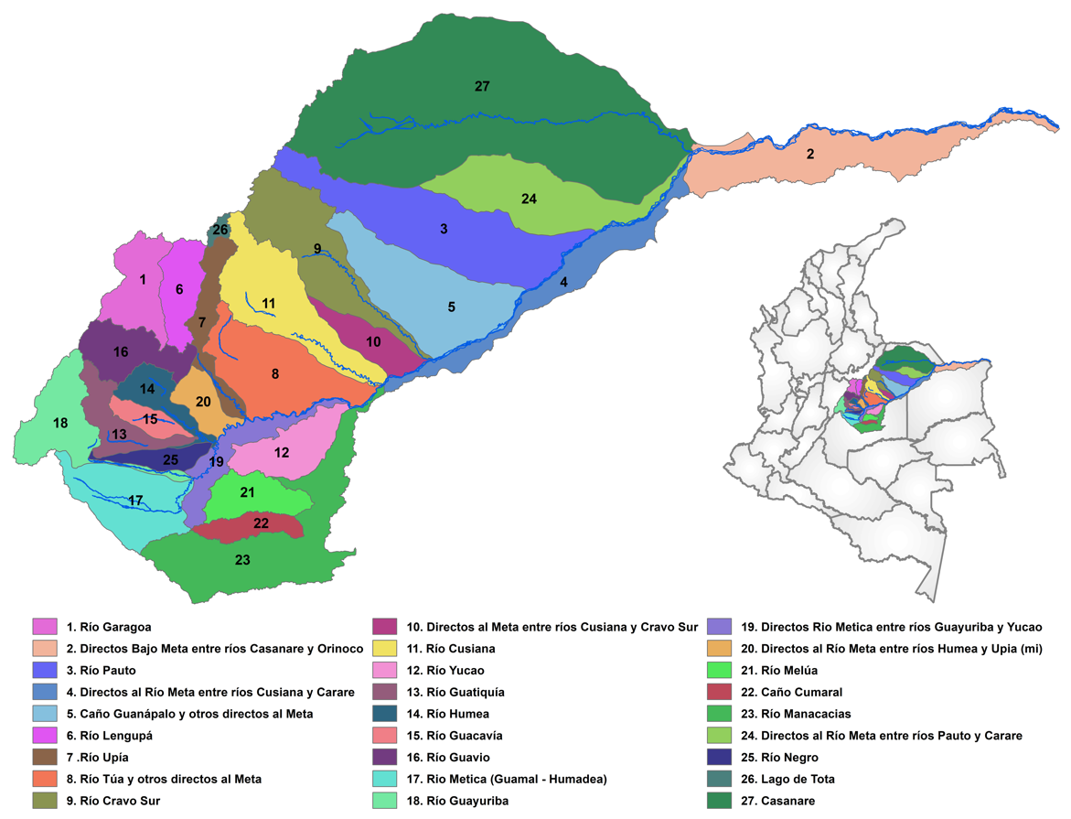

*Figure 11. Catchments / hydrographic response units for the Meta- Casanare River according to the Colombian Water Resources Information System of Colombia (SIRH).*

The Agricultural Rural Planning Unit (UPRA) was established for Colombia for the zoning of different crops and land evaluations to the Information System for Agricultural Rural Planning (SIPRA) in order to identify suitable areas for agricultural production.

SIPRA uses information from multiple databases to identify soil quality based on climatic classes, relief, availability of root oxygen, availability of water in the root zone, availability of nutrients, excess of salts, tillage capacity, risk of erosion, risk of degradation, flood risks, climatic risks, and pests and diseases (UPRA, 2014).

**Figure 12** (left) shows the spatial distribution of the three main land use activities considered in this analysis: palm, rice, and livestock; including only the categories of medium and high suitability. With the exception of the flooded plains in Casanare Department, a large part of the Meta River basin is suitable for production in all of these three options. In addition, the maps are not exclusionary as all areas suitable for rice and oil palm are almost always medium or highly suitable for livestock.

Figure 12 (center) shows the preservation and conservation areas considered in exercise, which include National Parks; Civil Society Natural Reserve Areas; Areas of high conservation value including: Wetlands; APCO CONPES (Areas prioritized for environmental conservation according to the National Council of Economic and Social Policy (CONPES); the Manacacías protected area; Forest conservation areas; and areas prioritized for conservation by the Alexander von Humboldt Biological Resources Research Institute (IAVH)***.*** Figure 12(right) also shows a map of areas suitable for adopting irrigation technology, which includes areas that are categorized by gravity fed and those that require pressurized systems.



*Figure 12. Areas suitable for the production of rice, oil palm and cattle in the Meta- Casanare River Basin (left); Preservation and conservation areas (center); Irrigation area and options (right)* (UPRA, 2019).

Finally, there are emerging concerns about the continued ability of the Meta River to serve as an infrastructure integrator, highlighting the navigability of the Meta River as one of the goals for regional development (Serje and Luna, 2017).

## Weather Generator Model

Results from climate models are highly variable, so projecting future climate remains deeply uncertain. To address this issue, this study applies a climate stress testing approach, where a wide range of scientifically plausible climate scenarios are used to identify the vulnerabilities of the system. **The weather generator** is built from observed historical data and **is designed** **to project a timeseries of precipitation and temperature** to be used as input to the stress test for the OWF to simulate the future effects of regional climate change.

### Material and methods

The weather scenario generator uses a Hidden Markov Model (HMM) (e.g., Michelangeli et al., 1995) to produce a time series of weather variables that exhibit similar statistical characteristics as the historical record, thus capturing natural variability in scenarios.

This output is then used as data for stress tests within the hydrologic models, associated hydro-systems, and the water demand models to examine the spatial and temporal vulnerability of the system.

Variation in one or more parameters in the stress testing platform is used to simulate future scenarios under different climatic conditions, including the intensity and frequency of daily precipitation, the number of days with extreme temperatures, or the occurrence of variable drought periods.

The steps to build the weather generator include data collection and filling, completion of historical climatology data, and then simulation of the climate variables, a process that is roughly summarized below in **Figure 13**.

*Figure 13. Weather generator model steps summarized*

### Data and data filling

The meteorological and climatic information was provided by the Institute of Hydrology and Environmental Studies of Colombia (IDEAM). Data was available from 341 stations whose metadata includes the year of establishment, type of station, parameters measured and scale of the registry, character (private or public), and availability of information.

Temperature data comes from seventy-four weather stations that record daily minimum and maximum temperature, but only forty-four of which had less than 40 percent missing data for the period 1980-2014. [36] Precipitation data comes from 261 hydrometeorological stations[37] with historical records from January 1950 to December 2018. Most stations have a coincident record from January 1980 to December 2014. However, of the 261 stations only 119 have less than 40 percent missing data.

Using the parsed data, the HMM model's parameters are adjusted for the area of interest. The model parameters determine the probability of precipitation on a given day based on the precipitation on previous days, thus preserving the historical temporal variability of precipitation. It does this by defining states, which are categorized by their probability of precipitation for each of the stations in the domain of interest. These parameters will be defined by searching for the number of states “k” that minimizes the Bayesian Information Criterion (BIC),[38] which seeks to reduce the number of parameters by looking for the parsimony of the model to avoid overfitting.

This phase generates the optimal number of meteorological “states “in the region, the transition matrix between states, the temporal distribution of the most probable state on a daily scale, and the adjustment parameters of the mixed functions, coupled with the probability distribution of precipitation for each state. These are then used in to generate the stochastic weather scenarios.

Following Rabiner & Juang (1986), let $R_{t}$ be an M-dimensional vector of precipitation measurements at M places at time t. Let $S_{t}$ the corresponding sequence of hidden (latent) states taking one of K values at time t. $R_{1:T}$ and $S_{1:T}$ denote the daily sequences of precipitation and precipitation states respectively (i.e., shorthand notations $R_{1:T}=R_{1}, R_{2}⋯R_{T}$).

A Hidden Markov Model (HMM) defines a joint distribution of $R_{1:T}$ and $S_{1:T}$ using two conditional independence assumptions (see Hughes & Guttorp, (1994) for details).

Individual vector observations of $R_{t}$ are conditionally independent of all other variables in the model given the state St at time t,

|  |  |
| --- | --- |
| . | (1) |

The sequence of precipitations states $S_{1:T}$ is a stationary Markov process, such that given the present and the past states, future states are independent of the past and depend only on the present. In terms of the probability distributions,

|  |  |
| --- | --- |
| . | (2) |

In addition, this first-order Markov process is assumed to be homogeneous in time, that is, the $K×K$ transition matrix $Γ$ is constant, defining what is known as a homogeneous hidden Markov model. The conditional independence assumptions are easily visualized as edges in a directed graph of the HMM.

For this homogeneous HMM, let $Π=\left(π_{1},…,π_{k}\right)$ be the initial-state probability vector, $Γ=\left(γ_{1,1},…,γ_{k,k}\right)$ be the transition probability matrix, and $Υ$ the set of emission parameters $F_{i}\left(r\right)=P\left(r_{t} | S_{t}=i\right)$. The joint probability of the data and the hidden states can then be written as:

|  |  |
| --- | --- |
|  | (3) |

The generated dataset of daily, multi-variable, multi-site climate runs are then reduced by selecting criteria for ranking the climate results (e.g., drought severity, extreme precipitation), and then subset from the initial set of realizations using the KNN algorithm. This creates a set of equally likely and novel realizations (time series) of natural variability of the climate variables (temperature and precipitation).

In a climate stress test, daily, multi-site, multi-variable climate realizations are the basis for simulating a wide range of future climate changes. This generation of scenarios is completed by imposing changes to the realizations that represent climate changes. For temperature variables (i.e., minimum, average, and maximum daily temperature), additive change factors are used to impose an increase over historical conditions (e.g., 4°C). For precipitation, multiplicative change factors are used to perturb the historical mean values (e.g., 10%) and generate new precipitation time series that are consistent with a climate change of increasing or decreasing mean precipitation.

#### Fitting the HMM model

Using the Hidden Markov Model Tools (HMMTool) developed by Kirshner (2007) for the Earth Institute of Columbia University, the ‘hidden’ states of precipitation dynamics in the Orinoquía region from January to December were identified as:

State 1 representing a drier condition for the whole catchment. This condition occurs during the drought of months of December through February.

State 2 is the transition to the wet season.

State 3 is the full onset of the rainy season in the Orinoquía region.

State 4 consolidates the rain in the entry catchment; and

State 5 represents the period of heavy rainfall in the Meta basin.

The HMM Tool estimates the HMM parameters for a set of observations represented in time series. The results include the transition matrix, the Viterbi matrix, and the model adjustment indicators. We run HMM 10 times from different initial conditions, applying 100 iterations for parameter estimation (precipitation and temperature).

We used cross-validation to estimate the quality of the fitted HMMs as a function of K, which is the number of possible states. The resulting out-of-sample values of the cross-validated log-likelihood function for each model is given in Table 2 for K =1, 2, 3, 4, 5, 6, (with Markov Chain estimates from k=2 to k=7) together with the Bayes Information Criterion (BIC). The lowest estimated value of the BIC criterion is reached for k = 5 (@ 5.17E+07). Therefore, results for the k=5 states from January to December are plotted in **Figure 14** below.

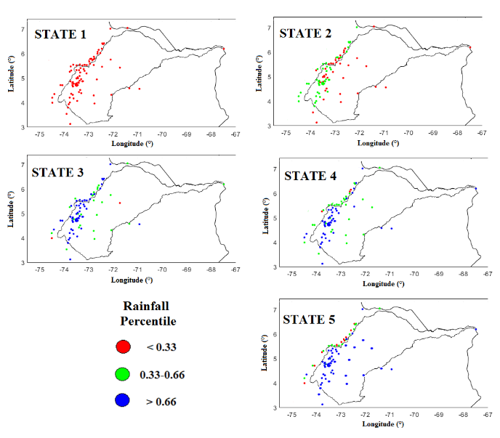

*Figure 14. Five-state HMM rainfall probabilities for the Meta River Basin precipitation from January to December. The annual cycle from dry to wet season are shown through state 1-5, where the rainfall probabilities lower than 0.33 are presented in red circles (low rainfall), and between 0.33 and 0.66 are plotted in green (average rainfall). In contrast, percentiles higher than 0.66 are presented in blue (heavy rainfall).*

**Table 2** shows the transition probability matrix. The matrix's most significant values lie along its diagonal, indicating that the probability of remaining in a given state is larger than the likelihood of transitioning to a different state, indicating that the precipitating states are highly persistent.

*Table 2. Transition probabilities for a 5-state HMM from January to December in the Meta River*

|  |  |  |  |  |  |  |
| --- | --- | --- | --- | --- | --- | --- |
| To | From | 1 | 2 | 3 | 4 | 5 |
| 1 | Dry season | 72% | 18% | 0% | 2% | 8% |
| 2 | Dry to wet transition | 14% | 61% | 14% | 6% | 5% |
| 3 | Start wet season | 0% | 13% | 63% | 20% | 3% |
| 4 | Wet season consolidation | 1% | 6% | 17% | 53% | 22% |
| 5 | Wet season (dry in Andean region) | 6% | 4% | 1% | 27% | 62% |

The sub-diagonal and upper diagonal entries are next in magnitude; this shows that when the process leaves a given state, it is more likely to go to the next neighbor.

Finally, **Figure 15** presents the Viterbi Matrix, which shows the state of each day of the year (columns) for each year of the simulation (rows) thus capturing the evolution of the states over time.

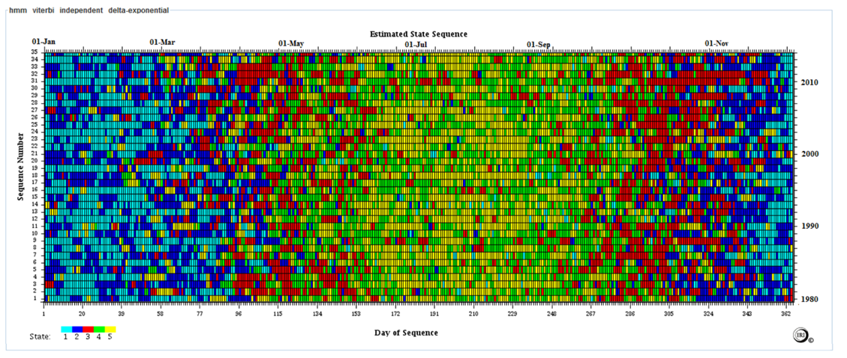

*Figure 15. Viterbi Matrix for the Meta River weather stations. Each color represents a state and the matrix shows the probable occurrence of individual states over a year.*

The observed states are highly persistent, which implies they can be considered stationary atmospheric modes and are related to low-level circulation under steady conditions. These results can be generated at various time intervals and confirm the transitional and temporal nature of the states and quantify probabilities of transition for use in the simulations.

**Figure 16** shows the temporal variation of precipitation states over the Meta River along the year. The driest state, or state 1, prevails in the beginning of November, with a maximum during the months of December through February and decreases as the month progress to finish during April. On the other hand, state 2 becomes more probable from the end of October to the beginning of March, explaining the start (and ending) of the rainy season in the country.

State 3 has a bimodal cycle. Its frequency increases from early March and maximizes in April, indicating the first peak of the wet state; during the second semester. State 3 increases its frequency from September and reaches the second peak of October and November. In each case, state 3 alternates between state 2 and state 4. State 4 is at its maximum during May and September, and state 5 has a high frequency from mid-June to mid-August.



*Figure 16. Frequency for each HMM state along the year for the Meta River basin.*

#### Filling missing values.

The threshold of 40 percent missing data has been imposed on building the Viterbi matrix in the HMM algorithm. The Viterbi matrix and the probability density functions are used for each state to fill in the missing data in the daily precipitation series whose emission parameters have been adjusted during the HMM. The missing data are filled in with random values given by the probability distribution function of each station known to the date of the missing data.

On the maximum and minimum temperature series, empirical probability functions are fitted for each state from the Viterbi matrix under the hypothesis that in the tropics, the temperature is strongly related to the dry and wet seasons of the region since the region has no seasons. Therefore, the adjusted empirical functions allow for the simulation of the temperature. Time series are filled with a simulation of the HMM for the state k knowing the day of the missing data.

Finally, the complete series of precipitation and maximum and minimum temperatures, and the parameters of the HMM will serve in the subsequent steps of the climate generator.

For example, **Figure 17** shows the complete series of maximum temperatures for station 35120524. There is another additional step in filling in the missing data, which includes the analysis of the coherence of the information. For example, the maximum temperature must always be higher than the minimum temperature.

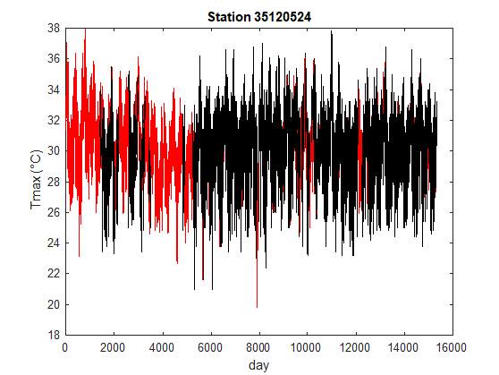

*Figure 17. Maximum temperature at daily time scale for sample station #35120524 (filled data in Red).*

**Defining the historical mean for each sub-basin**

In this step, the complete hydrological series are used to estimate the maximum and minimum precipitation and temperature of each sub-basin. The series of each station are weighted based on their proximity to each catchment using simple averages when there are enough information or Thiessen polygons[39] for poorly instrumented basins.

These three meteorological variables are chosen for simplicity in their management. Although usually climatic stress can be expressed in terms of changes in precipitation and temperature, other variables, such as winds, relative humidity, solar radiation, etc., have lower quality and quantity of records in the region and are more challenging to simulate.

The agricultural production model requires data on precipitation, maximum and minimum temperature, and evaporation on a daily scale for its operation. The hydrological model requires similar inputs at a monthly scale, for which the daily data is aggregated according to the number of days in the month. As an example, **Figure 18** shows the historical time series for the Pauto River.

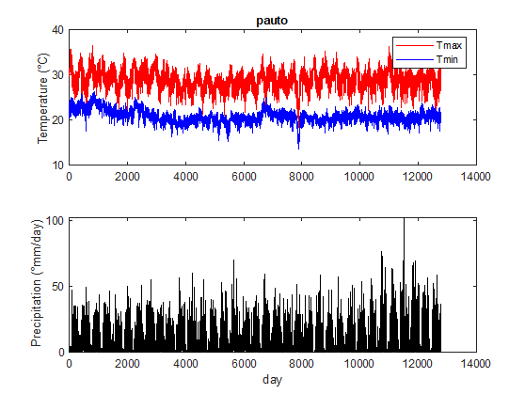

*Figure 18. Completed historical records of temperature (maximum and minimum) and precipitation for the Pauto River (an example) at daily time scale.*

#### Estimating potential evapotranspiration time series

The term potential evapotranspiration generally refers to the maximum evaporation rate from a large area covered completely and uniformly by actively growing vegetation with adequate moisture supply. Since potential evaporation cannot be directly measured, various estimation methods must be used.

Evaporation depends on meteorological factors such as temperature, wind speed, atmospheric pressure, solar radiation, the surface's shape, and the vegetation's characteristics, parameters that as a whole, are not monitored and whose detailed analysis would require extensive analysis.

Considering the main outputs of our climate generator and the results of the global climate models (GCM), we will consider the Hargreaves methodology that only requires T*max* and T*min* for estimating the reference potential evapotranspiration***:***

|  |  |
| --- | --- |
| $$E=0.0023{\left(T_{max}-T_{min}\right)}^{0.5}\left(T_{max}+17.8\right)R_{a}$$ | (4) |

Where $E$ is the reference evaporation in mm and $T_{max} T_{min}$ are the maximum and minimum temperature in °C. $R_{a}$ is the extra-terrestrial radiation in MJ/m2-day.

### Stochastic scenarios using the HMM

The transition matrix of Figure 10 is then used to simulate the temporal evolution of the states of the HMM. In other words, stochastic simulations of the weather series (states) for each station on a daily scale are estimated. For example, 20 stochastic time series is created for each station for 50 years at a daily time scale. Both precipitation and temperature thus are simulated on a daily scale.

The results of the Viterbi matrix are produced on a daily scale with a simulation length of 50 years. For example, **Figure 19** shows the result of 25 simulations as a Viterbi matrix from the HMM transition matrix, with each run preserving the main spatiotemporal parameters of the series involved. Each matrix below, therefore, is a novel sequence of daily precipitation states over 50 years.

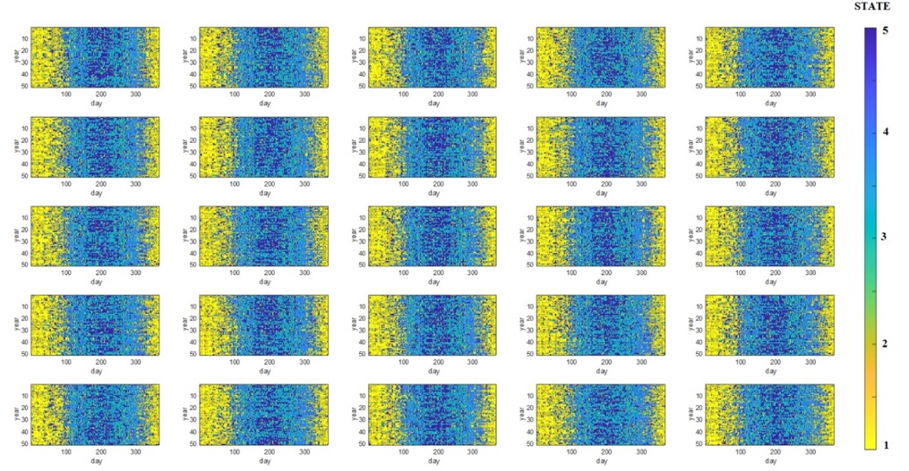

*Figure 19. Example of a Viterbi Matrix Simulation using the HMM weather generator.*

The simulations of the Viterbi matrix are accompanied by the random values of precipitation provided by the emission functions (probability distribution functions fitted to the precipitation data). For each simulation of the Viterbi matrix the spatiotemporal simulation of precipitation considers the joint variation of multiple time series. For temperature, the simulated matrices define the meteorological state, which allows the simulation of the new temperature series using the empirical probability functions derived from the historical Viterbi matrix.

The HMM modeling framework resulted in the simulation of 1,000 precipitation and temperature realizations of 50 years. In addition, a subset of 20 climate runs was also selected from the initial ensemble of 1,000 using the KNN algorithm. This subset covers a broad and balanced range of possible future climates holding true to the long-term mean, standard deviation and autocorrelation at the sub-basin level. **Figures 20 and 21** display the result of the annual cycle of precipitation and maximum and minimum temperature for the selected runs.

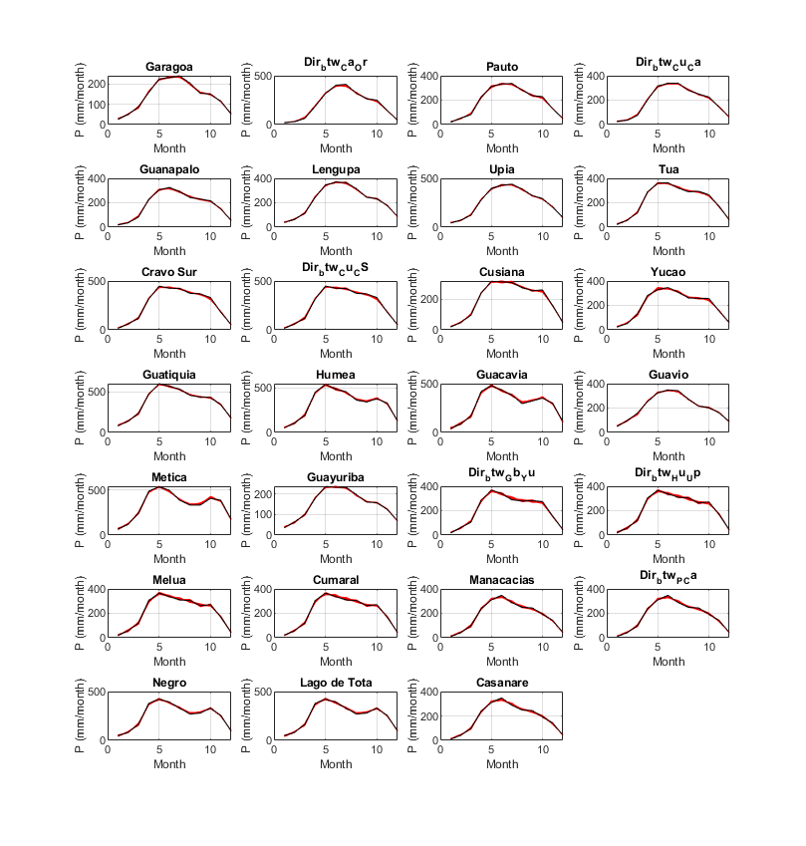

*Figure 20. Examples of* ***Precipitation*** *simulation in each basin using HMM weather generator. The annual cycle is in black, and the value of each simulation is presented in red. Twenty runs were selected using the KNN algorithm to best represent the historical series.*

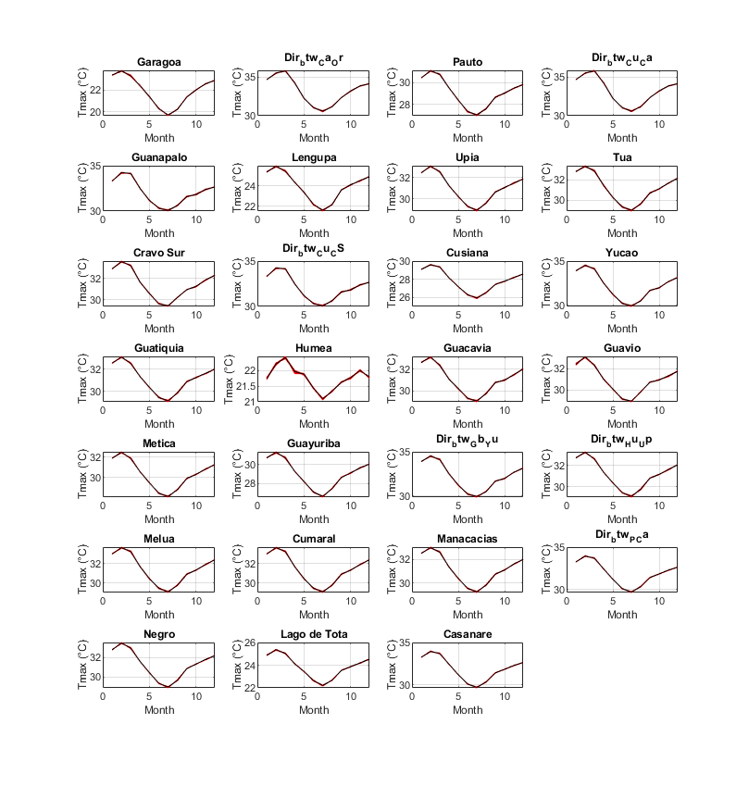

*Figure 21* *Examples of* ***Maximum Temperature*** *simulation in each basin using HMM weather generator. The annual cycle is in black, and the value of each simulation is presented in red. Twenty runs were selected using the KNN algorithm to best represent the historical series.*

With these results, the climate generator demonstrates its ability to reproduce the historical climatology for each unit of analysis within the hydro-systemic model. This then serves as an input to simulate future estimates of precipitation and temperature.

## The Hydrology Model

In hydrological models the water cycle is represented by simplifying atmospheric, surface and subsurface flows with the hydrographic basin as the spatial element of analysis. A common simplification of the system for modeling purposes is the use of storage places, or tanks, through which water circulates and whose flows simulate the most relevant processes of the hydrological cycle.

The assumptions underlying the system processes can vary over time depending on the particular conditions or elements of the system in question.[40] Monthly scale models are commonly known as water balance models because their primary purpose is the conservation of overall mass. The parameterizations of these models assume physical hypotheses that define the fraction of water that moves through storage sites—each with limited capacity—which simulate the water storage in the surface, the soil, and the aquifers, and whose outputs can represent direct runoff, surface flow, and base flow.

Water Balance models were initially applied in agricultural planning (Thornthwaite & Mather, 1957). They were then used in the context of water resource management and planning (Alley, 1985, Xu & Vandewiele, 1995), as well as understanding the impacts of climate change and variability (Guo et al., 2002) and parameter regionalization studies (Kling & Nachtnebel, 2009). Vandewiele et al., (1992) summarizes the primary applications of this type of model as useful to: fill in missing flow data; estimate hydrological parameters and variables in non-instrumented basins; generate estimates of soil moisture; improve water resources management planning; and evaluate water availability and conduct risk analysis.

The calibration and validation procedure of the monthly balance models follows basic standards that maximize plausibility in estimating parameters and optimizing an objective error function (Martinez & Gupta, 2010). In general, the number of parameters of this model type usually oscillates between three and six, allowing robust calibrations and intuitive sensitivity analyses.

Monthly models are ideal for analyzing the effects of climate variability over a region of interest, including climate change, even when stationary parameters are assumed. In particular, the climatic patterns simulated by the model are associated with the variability of precipitation (and potential evapotranspiration or temperature) under different scenarios.

One of the simplest but most rigorous hydrological models, and the one used herein, is the three-parameter GR2M model. This model, developed in France, and applied in multiple places on the planet, has shown promising results in reproducing the hydrological cycle in multiple environments. Importantly, the parameters of this model allow the quantification of soil moisture and can therefore be correlated with different types of land use and cover.

In Colombia, versions of the GR2M model have been applied to the Medellín river Basin (Carvajal & Roldán, 2007), the Gualí in Tolima state (Rincón, 2019), the Subachoque and Cota rivers (Herrera, 2015) in Cundinamarca, as well as of some specific applications in the Orinoquía (Vargas, 2020). In a national model for Colombia, Roldán (2009) used average monthly flows modeled throughout the entire drainage network using the precipitation reanalysis developed by Hurtado (2008). These results showed an excellent balance adjustment, with errors of less than ten percent in the national territory, and a good representation of the monthly flows, particularly for poorly instrumented regions such as the Orinoquía and the Amazon.

The main objective of this project's hydrological model is to adequately represent the process of converting precipitation into runoff in the Meta River Basin. Although simplicity is necessary to guarantee parsimony when evaluating thousands of scenarios, the parameters must be adapted to include inputs easily simulated by the climate generator (precipitation and evapotranspiration) and adequately represent the hydrological response depending on the types of land uses and covers.

### A GR2M Model Construction

The family of GR Models were first developed during the 1980s, with the Orgeval River as an experimental basin of 104 km2, a sub-basin of the Seine River, whose monitoring dates backed to 1962. Historically, each conceptual model depends on the temporal scale, so different structures based on storage tanks have been proposed that allow the simulation of a current of interest on a daily, monthly, or annual scale. When the time scale increases, a structural simplification appears in the model, implying the suppression of some storage tanks.

The GR4J model is the daily timescale version of the GR family of models. Through the simplification proposed by (Mouelhi, 2006), its monthly aggregation called GR2M is achieved, which has been evaluated in basins with different hydroclimatic conditions in countries such as France, Brazil, Australia, the United States, and Colombia, obtaining entirely satisfactory results.

This model represents the water flows within a basin through a production and transit tank. Furthermore, while the daily scale version of the GR models has four parameters, the monthly version consists of only two parameters: X1, which represents the maximum capacity of the production tank, and X2, which is a water exchange coefficient (both in red circles below).

The schematic representation of the GR2M model is in **Figure 22**. This model has two parts: one associated with the production tank and another linked to the transit tank. In addition, all the model variables are in millimeters.

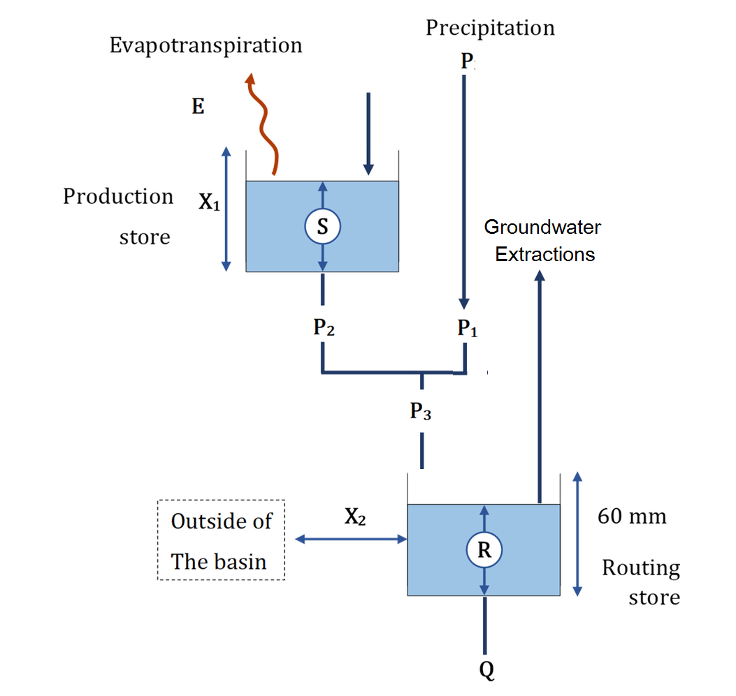

*Figure 22. Illustration of the GR2M model (Source: Mouelhi, 2006)*

#### The Digital Elevation Model

We created the Digital Elevation Model (DEM) for the target river basin and its neighborhood using topography maps. The DEM processing consisted of the estimation of the flow directions map, as well as the correction of drains, flat areas, and bifurcations using the Geographic Resources Analysis Support System (GRASS GIS) python package. The corrected flow direction map has the exact resolution and extent of the DEM. This information is used to trace the basins up to each hydrological gauge station, allowing the calculation of the drainage area and the entire water network through the accumulation flow.

#### Mean precipitation time series

The monthly median precipitation data have been subjected to a pre-processing that consists of filling in the missing data through the climate generator, which uses the Hidden Markov Model simulations based on the Viterbi Matrix to fill the gaps. Aspects related to the homogeneity of the records, or the detection of anomalous data were also analyzed.

Once the missing precipitation data was filled in, the average spatial precipitation maps were constructed by interpolation by the Inverse Distance Weighting (IDW) method. In this methodology, the weight is assigned to the sampling points by using a weighting coefficient that controls the influence of the weight as the distance to the new point increases. The larger the weighting coefficient, the less effect the points will have if they are far from the unknown point during the interpolation process. Usually, the weighting is tied to the inverse of the distance raised by some power. The best interpolation result was obtained, in our case, by assuming a power of three.

Finally, the precipitation time series for each hydrographic unit are collected, for which, it is assumed that the data is more credible where there is a greater density of information, with the potential more significant errors at the borders.

#### Calibration and verification

The objective of the calibration stage is to find the values of the parameters for which the model presents better performance in the study area. For example, in the structure of the monthly GR model, the parameters that need to be calibrated are X1 (maximum storage capacity of the production tank) and X2 (water exchange parameter with other basins).

However, from the available data, it is not possible to evaluate the hypothesis of the existence of a groundwater exchange component since the value that X1 takes within the calibration process could be interpreted as a correction parameter due to possible biases in the estimation of the input data. On the other hand, considering a groundwater flow component may be more important in arid or semi-arid climates but not so much in humid climates such as Colombia (Roldan, 2009). For these reasons, a value of X2 close to but not uniquely assigned as 1 can be assumed.

The calibration seeks to iteratively modify the parameters X1 and X2 so that minimum error or maximum efficiency values are obtained when comparing the simulation results with those derived from a gauging station. The parameters will be considered constant in each of the study basins. However, the application of the model will be given pixel by pixel, with which the variation of the flow components will depend on the changes in precipitation. The simulated flows to each of the gauging stations correspond to the accumulated flow of the model to the gauge station or dam whose coordinates are known.

The essential criteria for the analysis of the adjustment of the parameters are the following:

*Determination coefficient* *or R2* between the series simulated by the model and the series measured at the reference station: the higher the determination coefficient, the better the simulation results. This metric makes it possible to identify good fits between observed and simulated flows, even when there are systematic errors.

*Mean absolute error (MAE)*: corresponds to the average value of the relationship between the absolute value of the difference between the simulated flow and the observed flow over the observed flow:

|  |  |
| --- | --- |
|  | (5) |

*Root-mean-square error (RMSE)*: Is a frequently used measure of the differences between values predicted by a model and the values observed. These deviations are called residuals when the calculations are performed over the data sample that was used for estimation and are called errors when computed in the verification test.

|  |  |
| --- | --- |
| $$RMSE=\sqrt{\frac{1}{n}\sum_{i=1}^{n}{{\left(Q_{i}-\hat{Q_{i}}\right)}^{2}}}$$ | (6) |

*The Nash–Sutcliffe model efficiency coefficient (NSE*): is calculated as one minus the ratio of the error variance of the modeled time-series divided by the variance of the observed time-series. In the situation of a perfect model with an estimation error variance equal to zero, the resulting Nash–Sutcliffe Efficiency equals 1. Conversely, a model that produces an estimation error variance equal to the variance of the observed time series results in a Nash–Sutcliffe Efficiency of 0.0 (NSE = 0). In reality, NSE = 0 indicates that the model has the same predictive skill as the mean of the time-series in terms of the sum of the squared error.

|  |  |
| --- | --- |
| $$NSE=1-\frac{\sum_{i=1}^{n}{{\left(Q_{i}-\hat{Q_{i}}\right)}^{2}}}{\sum_{i=1}^{n}{{\left(Q_{i}-\overline{Q_{i}}\right)}^{2}}}$$ | (7) |

These criteria are calculated following Pimentel et al. (2022) cumulatively and homogeneously calibrating the subbasins up to the closure point with a flow gauge using the Monte Carlo Analysis Toolbox (MCAT) (Beven & Binley, 1992).

Finally, the***Long-term Water Balance***, which is the value of the multi-annual average flow simulated by the model for each basin should be as close as possible by averaging the records of the hydrological station.

|  |  |
| --- | --- |
| $$Balance=\frac{\frac{1}{n}\sum_{i=1}^{n}{Q_{i}}-\frac{1}{n}\sum_{i=1}^{n}{\hat{Q_{i}}}}{\frac{1}{n}\sum_{i=1}^{n}{Q_{i}}}$$ | (8) |

The calibration time period corresponds to January 1980 to December 2004 (25 years), while the verification period goes from 2005 to 2014 (10 years).

### Hydrology Model Results

The results for the hydrology model include a tabular comparison at the basin level of the historical discharge, the discharge from the model, the discharge expressed as a percentage of the multi-annual monthly mean value, the standardized discharge value (subtracting the annual cycle), the value of total precipitation, precipitation anomalies, potential evaporation, soil moisture, percolation, and groundwater interchange. There is also a computation of the main performance scores during the calibration and verification process.

**Table 3** shows the parameters obtained during the model calibration in 11 hydrological stations along the Meta River drainage network. These stations are located near the outlet of each of the main sub-basins of the Meta River, including the Casanare River at the Cravo Norte station.

*Table 3*. *GR2M mean parameters in Gauge stations around Meta River.*

|  |  |  |  |  |  |  |  |
| --- | --- | --- | --- | --- | --- | --- | --- |
| Station ID | Station Name | Latitude  (°) | Longitude  (°) | Catchment | X1* | X2 | Gauge Area  (km2) |
| 35077040 | Garagoa Dam | 4.88 | -73.28 | Garagoa | 373 | 1.01 | 2,626 |
| 35217020 | La Estacion | 4.69 | -71.56 | Cravo Sur | 1,183 | 0.84 | 5,395 |
| 35127020 | Campamento | 4.34 | -72.15 | Yucao | 2,159 | 0.98 | 2,556 |
| 35037100 | Puente Abadía | 4.23 | -73.63 | Guatiquia | 1,643 | 1.06 | 850 |
| 35057010 | El Cable | 4.40 | -73.29 | Humea | 1,174 | 1.35 | 1,050 |
| 35047030 | Puente Carretera | 4.31 | -73.41 | Guacavia | 3,572 | 1.75 | 357 |
| 35037022 | Guavio Dam | 4.71 | -73.47 | Guavio | 285 | 0.93 | 2,287 |
| 35017040 | EL Barro | 3.75 | -73.17 | Metica | 1,272 | 0.82 | 2,569 |
| 35027010 | Caseteja-Delicias | 4.19 | -73.76 | Guayuriba | 324 | 1.60 | 2,662 |
| 35107020 | El Viso | 4.35 | -72.78 | Upia | 1,342 | 0.93 | 1,919 |
| 36028030 | Cravo Norte | 6.25 | -70.33 | Casanare | 995 | 0.92 | 14,826 |

*\* X1 represents the maximum storage capacity in the Production Store and X2 is the water exchange parameter in the Routing Store that accounts for transfers water between Basins. Gauge Area represents the area of the catchment considering the outlet at each station.*

The parameter value range for X1[41] is from 280 and 3,600, but 64 percent of the values fluctuate between 900 and 1,400, which is consistent with the existing literature. The X2 value has a minimum value of 0.82 and a maximum of 1.75, but 82 prcent of the values are between 0.9 and 1.1, which indicates a low exchange of underground flows between the basins of interest.

In the case of high values of X2 (Humea, Guacavia, and Gauyuriba rivers), the gauging stations are often located right at the foot of the mountain (transition between the Andes and the plains), which means that water is flowing consistently between the sub-basins of the Meta. On the other hand, sub-basins located in the Andes mountains range, such as Guavio, Garagoa, and Guayuriba[42], have the lowest values of X1, which means that the water remains in the system or captured by the reservoirs.

**Figure 23** compares the historical series and those simulated with the GR2M model for each station described in Table 2. The figure on the left shows the ability of the model to reproduce the patterns of the historical series, including the maximum and minimum values, the annual cycle, and the interannual variability. The available historical record is shown in this case, while the simulated flows use the parameters calibrated between 1980 and 2004. The figure in the middle shows the reproduction of the annual flows showing how the GR2M reproduces the climatic variability on an inter-annual scale. In particular, the conditions of dry years (relevant for evaluating water availability) are well represented by the model. Finally, the figure on the right shows the dispersion between the historical and simulated flows for the calibration period 1980-2004.

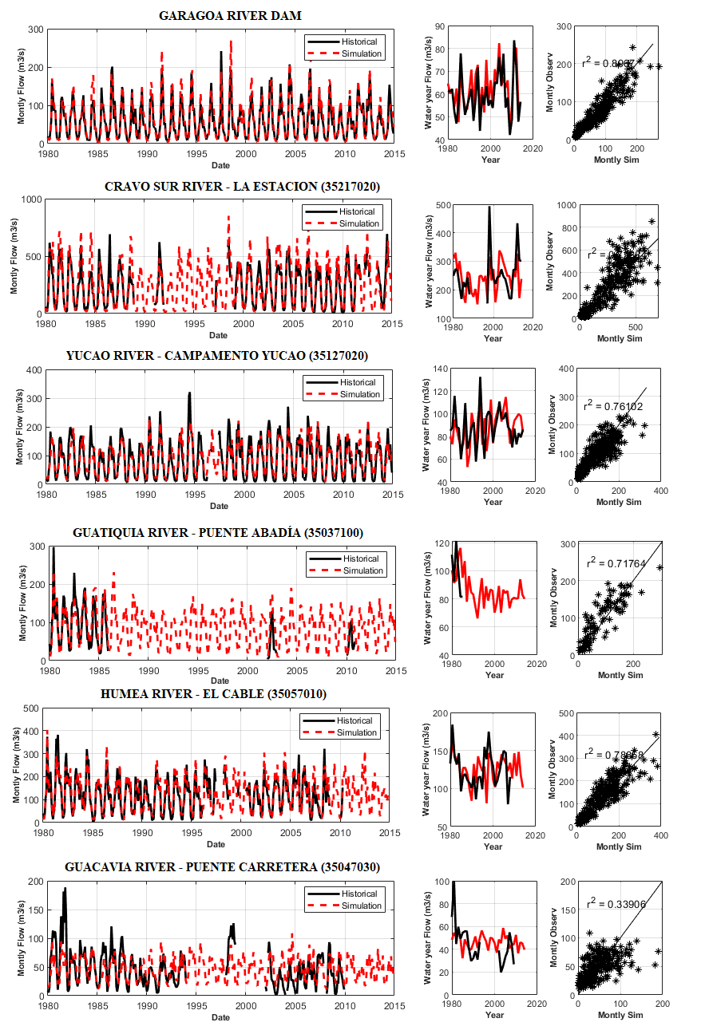

*Figure 23. Comparison between the historical series and those simulated with the GR2M model for selected gauge stations inside the Meta River basin*

**Table 4** shows the efficiency indicators of the model on the gauging stations in the calibration period. In general, the model is quite efficient in representing the observed data, particularly reproducing the long-term average flows, which guarantees the water balance with errors of less than 3 percent. In addition, most of the models present an efficiency higher than 60 percent and a robust R2 that ensures an adequate reproduction of the flows during the calibration period. However, the Upía and Casanare River basins are the ones with the lowest performance, mainly due to the lack of meteorological information that adequately covers all these basins.

*Table 4*. *GR2M efficiency indicators of the model on the gauging stations in the calibration period*

|  |  |  |  |  |  |  |  |  |
| --- | --- | --- | --- | --- | --- | --- | --- | --- |
| Station ID | Station Name | Latitude  (°) | Longitude  (°) | Catchment | Balance  (%) | RMSE  (%) | NSE  (%) | R2 |
| 35077040 | Garagoa Dam | 4.88 | -73.28 | Garagoa | 2.39 | 17.58 | 87.80 | 0.90 |
| 35217020 | La Estación | 4.69 | -71.56 | Cravo Sur | 0.11 | 41.30 | 64.50 | 0.76 |
| 35127020 | Campamento | 4.34 | -72.15 | Yucao | 0.20 | 21.27 | 75.78 | 0.76 |
| 35037100 | Puente Abadía | 4.23 | -73.63 | Guatiquia | 0.13 | 38.75 | 67.20 | 0.72 |
| 35057010 | El Cable | 4.40 | -73.29 | Humea | 2.85 | 29.32 | 76.84 | 0.79 |
| 35047030 | Puente Carretera | 4.31 | -73.41 | Guacavia | 0.91 | 58.23 | 33.42 | 0.34* |
| 35037022 | Guavio Dam | 4.71 | -73.47 | Guavio | 1.11 | 31.20 | 74.37 | 0.86 |
| 35017040 | EL Barro | 3.75 | -73.17 | Metica | 0.53 | 28.11 | 75.41 | 0.77 |
| 35027010 | Caseteja-Delicias | 4.19 | -73.76 | Guayuriba | 0.60 | 41.37 | 62.60 | 0.70 |
| 35107020 | El Viso | 4.35 | -72.78 | Upia | 0.10 | 33.88 | 51.00 | 0.69 |
| 36028030 | Cravo Norte | 6.25 | -70.33 | Casanare | 0.22 | 85.31 | 48.32 | 0.52 |

*Low R2 for individual stations does not affect overall model performance.

**Table 5** shows that the model's performance, in general, is preserved during the validation period (2005-2014), presenting small changes in the verification metrics. However, in most cases, during the validation process, the efficiency of the GR2M decreases 3-5 percent approximately. Meanwhile, Table 5 shows the performance indicators during the validation process.

*Table 5*. *GR2M efficiency indicators of the model on the gauging stations in the verification period*

|  |  |  |  |  |  |  |  |  |
| --- | --- | --- | --- | --- | --- | --- | --- | --- |
| Station ID | Station Name | Latitude  (°) | Longitude  (°) | Catchment | Balance  (%) | RMSE  (%) | NSE  (%) | R2 |
| 35077040 | Garagoa Dam | 4.88 | -73.28 | Garagoa | 3.31 | 21.31 | 80.35 | 0.85 |
| 35217020 | La Estación | 4.69 | -71.56 | Cravo Sur | 0.23 | 44.32 | 60.25 | 0.72 |
| 35127020 | Campamento | 4.34 | -72.15 | Yucao | 0.01 | 18.35 | 78.21 | 0.79 |
| 35037100 | Puente Abadía | 4.23 | -73.63 | Guatiquia | 0.05 | 33.21 | 71.22 | 0.75 |
| 35057010 | El Cable | 4.40 | -73.29 | Humea | 3.01 | 34.28 | 72.13 | 0.71 |
| 35047030 | Puente Carretera | 4.31 | -73.41 | Guacavia | 0.90 | 59.33 | 38.21 | 0.33 |
| 35037022 | Guavio Dam | 4.71 | -73.47 | Guavio | 2.17 | 33.18 | 70.28 | 0.81 |
| 35017040 | EL Barro | 3.75 | -73.17 | Metica | 0.33 | 27.18 | 77.32 | 0.79 |
| 35027010 | Caseteja-Delicias | 4.19 | -73.76 | Guayuriba | 0.60 | 41.37 | 62.60 | 0.70 |
| 35107020 | El Viso | 4.35 | -72.78 | Upia | 0.10 | 33.88 | 51.00 | 0.69 |
| 36028030 | Cravo Norte | 6.25 | -70.33 | Casanare | 0.38 | 92.31 | 45.32 | 0.48 |

Finally, the hydro-systemic model will consider the runoff from the GR2M as a node within the system that provides water. The main objective of the rainfall-runoff model is to be able to integrate hydrology with the climate generator to simulate multiple precipitation and temperature scenarios in stress tests.

There are 27 basins, including the Casanare River, which implies that the hydro-systemic model will have 27 hydrological nodes, which can include water demand, infrastructure operation, and environmental requirements (ecological flows).

For non-instrumented basins (those that do not have streamflow measurement), the model parameters are assumed by transposition considering the closest neighbors with similar climatic and relief conditions. **Table 6** shows the final parameters for each basin defined in the hydro-systemic model following the SIRH guidelines.

*Table 6*. *GR2M mean parameters for all the sub-basin catchments (sorted by catchment size)*

|  |  |  |  |  |
| --- | --- | --- | --- | --- |
| Catchment /response unit | ID | Area (km2) | X1 | X2 |
| Lago de Tota | 26 | 225 | 568 | 3.64 |
| Guacavia | 15 | 850 | 3,572 | 1.75 |
| Negro | 25 | 927 | 13,320 | 0.86 |
| Cumaral | 22 | 1,112 | 13,320 | 0.86 |
| Dir_btw_Hu_Up | 20 | 1,243 | 1,174 | 1.35 |
| Humea | 14 | 1,440 | 1,174 | 1.35 |
| Dir_btw_Cu_CS | 10 | 1,662 | 1,183 | 0.84 |
| Guatiquia | 13 | 1,780 | 1,643 | 1.06 |
| Upia | 7 | 1,824 | 1,272 | 0.82 |
| Melua | 21 | 1,878 | 13,320 | 0.86 |
| Lengupa | 6 | 1,883 | 1,272 | 0.82 |
| Dir_btw_Gb_Yu | 19 | 1,967 | 324 | 1.6 |
| Guavio | 16 | 2,288 | 285 | 0.93 |
| Yucao | 12 | 2,438 | 2,159 | 0.98 |
| Garagoa | 1 | 2,486 | 373 | 1.01 |
| Guayuriba | 18 | 3,198 | 324 | 1.6 |
| Dir_btw_Cu_Ca | 4 | 3,434 | 1,183 | 0.84 |
| Metica | 17 | 3,844 | 1,272 | 0.82 |
| Tua | 8 | 4,970 | 1,183 | 0.84 |
| Cusiana | 11 | 5,096 | 1,183 | 0.84 |
| Cravo Sur | 9 | 5,155 | 1,183 | 0.84 |
| Dir_btw_P_Ca | 24 | 5,347 | 1,272 | 0.82 |
| Dir_btw_Ca_Or | 2 | 6,231 | 1,272 | 0.82 |
| Guanapalo | 5 | 6,300 | 1,183 | 0.84 |
| Manacacias | 23 | 6,980 | 4,025 | 1.31 |
| Pauto | 3 | 8,005 | 1,272 | 0.82 |
| Casanare | 27 | 24,187 | 995 | 0.92 |

*“Dir_btw_Hu_Up”is runoff from the catchment in-between Humea and Upia catchments.*

*“Dir_btw_Gb_Yu”is runoff from the area along the Metica river in-between Guayuriba and Yucao.*

*“Dir_btw_Cu_CS”is runoff from the catchment in-between Cusiana and Cravo Sur.*

*“Dir_btw_P_Ca”is runoff from the catchment in-between Pauto and Carare.*

*\*“Dir_btw_GuDam_Up”: runoff from the area downstream the Guavio dam and the Upia catchment. This sub-catchment is part of the ‘Guavio’ hydrological unit (catchment #16) defined by the Federal agency. The ‘Dir_btw_GuDam_Up’ unit is used by the water system model (Section) to split the Guavio unit upstream and downstream the Albertos Lleras Dam, but is not reported as an individual catchment.*

And finally, the model is checked and verified by comparing the simulated model flow against the outlet flow from the historical data the figures below show (**Figure 24**).

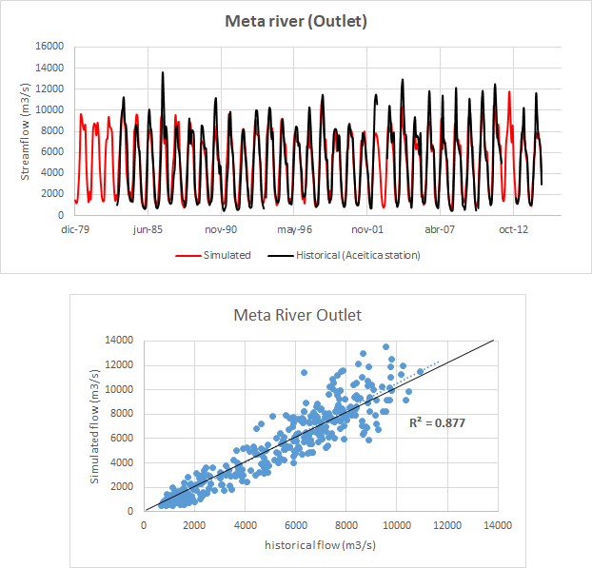

*Figure 24. Simulated streamflow at the outlet of the Meta River using the long-term water balance as a target in the GR2M model.*

### Long-term water balance

The physical principle underlying long-term hydrological balance are mass conservation equations. In this case, the control volume are the atmospheric and soil columns, with the horizontal border as the watershed dividing line, using the lower edge of the soil column as an impermeable layer and the upper edge of the atmospheric column as its top.

The hydrological model is calibrated on in the sub-basins against historical information and the parameters of the sub-basins are adjusted to comply with the overall long-term water balance in the Meta River.

The long-term water balance equation is the following:

|  |  |
| --- | --- |
| $$\overline{Q}=\int{\left[\overline{P}\left(x,y\right)-\overline{RET}(x,y)\right]dx}$$ | (9) |
|  |  |

Where $\overline{P}\left(x,y\right)$ denotes the multi-year mean field of regional precipitation, $\overline{RET}(x,y)$ is the multi-year mean real evaporation field, both of which are calculated as 30-year historical averages, complemented by the re-analysis of Hurtado and Mesa (2014) for precipitation. In addition, a Kriging interpolation with a variogram defined by the direction of the Andes Mountain range complements the calculation.

The potential evapotranspiration values $\overline{PET}\left(x,y\right)$ were estimated using the Hargreaves method described in equation (4) based on the maximum and minimum temperature stations with at least 30 years of record.

Then, we used the Budyko equation[43] (see Sposito 2017) to transform potential evapotranspiration into real evapotranspiration as follow:

|  |  |
| --- | --- |
| $$\overline{RET}={\left\{\overline{PET}∙\overline{P}∙tanh\left(\frac{\overline{P}}{\overline{PET}}\right)\left[1-cosh\left(\frac{\overline{PET}}{\overline{P}}\right)+sinh\left(\frac{\overline{PET}}{\overline{P}}\right)\right]\right\}}^{1/2}$$ | (10) |

In the case of hydrological modeling, the aim is to preserve the mass balance to obtain the average flows in multiple sites along the drainage network. It must adjust its parameters to comply with the long-term water balance.

Along the main course of the Meta River, several gauging stations are used to adjust the water balance of the model. The closest station to the outlet of the Meta River is Meta-Aceitico station, where the multi-annual average flow is close to 4,927 m3/s.

We can estimate the long-term water balance along the drainage network using Equation 1 based on the precipitation and real evapotranspiration fields. **Table 7** compared the estimated and historical flows in each gauge station to check the long-term water balance along the Meta River.

*Table 7*. *Long term water balance in the main gauge stations along the Meta River.*

|  |  |  |  |  |  |
| --- | --- | --- | --- | --- | --- |
| Station | Latitude  (°) | Longitude  (°) | Area  (km2) | Historical Q*  (m3/s) | Simulated Q  (m3/s) |
| Casanare_cravonorte | 6.30 | -70.20 | 14,816 | 366 | 529 |
| Meta_aceitico | 6.18 | -68.45 | 106,140 | 4,927 | 4,565 |
| Meta_aguaverde | 5.82 | -69.97 | 79,710 | 3,565 | 3,595 |
| Meta_santamaria | 5.27 | -70.72 | 66,050 | 3,195 | 3,180 |
| Meta_lapatagonia | 4.57 | -71.83 | 46,913 | 2,720 | 2,445 |
| Manacacías_ptogaitan | 4.32 | -72.08 | 10,028 | 481 | 503 |
| Manacacías_laesperanza | 3.90 | -72.22 | 9,178 | 413 | 466 |
| Cusiana | 4.83 | -72.30 | 3,938 | 211 | 220 |
| Meta_humapo | 4.33 | -72.35 | 27,357 | 1,573 | 1,493 |
| Upia | 4.35 | -72.78 | 8,724 | 489 | 354 |
| Metica | 3.75 | -73.18 | 8,091 | 396 | 447 |

*Q is the long-term water balance

The data on historical monthly mean long-term water flows were taken from the IDEAM database in each sub-basins, that is, river flow stations near the mouth of each hydrological unit from 1980 to 2014. The long-term water balance model presents a robust fit (R2=0.99) in all gauge stations representing the average flow of the system.

According to these results, the long-term water balance is adequate when comparing the observed values with those obtained by applying Equation 1, especially in the case of flows along the Meta River.

Therefore, the multi-year natural mean flow reference value for each hydrological unit used in The Orinoquía Water Futures model (OWF) is presented in **Table 8**.

Finally, the multi-annual average flows obtained by the long-term water balance will be used as an objective for the calibration of the parameters in those basins that are not instrumented, guaranteeing the long-term water balance.

*Table 8*. *Long term water balance ‘Q’ (natural flows) by Sub-hydrozone. Sorted by “Q” from lowest to highest.*

|  |  |  |  |  |
| --- | --- | --- | --- | --- |
| Catchment /response unit | ID | Precip.  (mm/year) | Evapotrans.  (mm/year) | Q  (m3/s) |
| Lago de Tota | 26 | 237 | 934 | 653 |
| Garagoa | 1 | 2,626 | 1,643 | 746 |
| Guayuriba | 18 | 3,392 | 2,571 | 832 |
| Lengupa | 6 | 1,979 | 2,499 | 844 |
| Dir_btw_GuDam_Up* | NA | 237 | 2,751 | 852 |
| Guavio | 16 | 2,418 | 2,750 | 852 |
| Guatiquia | 13 | 1,883 | 3,383 | 909 |
| Upia | 7 | 1,920 | 2,867 | 950 |
| Casanare | 27 | 25,110 | 2,079 | 956 |
| Cravo Sur | 9 | 5,395 | 2,362 | 978 |
| Cusiana | 11 | 5,343 | 2,477 | 980 |
| Negro | 25 | 978 | 3,028 | 982 |
| Metica | 17 | 4,063 | 3,001 | 987 |
| Dir_btw_P_Ca | 24 | 5,539 | 1,875 | 992 |
| Humea | 14 | 1,520 | 3,402 | 993 |
| Pauto | 3 | 8,329 | 2,136 | 999 |
| Guacavia | 15 | 898 | 4,018 | 1,003 |
| Dir_btw_Hu_Up | 20 | 1,309 | 2,820 | 1,016 |
| Cumaral | 22 | 1,168 | 2,615 | 1,029 |
| Guanapalo | 5 | 6,488 | 2,037 | 1,030 |
| Dir_btw_Gb_Yu | 19 | 2,068 | 2,522 | 1,030 |
| Melua | 21 | 1,977 | 2,586 | 1,031 |
| Manacacias | 23 | 7,324 | 2,597 | 1,031 |
| Yucao | 12 | 2,556 | 2,502 | 1,039 |
| Tua | 8 | 5,213 | 2,522 | 1,042 |
| Dir_btw_Cu_CS | 10 | 1,735 | 2,164 | 1,050 |
| Dir_btw_Cu_Ca | 4 | 3,555 | 2,312 | 1,058 |
| Dir_btw_Ca_Or | 2 | 6,452 | 2,491 | 1,104 |
| TOTAL META RIVER |  |  |  | **26,964** |

## Water Demand Models

Between urban and rural communities, agriculture (oil palm and rice), and livestock (beef, pigs and chicken) there are approximately seven main sources of human-driven water demand. However, the variations within each of these sources add a degree of complexity. A quick example is that dairy cattle may consume more water than beef cattle and this may also vary regionally. So, while there are seven main consumers, there are countless variations to study in a set of complex policy, economic of climate scenarios.

In addition, the model includes a minimum flow requirement that simulates ecological requirements and can serve as a proxy for a number of biodiversity or other natural system indicators. The minimum flow can also be used to accommodate transportation requirements within the model, should those be greater than the minimum ecosystem flow requirement.

This variable, along with a couple of others (an adjustment in rural household freshwater demand, for example), can also be used to analyze illegal or informal removal of water from the system.

Within the proposed modeling framework, the water demand module includes four water demand categories:

$D_{fw}$: freshwater[44] demand for urban and rural communities

$D_{liv}$: water demand for livestock

$D_{irr}$: water demand for annual and perennial crops

$D_{env}$: a minimum flow requirement along the river reach

The water demand from each category is estimated for all hydrological units $k$ shown in the flow chart and the map of the Meta River basin. The total consumptive water demand [45] across the Orinoquía region is then:

|  |  |
| --- | --- |
| $$D_{Tot}=\sum_{k=1}^{K}{D_{fw,k}+ D_{liv,k}+D_{irr,k}},$$ | (11) |

where $K$ in the number of hydrological response units.

In addition, each of these sources of water demand can be ranked in terms of priority access, which is done through a system of dispatch orders. The Colombian government has already ranked access, but the model can vary that to demonstrate and study alternatives.

### Dispatch orders

When the water resource is in excess, OWF will deliver water to every user without shortage. However, during periods of water deficits the available resource no longer satisfies the demand. In these cases, the OWF model delivers water to users following a specific dispatch order[46] that is defined by the “cost”, or friction values, assigned to each user, thus providing a ranking. The higher the “cost” assigned to the user the lower the priority.

**Figure 25** illustrates a schematic of the dispatch curve highlighting the marginal cost per unit of volume. Should these values implemented in the OWF model, the dispatch order will be in the following order: 1. minimum flow requirement in rivers (Denv); 2. freshwater demand (Dfw); 3. livestock demand (Dliv); and 4. irrigation demand (Dirr).

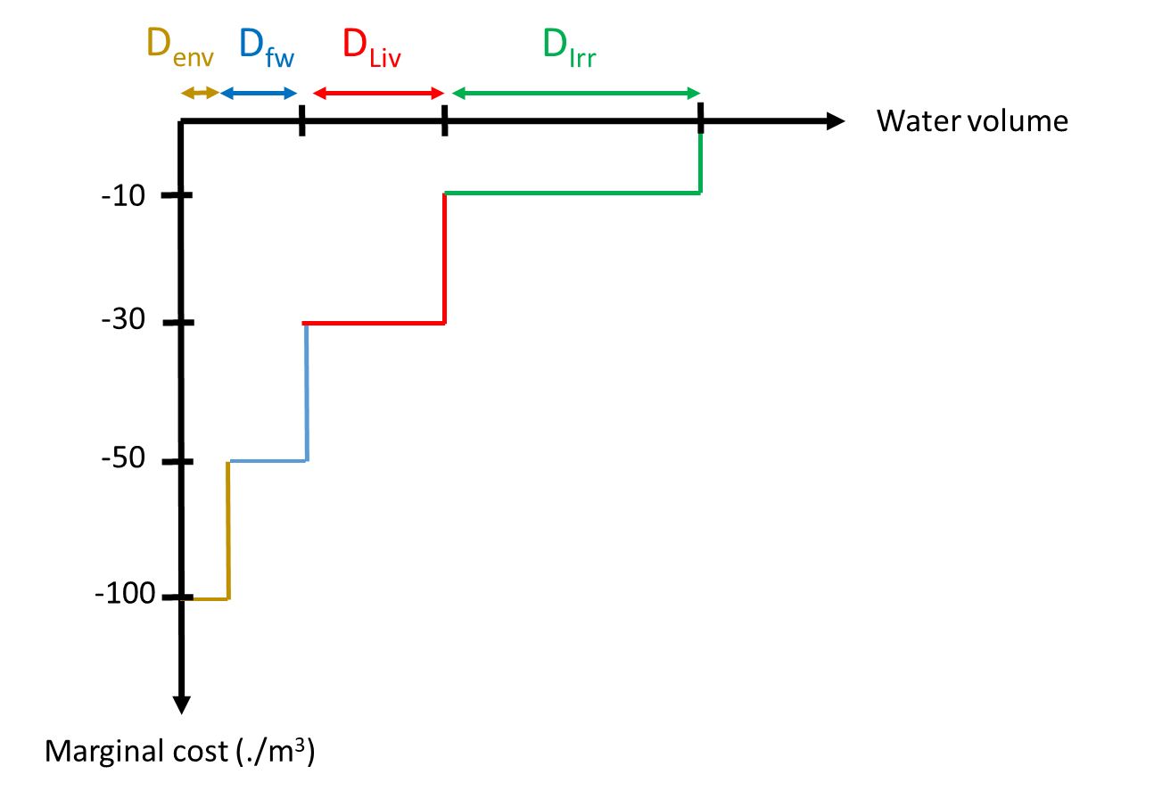

*Figure 25. Simplified representation of the dispatch order in the OWF mode. Note that cost values are here for illustration purpose and do not necessarily represent the values that will eventually be used for the vulnerability assessment.*

Two examples of different dispatch order ranking that might be considered in an assessment include:

* No collaboration across the region: in this scenario, water is dispatched at model nodes with no regards of the water need downstream. In other words, the scenario could be dubbed as ‘*first come first served*’ (FCFS).
* Full collaboration (FC) across the region: this scenario implies that responsible agencies enforce the regulated dispatch orders for all water users.

In addition to these two scenarios, the cost values can be adjusted for all demand categories and response units independently to create alternate user or access sequences. The first condition (FCFS) is the one used in the models reported herein, except for the final scenario, which uses the FC.

### Municipalities to watersheds

Formal government, and other, data, where available, is presented at the municipal level and not the watershed, which is where the water system modelling must occur.

Furthermore, while the Orinoquia region comprises four Departments, the Meta River Basin includes the six Departments of Arauca, Boyacá Meta, Casanare, Cundinamarca and Vichada, with important implications for the water system since both Boyacá and Cundinamarca are highland Departments that are important headwaters within the system (**Figure 26**).



*Figure 26. The Meta River Basin with the percentage area of the six Departments of the watershed.*

In addition, each of the Departments has a different percentage of their total land area located within the Meta River Basin (e.g., Casanare has 100 percent, while Vichada has only 9 percent).

And finally, the appropriate area of each the 132 municipalities to their 27 watersheds, which results in the geographic distribution and relative contribution of each sector, in each municipality, to each watershed. As a result, **Table 9** presents the reallocation of crop areas for the annual and perennial crops within the Meta River Basin, as opposed to the Orinoquía.

Table 9. Cultivated areas in ’00 ha for annual and perennial crops in the Meta River Basin (blank cells indicates no planting).

|  |  |  |  |  |  |  |  |  |  |
| --- | --- | --- | --- | --- | --- | --- | --- | --- | --- |
| Catchment /response unit | ID | Rice | Corn | Sorgh. | Other cereal | Other annual crops | Total  annual | Oil palm | AF |
| Dir_btw_GuDam_Up* | NA |  |  |  |  |  |  |  |  |
| Garagoa | 1 |  |  |  |  | 4.31 | 4.31 |  |  |
| Dir_btw_Ca_Or | 2 |  |  |  |  | 18.31 | 18.31 |  |  |
| Pauto | 3 | 262.91 |  | 36.8 | 22.80 | 118.36 | 440.87 |  |  |
| Dir_btw_Cu_Ca | 4 | 0.02 |  |  |  |  | 0.02 | 8.80 |  |
| Guanapalo | 5 | 233.41 |  |  | 29.54 | 24.97 | 287.92 | 72.48 |  |
| Lengupa | 6 |  |  |  |  |  |  |  |  |
| Upia | 7 | 47.97 |  |  |  |  | 47.97 | 72.41 |  |
| Tua | 8 | 51.77 |  |  | 48.92 | 7.54 | 108.23 | 280.43 | 0.37 |
| Cravo Sur | 9 | 152.54 | 20.10 |  | 53.04 | 13.80 | 239.48 | 55.83 |  |
| Dir_btw_Cu_CS | 10 | 11.61 | 0.51 |  | 22.65 | 5.48 | 40.25 | 61.43 |  |
| Cusiana | 11 | 115.97 | 23.68 |  | 100.66 | 8.28 | 248.59 | 177.22 |  |
| Yucao | 12 | 9.44 |  |  | 87.23 | 51.95 | 148.62 | 28.37 | 8.75 |
| Guatiquia | 13 | 19.37 |  |  | 16.37 | 0.98 | 36.72 | 15.83 |  |
| Humea | 14 | 55.52 |  |  | 3.07 | 0.26 | 58.85 | 39.73 |  |
| Guacavia | 15 | 12.05 |  |  | 5.36 |  | 17.41 | 109.55 |  |
| Guavio | 16 |  |  |  |  |  |  |  |  |
| Metica | 17 | 58.97 |  |  | 8.96 | 2.28 | 70.21 | 797.66 |  |
| Guayuriba | 18 | 10.70 |  |  | 5.51 | 5.27 | 21.48 | 68.02 |  |
| Dir_btw_Gb_Yu | 19 | 6.38 |  |  | 13.58 | 64.28 | 84.24 | 22.61 | 0.71 |
| Dir_btw_Hu_Up | 20 | 60.42 |  |  | 0.07 | 2.76 | 63.25 | 258.33 |  |
| Melua | 21 |  |  |  | 7.30 |  | 7.30 |  |  |
| Cumaral | 22 |  |  |  |  |  |  | 6.07 |  |
| Manacacias | 23 | 0.60 | 5.17 | 0.14 | 3.29 | 1.18 | 10.38 | 76.99 | 2.98 |
| Dir_btw_P_Ca | 24 | 104.58 |  |  |  | 3.57 | 108.15 |  |  |
| Negro | 25 | 56.77 |  |  | 28.19 | 1.00 | 85.96 | 27.63 |  |
| Lago de Tota | 26 |  |  |  |  | 15.54 | 15.54 |  |  |
| Casanare | 27 |  |  |  |  |  |  |  |  |
| Total Meta |  | **1,271.00** | **49.5** | **36.9** | **456.5** | **242.10** | **2,164.10** | **2,179.37** | **11.08** |
| Percent (%) |  | **58.70** | **2.3** | **1.7** | **21.1** | **11.20** | **70.21** | **99.40** | **0.6** |

Other annual crops not shown here contribute less than 1 % of total demand each include (soybeans, onions and potato). AF is mixed cropping agroforestry systems.

### Freshwater: urban and rural

The annual demand for freshwater for human consumption $D_{fw,k}$ is divided into urban ($D_{urb,k}$) and rural ($D_{rur,k}$) communities and is calculated for each hydrological unit $k$ following the equations:

|  |  |
| --- | --- |
| $$D_{fw,k}=D_{urb,k}+ D_{rur,k},$$ | (12) |

Where,

|  |  |
| --- | --- |
| $$D_{urb,k}=C_{C\&I}\frac{p_{urb,k} δ{wd}_{urb, c(k)}}{{(1-E}_{urb,k})},$$ | (13) |

and

|  |  |
| --- | --- |
| $$D_{rur,k}=\frac{p_{rur,k} δ{wd}_{rur,c(k)}}{(1-E_{rur,k})},$$ | (14) |

where $p_{urb,k}$ and $p_{rur,k}$ are the population of the urban and rural areas (of approximately 1 million urban and 590,000 rural) in the catchment $k$, respectively; $δ{wd}_{urb,c(k)}$ and $δ{wd}_{rur,c(k)}$ are the maximum water use per capita in urban and rural areas (liters per capita per day).

The maximum consumption rates are defined by Resolution 2320[47] issued by the formerly named Ministry of Environment, Housing and Territorial Development (MAVDT)[48]. The assigned maximum water use per capita per day varies with the level of complexity $c$ of the system (**Table 10**).

High complexity systems are assigned a larger water consumption right than systems with low complexity. In urban areas the level of complexity $c$ is defined based on population (higher population results in greater complexity), whereas the system complexity is assumed to be low for all rural communities across the region.

Table 10. Maximum water use defined by the Resolution 2320 Population threshold are from the RAS 2000[49]

|  |  |  |  |  |
| --- | --- | --- | --- | --- |
| Level of complexity ($c$) | Symbol | Urban Population threshold | Maximum net water use for cold or temperate climate  (L/capita/day) | Maximum net water  use for warm climate (L/capita/day) |
| Low | L | <2,500 | 90 | 100 |
| Medium | M | 2,501 to 12,500 | 115 | 125 |
| Medium-high | MH | 12,501 to 60,000 | 125 | 135 |
| High | H | >60,000 | 140 | 150 |

The allocation rule defined in Resolution 2320 also varies by climatic area. Cold and temperate climate areas have lower allocations than warm climate areas (defined by an elevation lower than 1,000 meters).

Since most of the Meta River basin is lower than the 1,000-meter elevation threshold, and because only a small fraction of its population lives above this elevation, the allocation for the ‘warm climatic areas’ is used for all catchments $k$.

In equation 23 and 24, $E_{urb,k}$ and $E_{rur,k}$ are coefficients to account for the water intake loss to the users’ taps. From Resolution 2320, the maximum acceptable loss coefficient is 25 percent. In the OWF, there is no variation between these two coefficients— creating a difference between rural and urban communities—although they could be adjusted in the future.

The constant $C_{C\&I}$ in equation 23 is a multiplier (=1.5) to scale up the urban population demand to account for the demand from commercial and industrial activities.

**Table 11** summarizes the values of the parameters used in equations **19-21** for each catchment area. The adjusted urban and rural population for each catchment originates from the 2014 census. In the modeling framework, the efficiency and consumption per capita parameters are defined for each catchment, enabling assessment of scenarios of uneven improvement in system efficiency and/or change in consumption rate/water rights.

The annual demand values obtained from equations 2-4 are then downscaled to monthly demand (the temporal resolution used by the water system model), assuming a uniform distribution of the annual demand within the year, which assumes that water demand from urban and rural communities is the same each month and not sensitive to weather conditions – note that in drier months the demand may not be satisfied, which will generate a deficit. Although this assumption is relevant due to the limited fluctuation range throughout the year, it could be adjusted in the demand model to simulate higher consumption during the dry season, for example.

Table 11. Parameters used for calculation of the freshwater demand.

|  |  |  |  |  |  |  |  |  |
| --- | --- | --- | --- | --- | --- | --- | --- | --- |
|  |  | Urban | | | Rural | | | Total** |
| Catchment /response unit | **ID** | **Pop.** | **Per capita L/day** | **System Complex** | **Pop** | **Per capita L/day** | **Syst** | **m3/day** |
| Dir_btw_GuDamUp* | NA | NA | NA | NA | NA | NA | NA | NA |
| Garagoa | 1 | 44,341 | 135 | MH | 139,083 | 100 | L | 19,894 |
| Dir_btw_Ca_Or | 2 | 0 | 100 | L | 1,611 | 100 | L | 161 |
| Pauto | 3 | 17,316 | 135 | MH | 18,025 | 100 | L | 4,140 |
| Dir_btw_Cu_Ca | 4 | 10,929 | 125 | M | 2,410 | 100 | L | 1,607 |
| Guanapalo | 5 | 5,216 | 125 | M | 9,068 | 100 | L | 1,559 |
| Lengupa | 6 | 11,339 | 125 | M | 35,683 | 100 | L | 4,986 |
| Upia | 7 | 6,775 | 125 | M | 13,707 | 100 | L | 2,217 |
| Tua | 8 | 111,213 | 150 | H | 12,290 | 100 | L | 17,911 |
| Cravo Sur | 9 | 110,226 | 150 | H | 39,325 | 100 | L | 20,466 |
| Dir_btw_Cu_CS | 10 | 0 | 100 | L | 2,211 | 100 | L | 221 |
| Cusiana | 11 | 76,960 | 150 | H | 21,722 | 100 | L | 13,716 |
| Yucao | 12 | 0 | 100 | L | 2,143 | 100 | L | 214 |
| Guatiquia | 13 | 420,532 | 150 | H | 18,141 | 100 | L | 66,343 |
| Humea | 14 | 907 | 100 | L | 15,907 | 100 | L | 1,681 |
| Guacavia | 15 | 6,858 | 125 | M | 8,770 | 100 | L | 1,734 |
| Guavio | 16 | 154 | 100 | L | 53,172 | 100 | L | 5,333 |
| Metica | 17 | 103,364 | 150 | H | 18,110 | 100 | L | 17,316 |
| Guayuriba | 18 | 10,381 | 125 | M | 79,591 | 100 | L | 9,257 |
| Dir_btw_Gb_Yu | 19 | 13,004 | 135 | MH | 1,804 | 100 | L | 1,936 |
| Dir_btw_Hu_Up | 20 | 2,584 | 125 | M | 9,674 | 100 | L | 1,290 |
| Melua | 21 | 0 | 100 | L | 1,716 | 100 | L | 172 |
| Cumaral | 22 | 0 | 100 | L | 1,347 | 100 | L | 135 |
| Manacacias | 23 | 12,763 | 135 | MH | 7,449 | 100 | L | 2,468 |
| Dir_btw_P_Ca | 24 | 3,119 | 125 | M | 3,838 | 100 | L | 773,7 |
| Negro | 25 | 14,845 | 125 | M | 7,793 | 100 | L | 2,365 |
| Lago de Tota | 26 | 5,764 | 125 | M | 6,440 | 100 | L | 1,365 |
| Casanare*** | 27 | 72,753 | 150 | H | 59,464 | 100 | L | 16,859 |

*\* Dir_btw_GuDam_Up is defined as the runoff from the area downstream the Guavio dam and the Upia catchment. This sub-catchment is part of the ‘Guavio’ hydrological unit defined by the Federal agency. In the model, all the population is associated with the ‘Guavio’ unit (#16). As such, the unit Dir_btw_GuDam_Up has no demand.*

*\* The right-hand column (Total) indicates the annual water demand obtained from equations 15-16.*

*\*\*\* Population described as ‘Casanare’ includes people living in the Casanare River Basin in both Casanare and Arauca departments.*

### Livestock: cattle, pigs and chicken

Water is often the forgotten input to cattle ranching and it rarely considered in its negative externalities, which are usually associated with deforestation, soil compaction and/or animal welfare, depending on the system. But water is a vital input to production, and even more so for dual purpose and dairy systems.

While there is not a great deal of literature on water consumption in cattle systems in Colombia, there is considerable investigation in the US and other parts of the world. In recent years, there has been significant effort to increase livestock productivity as well as incentivize a better balance with nature and land use in silvopastoral systems.

The demand model for livestock farming across the Orinoquía region is similar than the freshwater demand model, but where urban and rural population are replaced by animal species raised in different sub-systems:

|  |  |
| --- | --- |
| $$D_{Liv}=\sum_{k=1}^{K}{\sum_{s=1}^{S}{D_{s,k}}},$$ | (15) |
|  |  |

where $D_{s,k}$ is the water demand for the animal species $s$ located in the response unit $k$. $K$ is the number of response units where the demand is calculated, and S is the number of species considered in the modeling framework.

The demand for each species in the response unit $k$ is next obtained from:

|  |  |
| --- | --- |
| $$D_{s,k}=\sum_{i=1}^{I}{\frac{p_{s,k} δ{wd}_{s}∅_{s,k,i} r_{s,k,i}}{(1-E_{s,k})} },$$ | (16) |

where $p_{s,k}$ is the number of animals of the species $s$ in the unit $k;$ $δ{wd}_{s}$ is the estimated average annual consumption per animal for the species $s$. $∅_{s,k,i}$ is an adjustment factor that may depend on the location (i.e., the response unit $k$), the animal species $s$ and the technological conditions $i$ in which the animals are raised. The adjustment factor is thus used to increase or decrease the estimated annual water consumption $δ{wd}_{s}$. Since the current model assumptions do not account for different sub-systems, which in the model is represented as ($∅_{s,k,i}$ =1 for all species, location, and sub-systems).

$E_{s,k,i}$ is a loss coefficient similar to the ones used for the freshwater demand model. It may also depend on the animal species $s$, the location $k$, and the environment $i$. The variable $r_{s,k,i}$ is a sharing coefficient that represents the fraction of the population $p_{s,k}$ raised under the technical conditions $i$.

The livestock demand is currently set to account three different species: cattle, pigs, and poultry. Given the data that is currently available, there is no variation in the water demand over time for each species. Furthermore, the model does not currently differentiate the demand between production systems. For example, dairy cattle and beef cattle are assumed to have the same water demand.

**Table 12** shows the estimated water use per capita from national statistics (2008). Per capita use includes the water used during the life of the animals as well as the water used by the slaughterhouses during processing. Since the off-take relative to total population is much larger for pigs than for cattle, the average consumption per animal is larger for pigs.[50] If the slaughtering phase were not included in the calculation of the average consumption per animal, the consumption will be larger for cattle.

Table 12. Parameters for water use per year in Colombia and per capita for all livestock, 2008.

|  |  |  |  |
| --- | --- | --- | --- |
| Species | Population | Total water consumption  (m3/year) | Water use / year / capita ()  (m3/head) |
| Cattle | 26,877,824 | 1,618,106,870 | 60.2 |
| Pigs | 3,808,415 | 332,972,592 | 87.4 |
| Chicken | 28,756,922 | 209,925,531 | 7.30 |

The consumption per capita is estimated from the 2008 census data while the population is from the 2022 census data.

The population $p_{s,k}$ and estimated water use $δ{wd}_{s}$ for the three species across the response units is shown in **Table 13**. The data available from the 2022 census does not allow identifying the sub-systems for each species.

Table 13. Approximate annual water demand by sector in the Orinoquía 2022.

|  |  |
| --- | --- |
| Livestock | Million cubic meters per year (Mm3/year) |
| Cattle | 432.4 |
| Pigs | 82.9 |
| Chicken | 81.4 |
| Total Annual Demand Livestock | **701.6** |

In the same manner to the freshwater demand model, the annual demand will be downscaled to monthly time step assumption a uniform distribution, although this assumption can easily be updated as more information becomes available and/or scenarios are established. **Figure 27** below shows the cattle herd density distribution per Km2 for each of the sub-hydrozones of the Meta River Basin.

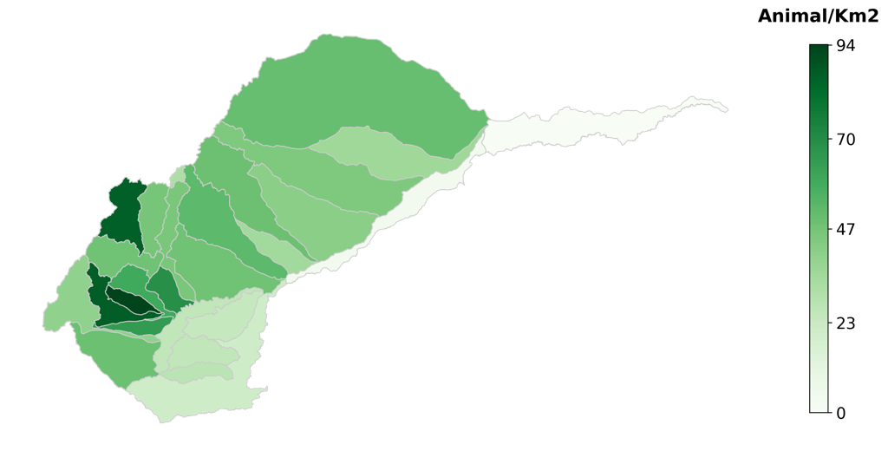

*Figure 27. Cattle population density (# Animals per km2) for cattle in the sub-hydrozones of the Meta River Basin of the Orinoquía.*

### Agriculture: rice and oil palm

The total irrigation demand for each catchment $k$ is obtained by summing the demand for all irrigated annual and perennial crops, such that:

|  |  |
| --- | --- |
| $$D_{irr,k}=\sum_{n}^{N_{k}}{D_{irr_grain,n,k}}+\sum_{tr}^{{Tr}_{k}}{D_{irr_trees,tr,k}},$$ | (17) |

where $D_{irr_grain,n,k}$ and $D_{irr_trees,p,k}$ are respectively the irrigation demand for grain crops and tree crops, respectively. $N_{k}$ and ${Tr}_{k}$ are the number of grain crops and tree crops in the response unit $k$, respectively. Note that equation 24 separates demand for grain crops and tree crops because the methods to estimate their specific demand differ.

Rice and oil palm are the two main industrial crops grown in the Meta River basin that use significant irrigation practices, and as such remove water from the system.

#### Rice

To model the irrigation demand for grain crops (e.g., rice, soy, maize, among others),[51] we use the United Nation Food and Agriculture Organization’s (FAO) crop model known as AquaCrop (Steduto et al., 2009), and more pointedly the python implementation of the AquaCrop model (v6.1) named AquaCrop-OSPy (Kelly and Foster, 2021)[52].

AquaCrop is a crop yield model that has many applications, including, but not limited to, assessment of the best irrigation practices/schedules, the impact of climate change on crop yields, and crop water demands.

AquaCrop simulation outputs used in this project include the daily time series of irrigation demand (expressed in mm) and the yield (expressed in ton/hectare).

Knowing the area $A_{n,k}$ for each crop $n$ across the different sub-catchments $k$ of the region allows the model to assess the total irrigation water demand for grain crops at the sub-catchment level $D_{irr_grain,k}$:

|  |  |
| --- | --- |
| $$D_{irr_grain,k}\left(t\right)=\sum_{n}^{N_{k}}{w_{n,k}\left(t\right)}A_{n,k}\left(t\right),$$ | (18) |

where $w_{n,k}$ is the irrigation water requirement (mm) for the crop $n$ over the sub-catchment $k$.

The value $w_{n,k}(t)$ at the time $t$ depends on multiple factors that include the type of crop, its maturity stage, the potential evapotranspiration, and the current soil moisture, which depends on the recent rainfall and evapotranspiration over the catchment.

$n_{k}$ is the number of crops accounted for in the sub-catchment $k$; $t$ is the time index (day). Crop area, $A_{n,k}$, could be set as a constant throughout the simulation or may vary from year to year.

The planting date for each crop type is an input to the model while the harvest date is an output and may vary slightly from year to year depending on the simulated crop growth resulting from the local climate/weather conditions.

Weather inputs to AquaCrop model include daily average temperature $T$, precipitation $P$ and the reference evapotranspiration $ET0$.

Daily temperature and precipitation variables for each sub-catchment of the Meta River basin are obtained from the stochastic weather generator presented in Section 2.

The daily potential evapotranspiration is obtained using the equation 26 based in the equation 52 in Allen et al. (1998):

|  |  |
| --- | --- |
| $${ET0}_{k}\left(t\right)=0.0023×\left(T_{mean,k}\left(t\right)+17.8\right){\left(T_{max,k}\left(t\right)-T_{min,k}\left(t\right)\right)}^{0.5}×0.408×E_{Rad,k}\left(t\right),$$ | (19) |

where $T_{mean}$, $T_{max}$ and $T_{min}$ are the mean, maximum and minimum temperature (oC), respectively. $T_{mean}$ is estimated as the average between $T_{max}$ and $T_{min}$. $E_{Rad}$ is the extraterrestrial radiation (MJ m-2 day-1).

The numeric constant 0.408, absent in the Allen et al. (1998) equation, is a conversion factor applied to $E_{Rad}$ that is expressed in the original equation as equivalent evaporation in mm day-1.

AquaCrop enables the assessment of multiple irrigation schedules or practices. For instance, Figure 3 illustrates the impact of choosing a specific irrigation strategy on the average pattern of the irrigation water demand and crop yield obtained for rice plantations across the Guayuriba (top) and Humea (bottom) sub-catchments and for two plantation dates: April 1st (left) and September 1st (right).

**Figure 28** illustrates two irrigation strategies:

* Soil Moisture Threshold 80 percent (SMT80) – when the soil moisture drops to 80 percent, fields are irrigated return soil moisture to 100 percent.
* Net Irrigation Soil Moisture 80 percent (NetirrSMT80) – fields are irrigated so that the soil moisture is kept constant equal to 80 percent.

Results show that the choice of a specific strategy may have significant consequence on the temporal pattern at which the water is delivered to the fields and on the crop yields.

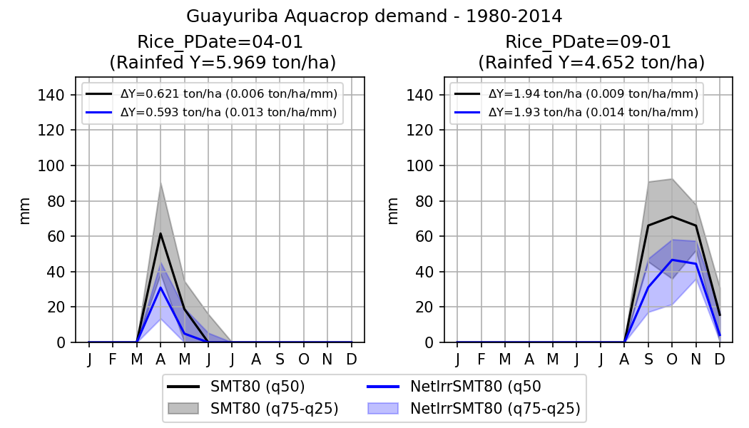

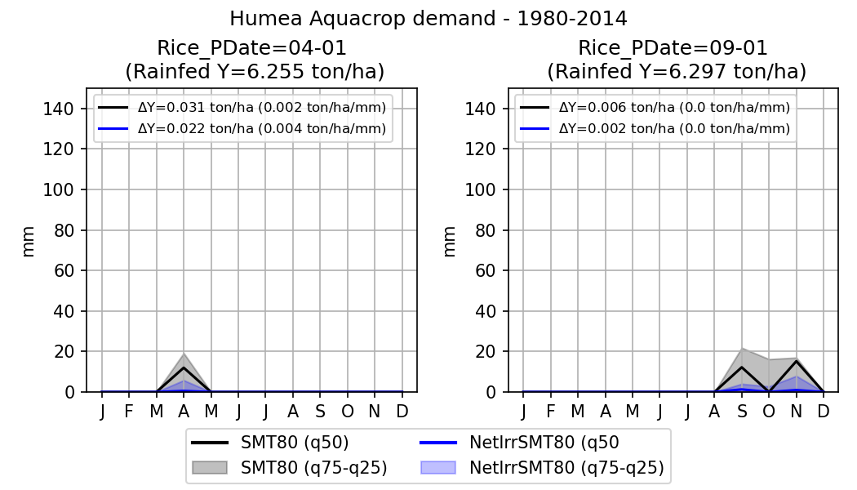

Figure 28. Illustration of the impact of the irrigation strategy on the temporal dynamic of the irrigation water demand.

Figure summary: Each of the panel shows results obtained for a different crop and for two different irrigation strategies; blue: Soil Moisture Threshold (80%). Black: Net Irrigation Soil Moisture Threshold. The description of these two strategies is provided in the text. The First row shows results obtained for the Guayuriba and Humea sub-catchment.

Left and right columns show the results obtained for two planting dates (respectively April 1st and September 1st). Results are aggregated at monthly time steps. The marginal crop yields (ton/hectare/mm) are given for both strategies in the legends.

#### 

#### Oil Palm

The OWF model uses the water demand methods provided by CENIPALMA, which is based on a methodology similar to CROPWAT that itself is based on the FAO Irrigation and Drainage Paper 33.

In this case, oil palm irrigation requirements (*Dirr_palm,k*) are estimated using the following equation:

|  |  |
| --- | --- |
| $$D_{irr_palm,k}\left(t\right)=\sum_{n}^{k}{w_{palm,k}\left(t\right)}A_{palm,k}\left(t\right)$$ | (20) |

where $w_{palm,k}\left(t\right)$ is the irrigation water requirement (mm) for oil palm over the sub-catchment k.

Note that the value $w_{palm,k}\left(t\right)$ depends on multiple factors that include potential evapotranspiration (i.e., temperature) and the current soil moisture, which depends on the recent rainfall and evapotranspiration over the catchment *k*.

$A_{palm,k}\left(t\right)$ is the crop area that can be set as a constant throughout the simulation, or vary based on scenarios of irrigation expansion. *(t)* is the time index in days.

The CROPWAT model estimates the $w_{palm,k}\left(t\right)$ as:

|  |  |
| --- | --- |
| $$w_{palm,k}\left(t\right)=\left\{\begin{aligned}\frac{{ET0}_{k}\left(t\right)-{ER}_{k}\left(t\right)}{\left(1-E_{spalm}\right)}\overset{⇒}{}{ET0}_{k}\left(t\right)-{ER}_{k}\left(t\right)>0 \\ 0\overset{⇒}{}{ET0}_{k}\left(t\right)-{ER}_{k}\left(t\right)≤0\end{aligned}\right.$$ | (21) |

$E_{spalm}$ is a loss coefficient similar to the ones used for the freshwater demand model, and ${ER}_{k}\left(t\right)$ represents the effective rainfall and is computed at monthly time scale as:

|  |  |
| --- | --- |
| $${ER}_{k}\left(t\right)=\left\{\begin{aligned}{P_{k}\left(t\right)\left[125-0.2P_{k}\left(t\right)\right]}/{125}\overset{⇒}{}P_{k}\left(t\right)<250mm \\ 125+0.1P_{k}\left(t\right)\overset{⇒}{}P_{k}\left(t\right)≥250mm\end{aligned}\right.$$ | (22) |

Where $P_{k}\left(t\right)$ is the monthly precipitation at month t and catchment t.

Marginal water use for oil palm is said to be approximately one liter/(s-ha) during the dry months. However, irrigation technology in oil palm is often rudimentary—channels and furrows—and there is considerable room of increased efficiency, so in this case the value of the $E_{spalm}$ losses are relatively high.

### Minimum flow requirement

In Colombia, federal and regional environmental agencies set minimum flow requirements for all rivers. In the Orinoquía region, the minimum flow requirement $Q_{E}$ is defined in the Resolution 200.41-10.1398 (2010) as 25 percent of the average dry season flow:

|  |  |
| --- | --- |
| $$Q_{E,k}=Q_{m,k}*0.25,$$ | (23) |

where $Q_{m}$ is the average flow during the dry season (December to March).

**Table 14** provides the estimated environmental flow values at the outlet of each catchment (downstream catchments include the sum of all upstream catchments), and lists which sub-catchments are used to calculate the minimum flow requirement at for all downstream catchments. These values are estimated from the GR2M streamflow simulations from 1980 to 2014 and are estimated at a monthly time scale.

*Table 14. Minimum flow requirement at the outlet of each catchment. The values in brackets are the contribution to the minimum flow requirement from the principal catchment.*

|  |  |  |  |
| --- | --- | --- | --- |
| Catchment /response unit | ID | Catchments used to calculate the average dry season flow ($Q_{m}$) | Minimum Flow Requirement Mm3/month |
|  |  |  |  |
| Dir_btw_GuDam_Up* | NA | Guavio, Garagoa, Lengupa, Dir_btw_GuDam_Up | 32.3  (10.3) |
| Garagoa | 1 | Garagoa | 8.5 |
| Dir_btw_Ca_Or | 2 | Metica, Guayuriba, Negro,Guatiquia, Guacavia, Humea, Dir_btw_Hu_Up, Guavio, Garagoa, Lengupa, Lago de Tota, Upia, Dir_btw_Gb_Yu, Yucao, Manacacias, Cumaral, Melua, Tua, Cusiana, Dir_btw_Cu_Cs, Cravo Sur, Guanapalo, Pauto, Dir_btw_Cu_ca, Dir_btw_P_Ca, Guachiria, Dir_btw_Ca_or | (20.55) |
| Pauto | 3 | Pauto | 34.1 |
| Dir_btw_Cu_Ca | 4 | Metica, Guayuriba, Negro,Guatiquia, Guacavia, Humea, Dir_btw_Hu_Up, Guavio, Garagoa, Lengupa, Lago de Tota, Upia, Dir_btw_Gb_Yu, Yucao, Manacacias, Cumaral, Melua, Tua, Cusiana, Dir_btw_Cu_Cs, Cravo Sur, Guanapalo, Pauto, Dir_btw_Cu_ca | 706.9  (12.6) |
| Guanapalo | 5 | Guanapalo | 21.4 |
| Lengupa | 6 | Lengupa | 13.5 |
| Upia | 7 | Lago de Tota, Upia | 29.4  (13.3) |
| Tua | 8 | Tua | 24.0 |
| Cravo Sur | 9 | Cravo Sur | 27.3 |
| Dir_btw_Cu_CS | 10 | Dir_btw_Cu_Cs | 8 |
| Cusiana | 11 | Cusiana | 22.4 |
| Yucao | 12 | Yucao | 47.2 |
| Guatiquia | 13 | Guatiquia | 47.2 |
| Humea | 14 | Humea | 43.6 |
| Guacavia | 15 | Guacavia | 41.2 |
| Guavio (downstream) | 16 |  |  |
| Metica | 17 | Metica | 62.7 |
| Guayuriba | 18 | Guayuriba | 28.5 |
| Dir_btw_Gb_Yu | 19 | Metica, Guayuriba, Negro,Guatiquia, Guacavia, Humea, Dir_btw_Hu_Up, Guavio, Garagoa, Lengupa, Lago de Tota, Upia, Dir_btw_Gb_Yu | 323.7 |
| Dir_btw_Hu_Up | 20 | Dir_btw_Hu_Up | 14.2 |
| Melua | 21 | Melua | 37.4 |
| Cumaral | 22 | Cumaral | 22.1 |
| Manacacias | 23 | Manacacias, Cumaral, Melua | 186.2  (126.7) |
| Dir_btw_P_Ca | 24 | Dir_btw_P_Ca | 16.8 |
| Negro | 25 | Negro | 24.6 |
| Lago de Tota | 26 | Lago de Tota | 16.1 |
| Casanare | 27 | Casanare | 43.2 |

## The OWF Infrastructure Model

The final step in creating the OWF platform is the water system model that simulates the movement of water through the Meta River basin.

### Hydro-system infrastructure

There are two large reservoirs in the basin (red pyramid symbols in **Figure 29**). The Alberto Lleras Dam (known as Guavio dam) was built across the Guavio river. Its total storage capacity is 1,043 Mm3­, it is operated by *Enel Generación Chile* and its main purpose is hydropower generation. La Esmeralda Dam was built across the Batá River, diverting water to a power station that discharges into the Lengupá River. Its total storage capacity is 758 Mm3 of which 680 Mm3 is active storage. The reservoir is operated for hydropower generation by AES Colombia[53].

Each of the sub-watersheds are shown in the grey octagons. The water demand off-take is represented by the IRR green boxes and the blue dots are the diversion nodes, which can vary in use and description.

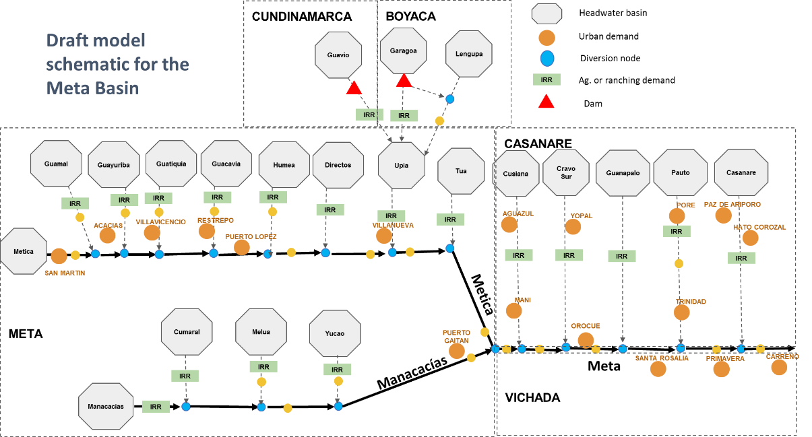

*Figure 29. Hydro-schematic representation of the Meta River basin.*

### Water resource allocation

Broadly speaking, the water system model is used to route the water from headwater catchments to the outlet of the catchment, while delivering water to users along the way.

The spatial resolution of the OWF model is the sub-hydrozone or sub-watershed of the Meta (called catchments).[54] Its temporal resolution is monthly, which is a tradeoff between the representation of the physical mechanism driving the system over a period of more than 20 years (i.e., seasonality of river flows and demand) and computation requirements and limitations of a large-scale model.

In the OWF, a time series of water runoff from each catchment is generated by the GR2M model, while water demand is estimated via the demand models.

The model output includes, but is not limited to, river flows in and out each hydrological unit and water deliveries to users (or deficit in the instance where demand is not fully met.

OWF model is developed in the Python programming language and is built on the python library Pywr (Tomlinson et al., 2020), a generalized network resource allocation model written in Python (<https://github.com/pywr/pywr>).

The Pywr modeling framework is a linear programming (LP) cost minimization problem. Mathematically, the LP problem is defined as the following objective function to be minimized:

|  |  |
| --- | --- |
| $$minimize c=\sum_{n}{C_{n}}Q_{n}+\sum_{r}{C_{r}}S_{r},$$ | (24) |

where $c$ is the objective to minimize; $n$ is any node in the model to which a cost is assigned. $Q_{n}$ is the volume of water passing through the node $n$ while $S_{r}$ is the water volume stored in the reservoir r. $C_{n}$ and $C_{r}$ are the marginal costs associated with the node $n$ or storage $r$, respectively.

In OWF model, the cost $C_{n}$ and $C_{r}$ are not expressed in monetary terms, although it could be if the shadow prices of water were known for each location and usage. Instead, cost values are a type of relative friction ranking and are used to prioritize the operations.

The LP optimization problem defined by equation 34 is subject to a list of constraints that ensure that the solution complies with the water balance and various channel and storage capacities throughout the system (e.g., water transfer capacity in channels, maximum and minimum storage capacities in reservoir). **Table 15** summarizes the main components of the model and their associated node type.

Table 15. The main node types used in OWF model.

|  |  |  |
| --- | --- | --- |
| System component type | | Comment/description |
| Catchment | | Each hydrological unit is associated with a runoff time series generated on-site from the GR2M model. |
| Reservoir | | Alberto Lleras and La Esmeralda Dams |
| Precipitation over the reservoirs/lakes | | Alberto Lleras and La Esmeralda Dams |
| Evaporation over the reservoirs/lakes | | Alberto Lleras and La Esmeralda Dams |
| Minimum Flow ($D_{env}$) | | Represents the targeted minimum flow requirement at the outlet of each sub-catchment. |
| Total consumptive use of water ($D_{Tot}$) | |  |
|  | Freshwater demand ($D_{fw}$) | Includes 18 largest cities across the region |
|  | Livestock demand ($D_{liv}$) | Each hydrological unit is associated with a livestock demand. It aggregates demand for all represented livestock (e.g., cattle, pig, chickens) |
|  | Agricultural demand ($D_{irr}$) | Each hydrological unit is associated with an agricultural demand. It aggregates demand for both grains and tree crops. In this case the focus is on rice and oil palm as the two main sources of demand. |

Catchments and precipitation over the reservoirs are represented as *input* *nodes*. Every time step, water is added to the system throughout input nodes. These nodes are not associated with any cost attribute. The water enters the system through these nodes even if it leads to unwanted consequences (e.g., spill). Note that some input nodes can also receive water from an upstream basin.

Alberto Lleras and La Esmeralda Dam reservoirs are *reservoir* *nodes*. These nodes are associated with a storage capacity and are able to carry water from one time step to the next.

The evaporation over the reservoirs is represented via *output nodes*. Every time step, output nodes are used to withdraw water out of the system. Output nodes used for evaporation over the reservoirs are assigned with the highest cost values (in absolute terms) because it represents a geophysical flux that cannot be avoided.

*Link nodes* are used to move water from one node to another with an assigned cost.

The demand for the environment (i.e., minimum flow requirement, $D_{env}$) is represented via a piecewise link node, which is a link node that accepts multiple cost values for different flow values. The piecewise link nodes used in the model are not constrained in terms of water flow, which means that flow values larger than $D_{env}$ can transit through the node. However, any water volume beyond $D_{env}$ is assigned a cost equal to 0, and thus does not help to minimize the objective function. In this model the minimum environmental flow or demand $D_{env}$ is enforced in each run by setting the lowest costs (equal to the highest priority)

The total consumptive use ($D_{Tot}$) that includes freshwater demand ($D_{fw}$), livestock demand ($D_{liv}$) and irrigation demand ($D_{irr}$), is represented using piecewise link nodes (red color in **Figure 30**) transferring water to an output node. In Pywr, the piecewise link allows accounting for the three demand categories ($D_{fw}$, $D_{Liv}$ and $D_{irr}$) within a single node while assigning different costs to each. Connecting an output node downstream from these piecewise link nodes allows then to take the water off the system.

In **Figure 30** light and dark blue bullets represent water input to the system (respectively runoff and precipitation). Red bullets represent the total demand for consumptive water use, while the green bullets represent the minimum flow requirement in-between two catchments/response units. The blue rectangles show the two reservoirs in the system, and the orange bullets is the outlet of the catchment. Grey bullets show additional link between nodes throughout the system.



*Figure 30. Model infrastructure and direction of water movement for the Meta River Basin system. Dark blue - precipitation; Red – water demand; Blue – catchment; Green – Environmental demand; Grey – junction node; Beige – final outflow.*

## A Climate Stress Test System

The decision-making process in the RbD methodology used in this study seeks to determine when a water system enters into unacceptable conditions due to external input; such as is expected with the effects of climate change. Due to the considerable uncertainty in future climate, the approach incorporates a range of plausible climate change projections but focuses on measurable variables. For this study, overall climate change effects are proxied by changes in mean annual precipitation and mean annual temperature in the river sub-basins that make up with the Meta River Basin.

The overall RbD model results not a singular point, but rather a range of plausible results each with a likelihood of occurrence. To create this outcome, a Stress Test is designed to integrate the results of multiple models and runs, and demonstrate the variability of results. The first step of this process is to identify input conditions and set bounds for results. In this manner, model results can be generated and set against realistic constraints.

In this case, the OWF stress test analysis is structured into three parts:

1. The choice of Representative Concentration Pathway (RCP) of greenhouse gases (GHG) for the study,
2. Setting the bounds of temperature and precipitation model projections
3. A general approach to assessing vulnerability: the so-called “Stress Test” of projected changes for use in the weather generator.

### The RCPs

In this section, results from recent climate projections are reviewed for the Meta Basin region based on the data from the Global Coupled Model Intercomparison Project phase 5 (CMIP5, Taylor et al. 2012). The information used evaluate the possible range of mean changes in long-term precipitation and temperature to that create realistic bounds for the variability in the weather generator results.

General Circulation Models (sometimes called Global Climate Models - GCM) are an excellent tool for developing and testing theories of the climate system by providing a valuable tool for understanding climate change and projections of future climate and related impacts. The Intergovernmental Panel on Climate Change (IPCC) developed a Fifth Assessment Report (AR5) that guided the development of the Community Combined Model Intercomparison Project, Phase 5 (CMIP5), with all available data associated with multiple general circulation models (IPCC, n.d.). CMIP5 is a collaborative climate modeling process coordinated by the World Climate Research Program (WCRP), resulting in a database of GCM simulations from various scientific institutions' main climate modeling centers. Each modeling center followed a standard set of assumptions and procedures, generating a set of GCM simulations of past, current, and future climate under various greenhouse gas emissions assumptions.

The emission scenarios adopted by the IPCC community and CMIP5 in AR5 to characterize future greenhouse gas (GHG) concentrations are the representative concentration pathways (RCPs). The amount of GHG emissions into the atmosphere from human-induced activities or natural feedback during the 21st century cannot be projected because the uncertainties are too significant, which is why the IPCC developed the RCP scenarios.

Each RCP has a prescribed increase in radiative change by 2100 relative to pre-industrial levels. Both long-term concentration levels and the trajectory followed over time are of interest (Moss et al. 2010). Four pathways for climate modeling and research were used for the AR5, each describing different climate futures, all considered possible based on the volume of greenhouse gases (GHGs) emitted in the coming years. The RCPs are labeled RCP2.6, RCP4.5, RCP6, and RCP8.5 after a possible range of values in the year 2100 (2.6, 4.5, 6, and 8.5 w/m2, respectively) as is shown in **Figure 31**.

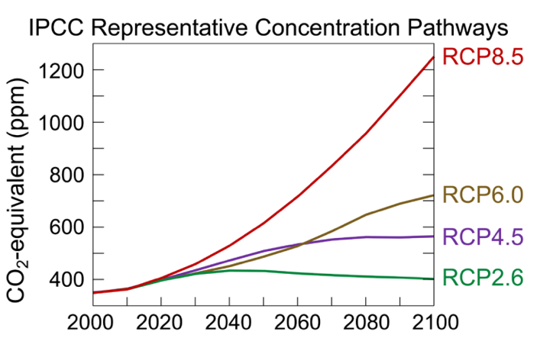

*Figure 31. Trends in Concentrations of CO2 Concentration for the Four RCPs of IPCC AR5 (Source: Efbrazil 2020)*

Generally, the different assumptions of each RCP tend to result in similar climate projections to the midcentury, which then diverge to the end-of-century. The RCP8.5 scenario results in the most significant amount of warming by the end-of-century and is the highest emissions scenario.

### Setting the bounds

The central tendency for both CMIP5 projections and elicitations agreed to warming roughly around 2°C in 2040 and 3.5°C in 2070 and minimal precipitation change. However, both datasets also suggest deep uncertainty about the potential climate change due to the large range of plausible changes for both temperature and precipitation as shown in **Figure 32**.

The figure presents the CMIP5 projections and elicitation results for 2040 and 2070 for the Meta River basin. This study follows the principle of decision making under deep uncertainty which is to utilize an approach that incorporates the full plausible range of climate change projections, without regard to likelihood, to explore a comprehensive set of possible outcomes and find system vulnerabilities.

Therefore, for the stress test, the warming in mean annual temperature will vary from 0 to 5°C and the change in mean annual precipitation will vary between -30% and +30% of historical conditions. The historical baseline is from 1980 to 2005.

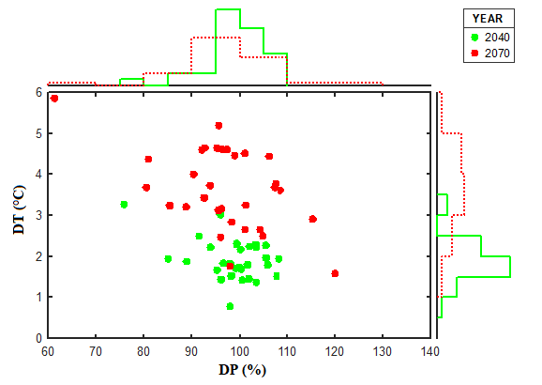

*Figure 32*. *Average relative change in precipitation (x-axis in %) and the average absolute change in temperature (y-axis in ⁰C). using CMIP5 projections. Results are given for the Meta basin region, two future periods: 2040 (2026-2055; green color) and 2070 (2056-2085; red color) and for the RCP8.5. Baseline is 1986-2005. The histogram plots show the distribution of CMIP5 projections*

Based on the findings of the CMIP5 models and a review of literature, the variables selected for consideration in this model are limited to mean annual temperature and precipitation. The adjustments to these variables in simulations are applied uniformly across seasons and regions.

### The Stress Test

The OWF is a suite of interconnected computer models and supporting analytical tools that representi the processes of the long-term water system conditions of the Meta River Basin. These models—which include the HMM weather generator, the GR2M hydrologic models, water demand models, and the water system infrastructure model – use projections of future climate and other socio-economic input, and result in quantitative estimates of future system conditions, which are then identifiable as vulnerable or robust.

Sources of vulnerability known to be important are systematically varied across a range of values to “stress test” various components of the water system and understand the consequent vulnerability associated with stressor variations.

Stress tests for climate (precipitation and temperature) were selected by analyzing the projected regional changes of climate through 2070. The range of temperature and precipitation change factors under consideration were based on the findings of climate projections. Temperature scenarios range from +0°C to +5°C with 1°C increments, for a total of 6 temperature scenarios. Precipitation scenarios range from -30 percent to 30 percent with 10 percent increments, for a total of 7 precipitation scenarios.

The final set of annual precipitation series that result from the combinations of the 20 runs with 7 changes in precipitation levels and 6 temperature changes, which together represent a wide range of both wet and dry conditions in the OWF as they consider natural climate variability and possible climate changes together. The projections used in the OWF model scenarios are a 20 temperature increase and a 10 percent loss in precipitation.

System performance and vulnerability results are mapped as illustrated by the color map (**Figure 33)**, hereafter termed as “climate response function,” which shows the range of parameter values (for combinations of temperature and precipitation) for which the performance of the system is acceptable (red is bad, blue is good).

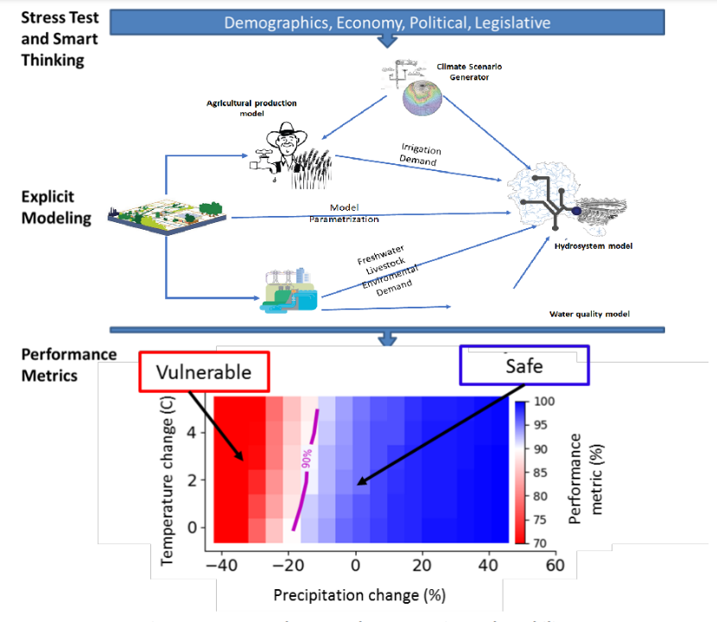

*Figure 33. Example of the stress test results.*

Given the potential combinations of changes across the systems – even beyond temperature and precipitation – the stress test may result in a very large number of possible, uncertain, modeled futures, the results of which are made more accessible through aggregated visual representation, as above.

# water demand scenarios

## Introduction

For more than two decades the Orinoquía has been the focus of economic development planning for Colombia. It is seen as the last economic frontier of the country and is expected to play a key role in Colombia’s economic future.

To create and test reasonable land use scenarios, we use a combination of available literature, participant surveys, and historical data. A key aspect of the RbD methodology, however, is active stakeholder engagement, which adds a diverse and rich set opinions to the mis as well as vital regional knowledge.

Land use scenarios[55] are projected to generate estimates of future water demand in the region. While regional agriculture is discussed in general terms in this document, projections are limited to the key sources of water demand sources used in the model: Livestock (cattle, pigs, chicken) and Agriculture (rice and oil palm).

It is important to note that other production systems, whether small farm mixed crop systems (so-called *mosaicos*), or cocoa and cashew, for example, are predominantly rainfed and so do not actively remove water from the system. This may change in the future, and it is possible to include these crops and their water use in future models (it would be based on crop needs and local rainfall estimates), but the current model is limited to water flowing through the river system and the active removal through freshwater consumption or irrigation.

## 

## A Stakeholder Engagement Process

The stakeholder engagement process has been conducted with three key goals: Build understanding and acceptance of project deliverables in local constituencies; provide local knowledge and input into model and scenario design; and deliver capacity building during project timeline.

Through a series of visits to each department, we identified potential partners and workshop participants. The goal of these introductory meetings was to secure support for the project and the process. In any multi-stakeholder workshop, one seeks a balance between the private sector, government, civil society and underrepresented local communities and actors and it is important to meet in-person since this creates the initial sense of community and understanding that catalyzes participation.

We held four opening workshops (one in each Department) with an attendance of between 30 and 40 people each. The workshop process was based on the deep experience of Alisos in bringing together disparate voices throughout Colombia over the past decade (**Figure 34**).

*Figure 34. Number of participants in the four opening workshops by Sector (above) and by Department (below)*

The method called Maximum Value Agreements (MVA) employed by Alisos specifically targets the process of incomplete agreement whereby everyone is compelled, through collective activities, to reduce barriers to compassion and understanding and be willing to achieve slightly less gain than they hoped for. In other words, everyone leaves with slightly less than they wished for but just enough to be satisfied, allowing for a negotiating space to be created.

Then, we created 3 technical working groups that focused on specific aspects of the overall project goals. These groups were designated to focus on: Agriculture and Livestock; Model Design, Build and Review; and Model Governance. The technical working groups served as a key vehicle for continual communication with the local partners and stakeholders, for capacity building and knowledge transfer; and to ensure that the models are representative of the ecological, economic and social conditions of the region.

The technical working groups met five times each, for a total of 15 technical working group meetings, but varied depending on need and availability of participants.

In July 2023, a “cross-pollination” workshop was held (**Figure 35**). This was a three-day meeting in Bogota in which a heterogeneous group of 21 people representing the four Departments and the different interest groups finished their MVA training, discussed the products developed in each of the technical working groups and presented the progress of the model to national authorities.

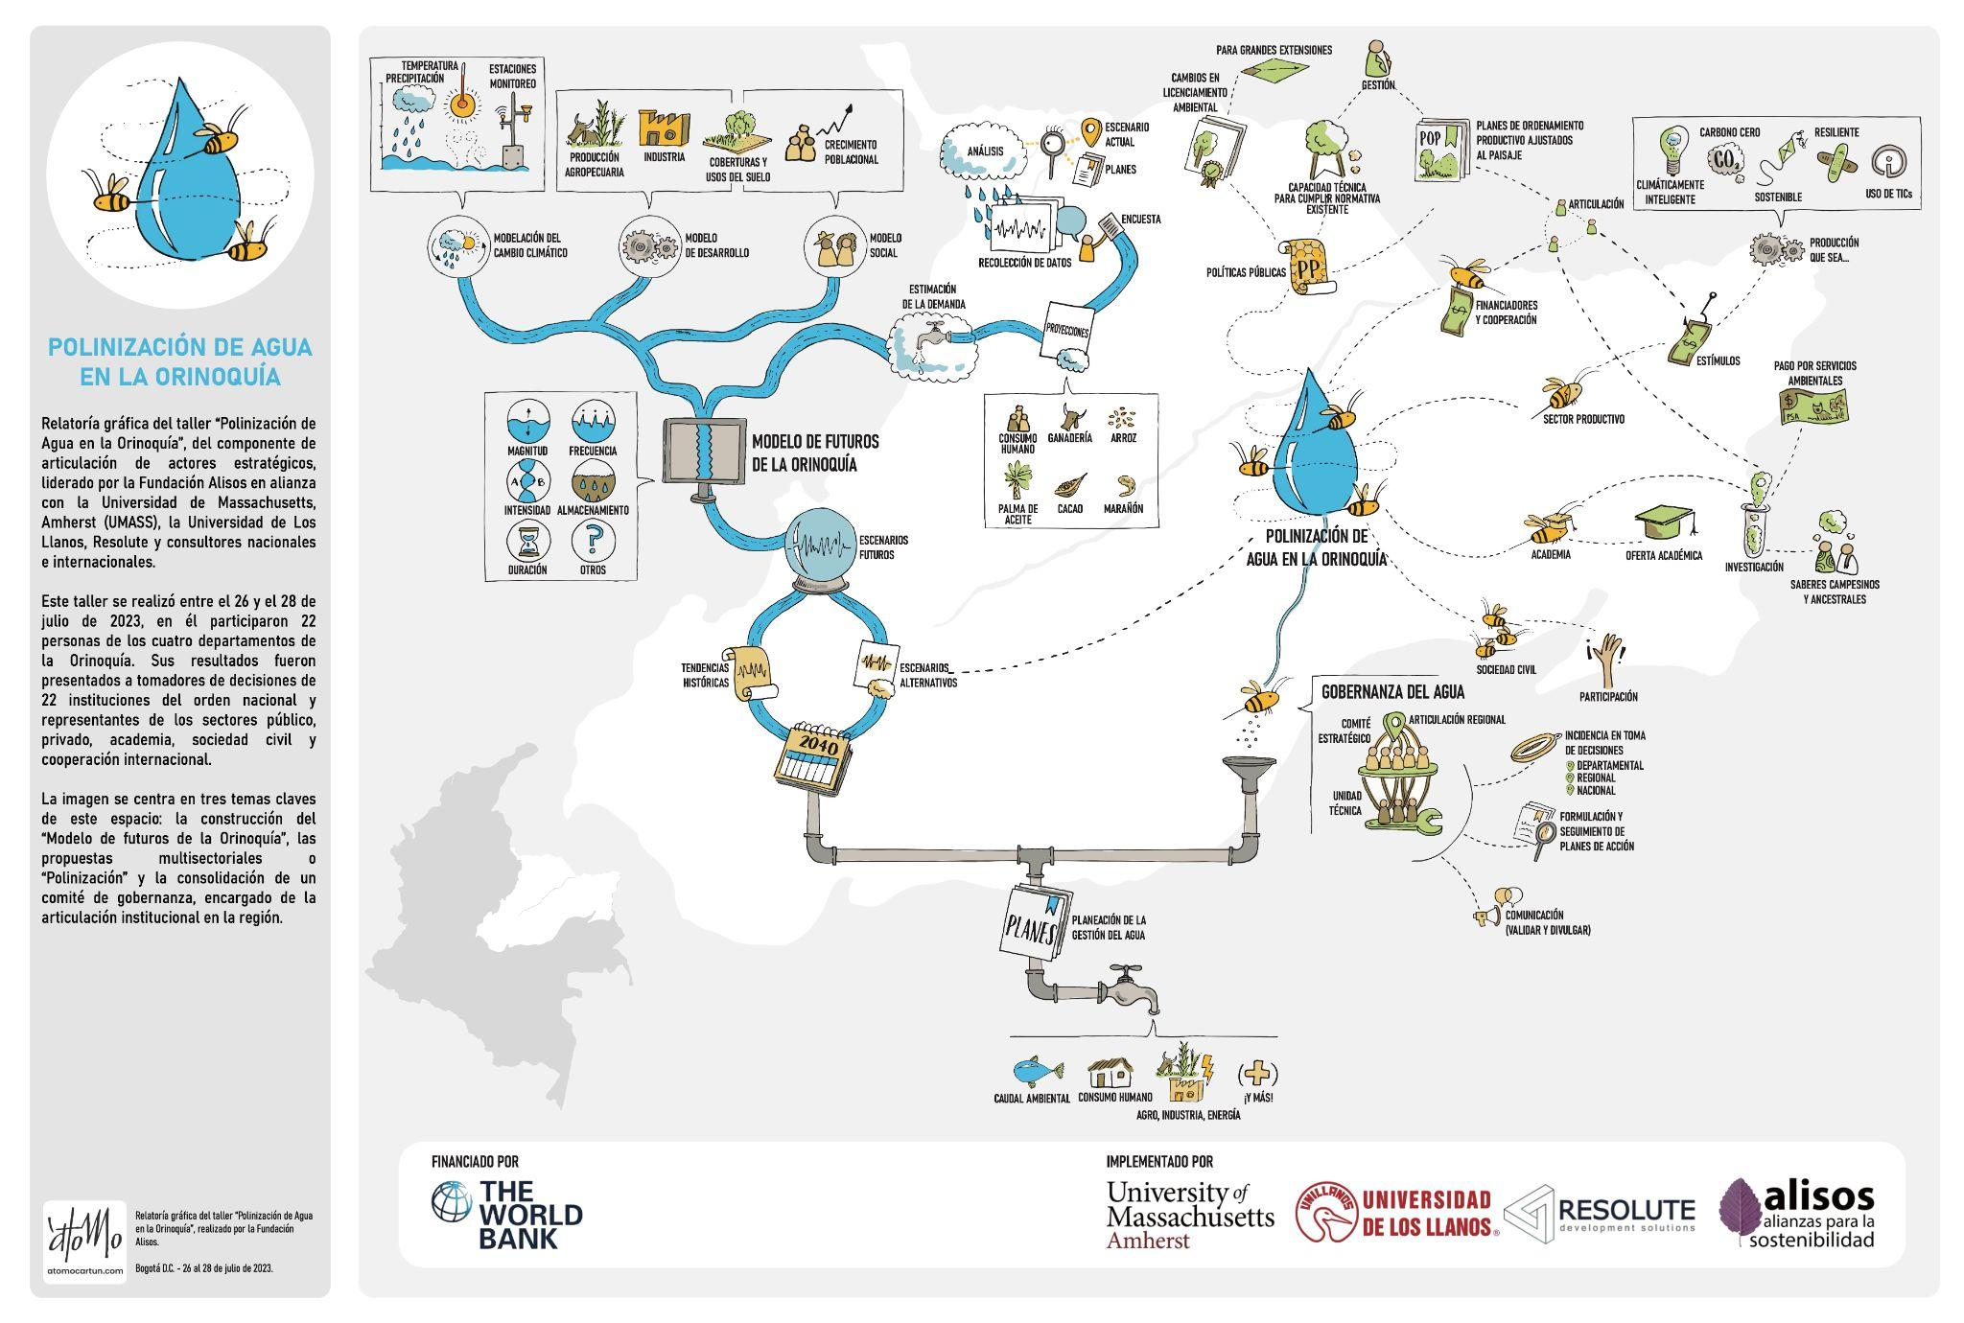

*Figure 35. Graphic representation of the project stakeholder engagement process with connection to the modeling effort.*

This meeting managed to consolidate relationships of trust between people from different Departments, tested the negotiation lessons learned, generated ownership of the model, and awakened the interest of institutions such as the Ministry of Environment and Sustainable Development and the National Planning Department to know in detail the hydro-economic model.

Finally, during the months of November and December 2023, closing workshops were held in which results were presented in each of the departments to find out what doubts there were about the model, how useful they found it and what advocacy opportunities the participants could generate from the sector in which they are located.

In addition, four closing workshops were held at the end of the project to show the results of the combined stakeholder input and modeling process, as well as a final 2-day technical training course to finalize the technology transfer and capacity building process.

## An Opinion Survey

A key component of developing land use scenarios is getting input from local stakeholders. We are doing this in a multi-pronged approach described in more detail below, but in summary including opening and closing workshops in each Department, 15 virtual Technical Working Groups covering three key issues (agriculture and ranching, modeling, and governance), and 3-day in-person meetings. In addition, we developed and applied an online survey of perceptions to individuals who had been contacted by the project at one time or another. We understand that this creates a biased sample but given the short time-frame for the project and that we added this activity as an important adaptation to provide additional information, we are willing to overlook this statistical issue.

The survey was applied in March to June 2023 to 400 individual and we received 103 responses (25%), which is an acceptable rate. Questions ranged from perceptions of land use change to drivers of deforestation and water conflict. The overall goal was to understand prevailing regional opinions on the water system and provide support to the design of land use scenarios. The survey was divided into two key sections: sectoral overviews and water system vulnerability.

*Sectoral responses*

The sectoral questions were designed to answer the following types of questions, among others: What do you expect to happen in Cattle, Oil palm and Rice sectors between now and 2040? Which cattle production systems demand the most water? What percent of commodity production will be irrigated now and in 2040?

For **Cattle** preliminary results include:

* 50 percent of respondents think that the cattle herd will increase, but 50 percent think it will stay the same or contract.
* The expectation of an increase is higher in Casanare and Meta than in Arauca or Vichada.
* Today 73 percent of respondents estimate that more than 50 percent of production is in extensive systems, but only 31 percent believe extensive systems will predominate in 2040.
* Expectations for Intensive and Semi-intensive (as a percent of production) are similar for today and 2040.
* 25 percent more respondents think that silvopastoral systems will be >50 percent of production in 2040.
* 73 percent of respondents believe there to be a significant difference in water demand between Extensive, Semi-intensive, Intensive and silvopastoral systems.
* 42 percent ranked intensive as the most water-demanding, while 34 percent ranked extensive as the most demanding.
* Semi-intensive production secured the most votes for mid-level consumption.
* Silvopastoral systems are widely regarded as the least demanding with 47 percent ranking them in that category.
* In a similar fashion 81 percent of respondents say that there are significant differences in consumption between dairy, beef, and double-purpose systems.
* Diary is heavily assumed (69 percent) to have the highest water demand per head, while beef the lowest (46 percent).

Two central elements stand out in the 2040 herd forecast:

1. The projection of the decrease of the extensive system at the regional level and the increase of silvopastoral systems; this perception is probably associated to the existence of initiatives in current development, such as the Biocarbon and climate-smart agriculture projects.
2. The greater expectation of an increase in the cattle herd for the two departments that support cattle production for national consumption and for export: Casanare and Meta, may be associated with this economic dynamic and their development plans that maintain this productive line as one of the axes.

In a high percentage (more than 70 percent) the stakeholders note differences in water demand for each type of livestock production system; the silvopastoral system stands is identified as the lowest water demand, followed by (increasing demand) extensive, semi-intensive and intensive, and dairy production systems.

Although there are different types of production systems in the Orinoquia, there are marked differences in terms of the areas where they are concentrated: dairy cattle ranching is mainly located in the mountain and piedmont areas, while beef production is generally located in the plains and savannahs.

For **Oil Palm** respondents suggest that:

* 88 percent of respondents believe that oil palm will either stay the same land area or increase (52 percent) by the year 2040.
* Respondents from Meta and Casanare expect a greater increase in oil palm by 2040 than those from Vichada and Arauca.
* 42 percent of respondents believe there to be some irrigation in oil palm in their region (26 percent say they do not know).
* The percent of respondents estimating that more than 30 percent of oil palm will be irrigated doubled to 54 percent when comparing today and 2040.

Additional comments on Oil Palm:

One of the main lines of the regional economy is the cultivation of oil palm and therefore, for the 2040 projections, it is expected that the area destined to its production in the departments of Casanare and Meta will increase, maintaining this crop as the commodity that is sustained, probably due to government incentives, the market and the favorable climatic conditions of this area; however, it is projected that this crop will increase in water demand, since irrigation will increase by 24 percent, compared to the current situation.

For **Rice** the answers include:

* 58 percent of respondents believe that irrigated rice production will either stay constant (34 percent) or increase area (24 percent) by 2040.
* 63 percent of respondents believe that dryland rice will either stay constant (27 percent) or increase (36 percent) area by 2040.
* In Arauca both systems are expected to increase. In Casanare and Meta, the predominant expectation is that irrigated rice will stay with the same area. With a small exception, dryland rice area is expected to increase everywhere.

Additional comments on rice:

Given the dynamics of rice cultivation, which depends on available land and the high level of water needs, there is a contrast between the two modes of production in the Orinoquia: irrigated and rainfed rice. Based on the perceptions of the actors surveyed, it is suggested that irrigated rice will be maintained by 2040, while rainfed rice will increase. The reason that can be argued to explain this projection corresponds to the predominance of this mode of cultivation, which depends on rainfall and runoff and is favored by maintaining large areas of overflow, flooding and shallow water table zones, mainly in the Orinoquía savannas. It is also associated with climate change projections that predict increases in precipitation and droughts in this region.

The department of Arauca is noteworthy because it is projected to increase both types of crops and has the largest area of floodable savannas, considered as large wetlands, unique and representative for the country. It is also important to associate to this reflection the sectoral policy that, through incentives, favors and maintains rice production. The important reflection should be related to the current dynamics of this commodity: land rental and impact on natural systems, such as wetlands (floodable savannas).

For **other promising crops** the following results were submitted:

* Cocoa is identified as a promising crop 70 percent of the time.
* Followed by banana and forestry, both identified 48 percent of the time.
* Cashew and citrus were also frequently identified as promising crops appearing in about 35 percent of the lists.
* Finally, coffee appeared in 24 percent of the lists and avocado in 18 percent.
* Selected in: Arauca (cocoa, banana, citrus); Casanare (cocoa, banana, coffee); Meta (cocoa, forest products); Vichada (native plants, cashew); and general Orinoquía(cocoa).
* Sixty-three percent of respondents indicated that promising crops would need irrigation in the future.

Additional comments for promising crops

In terms of promising crops, there is coincidence in the identification and selection of the three main products prioritized by the stakeholders surveyed; cocoa is the most promising crop, with close to 70% considering it so, followed by plantain and forestry. The recognition and international exposure of cocoa together with ongoing regional initiatives that support its implementation and technical improvement may be part of the reasons that support it; in the case of plantain, there is a traditional production rooted in the two axes of the piedmont plains, both in the departments of Meta and Arauca that support it; for forestry, the dynamics of transformation of the highlands, especially in the departments of Meta and Vichada, coupled with recent incentives from the government, favor the increase of this productive activity.

*Water system vulnerabilities and potential conflicts*

This section is designed to answer questions (understanding perceptions) such as:

Where is the water system most vulnerable? What are the main causes of land use change and what are the regional expectations? Does land use change affect the water system? And what are the major obstacles to achieving a resilient water system?

* Almost 90 percent of the respondents agree that the water system will be affected by land use change.
* Fifty percent of respondents identified agriculture and livestock (agribusiness) as the main regional threat.
* Only 16 percent identified urban use as a threat and 14 percent stated that oil and energy were a threat.
* Finally, agribusiness was identified by 12 percent.
* When asked to identify the three biggest obstacles to a resilient water system, respondents' lists included climate change 65 percent of the time, population increase, poor development policies, continuation of the extractive economy and pollution appeared 40 percent of the time.
* And finally, a weakened social fabric and agribusiness were identified as obstacles 30 percent of the time.
* In 50 percent of the cases, agriculture is identified as the main cause of vulnerability in the system that will emerge by 2040.
* Pollution from different sources was identified 65 percent of the time as one of the main causes of the potential conflicts that will arise by 2040.Followed by insufficient availability (55 percent) and lack of governance (53 percent).
* Weakness in state action and lack of infrastructure appeared in 48 percent and 36 percent of the lists respectively and water quality is the most frequently mentioned.
* Finally, lack of rural access was selected 18 percent of the time as opposed to lack of urban access which only appeared in 3 percent of the lists.

Additional comments on vulnerability and conflicts:

In the region, the greatest vulnerability of water resources is associated with the agricultural sector, especially in the department of Arauca; possibly the transformation of its ecosystems is not only related to agricultural production but also to deforestation and the demand for illegal settlements; In the departments of Casanare and Meta, the trend is similar because of their agricultural vocation, mainly extensive cattle raising and the increase in areas planted with African palm and rice; in the department of Vichada, the agroindustrial sector is also relevant because of the large agricultural and cattle raising industries that have begun to develop in the territory (**Figure 36**).

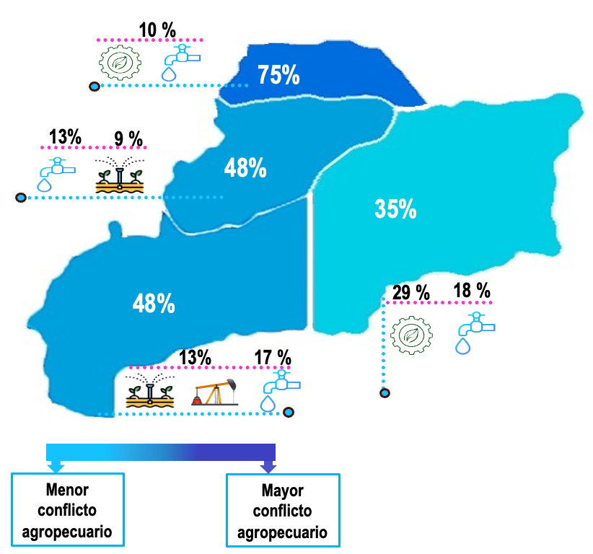 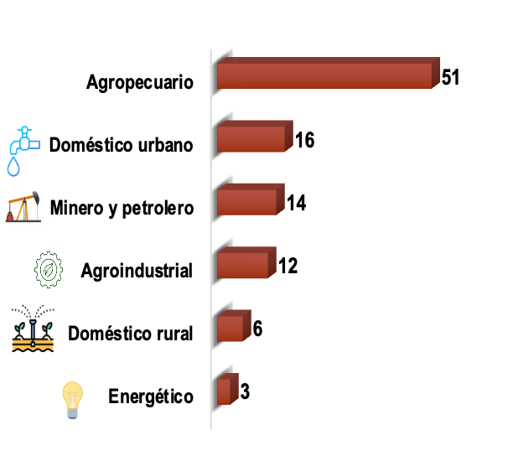

*Figure 36. Mapping vulnerability and potential conflict in the Orinoquia. Percentages reflect the frequency of selected conflict type and locations as represented by survey participants. Graph on left indicates chief causes of water conflict identified by stakeholders.*

The vulnerability of the water system is associated with the scarcity of the resource and in this scenario for all actors the agricultural sector is the one that will mainly affect this resource, this can be related to several factors that influence the future scenario such as the increase in population - which will require coverage of their food security -, climate change - by increasing rainfall and temperature with changes in some territories and decrease the suitability of soils for certain crops and in other cases, the ambiguous and poorly implemented policies due to the perspective of seeing the region as the great agricultural pantry of the country, with the implementation of development models similar to those of the Brazilian Cerrado in the Altillanura, do not consider the specific context of the Orinoquia: socio-environmental and economic conditions; also, the extractivist economy that is evident and prevalent in the agricultural sector.

For the stakeholders, five possible conflicts are relevant: contamination from different sources, insufficient water availability, lack of governance, weak state action and lack of infrastructure. These symptoms are consistent with the regional context, whereby there is a prevailing lack of environmental consistency and sustainable production, efficient technologies are not implemented, roads are in poor condition, and incentive policies only favor some sectors. However, several initiatives have been developed for over the past decades, supported by government policies that promote sustainability and economic development for the region's own benefit and for the benefit of the region, with support from national and international NGOs.

*Expectations of land use change*

The Orinoquía has three main ecosystems: Forests, Savannah and Wetlands:

* 98 percent of respondents express that there will be a significant loss by 2040 in all three ecosystems.
* Approximately 70 percent of respondents project there will be a 15 percent loss in all ecosystems by 2040.
* Approximately 30 percent of respondents expect more than 30 percent loss of cover in all ecosystems.
* The three main causes identified by the respondents are: (1) agricultural expansion, (2) livestock, and (3) human settlements.
* All of these causes were ranked in that order of impact for all ecosystems (with the exception of wetlands, which are expected to be more affected by human settlements than by cattle ranching).

Additional comments:

The general perception of the stakeholders has a high expectation (98%) of the transformation of key natural ecosystems and the loss of ecosystem services and the functioning of agroecosystems, such as forests, savannas and wetlands. In a similar way, it is expected that the area transformed will exceed 30% by the year 2040, and they also agree in identifying agricultural expansion and human settlements as common causes.

## Water Demand Scenarios

Using the information generated in the stakeholder engagement process, the available literature, and the participant survey, while respecting the limitations of modeling complex systems, two scenarios were identified and selected to demonstrate the functionality of the OWF model.

All scenarios begin from the BASE run, which evaluates the water system as it is today with no changes into future. In other words, what happens is things stay the same as today?

The first scenario represents the impact of climate change (CC), holding all else equal. The temperature and precipitation are adjusted to represent a project climate future and the water system adjust accordingly. The CC scenario is compared to the base and then used as input to the following scenarios.

The second scenario is a proxy of the current development path in which growth is “unrestrained”. Designated as "*Unlimited Demand Expansion*" (*UDE*), this scenario uses past trends to forecast into the future and is comparable to “Business-as-Usual”. Here, population, livestock, and agriculture all grow, in slightly different paths, without significant restrictions, and are only limited by the overall agricultural frontier delimited by UPRA.

The second scenario, called the “Deficit Sensitivity” (DS) scenario represents growth constrained by the need to reduce water supply deficits in the region. The reduction of water supply deficits in this scenario is used as a proxy for resilience. In this scenario water demand is increased against the BASE until deficits appear. This scenario represents a political and economic strategy that manages water demand (agricultural expansion) to the points at which the system is unable to supply the demand. Finally, a missed scenario where various selected changes are included in the model (Selected Future or SF) demonstrates how a combination of changes can drastically reduce deficits.

#### General details

The scenarios use a first-come first serve dispatch order, whereby the system sends water to each node (demand, storage, etc.) and provides the annual allocation to each user, deliveries, storage in reservoirs, and generates the possible deficits in the system, independent of regulation.

Population (and thus urban and rural water demand) projections for 2020 to 2035, were taken from DANE, which was then extended to fit the project timeline with linear regression models. Using the projected trend, population expansion for the years 2035 to 2040 was calculated for each type of population and watershed. This population projection holds for both the UDE and DS scenarios.[56]

As noted above livestock projections follow either a trend analysis (pigs and chicken) or a structured expansion (cattle), each with prescribed per capita consumption in both production and processing. In both scenarios technology and per capita demand is assumed constant throughout the forecast timeline. This assumption can be changed in future scenarios.

For crops, linear expansion trends are estimated without area restrictions or crop competition, which is a feasible assumption since none of the UDE projections generate area as a limiting factor, even when including cattle production.

### System performance metrics

Performance metrics are commonly used to help identify key system vulnerabilities and further inform decisions about potential land uses and interventions. In other words, performance metrics are used to support the original objective of the vulnerability assessment that is to identify the conditions under which performance is no longer satisfying.

The proposed performance metrics were developed in collaboration with partners in the Orinoquía and represent commonly used metrics in the field of water resource system analysis:

* *Annual average deficit*: Corresponds to the mean value of amount of water missing to supply the water demand adequately. It corresponds to the difference between water demand and deliveries within the hydro systemic model. The annual average is a good representative estimate of deficits, especially in models that run over decadal time periods, but is slightly limited in that it may under identify intra-annual peaks of drought and water scarcity. The months-long droughts may have significant impact on water users.
* *Annual maximum deficit (AMD):* A specific year can be catastrophic for the system, so selecting the Maximum annual deficit value can indicate the order of magnitude of the deficit in critical conditions given by climate variability. This metric is an indicator of the potential intra-annual deficits that are potentially disastrous to production and human well-being. While more difficult to plan for, the AMD is a vital indicator in a risk analysis, which should include it alongside a likelihood of occurrence.
* *Frequency below environmental flow* (Frequency Q<Qenv): measures the number of months, as a percentage of the historical record, for which the system records river flows lower than the ecological flow. This measures system sustainability, and represents the impact of demand on the natural regime. Furthermore, this metric is useful to proxy other potential uses, such as transportation, while are affected by water levels.
* *The average value of the Colombian Water Use Index (IUA) during January-March* *(IUA dry season*): is the relationship between demand and available water during these months. January-March are considered the driest months of the year, so IUA during the dry season allows us to understand the sustainability of the water resources in the region when the system is at its most stressed. This metric is similar to the ADM in that it examines “extreme” conditions that are less frequent but more impactful. In this case the likelihood of deficits in the driest month are highest and therefore considerable.

### Scenario I. Climate Change

As mentioned previously, changes in climate are proxied by temperature and precipitation in this model. In this scenario a change is made in both variables. A scenario of DT=2°C and DP=-10% for the C02 RCP 4.5 and RCP8.5 trajectories is possible, so these changes are the selected for the analysis and are applied uniformly over the Basin as input to the model and subsequent scenarios.

### Scenario II. Unlimited Demand Expansion

**Figure 37** shows the configuration for the first scenario. The projections of population (human and livestock) and the expected changes crop area will be gradually applied in a stepwise manner to modify water demand over time. This option applies to all hydrographic subzones in the Meta River.

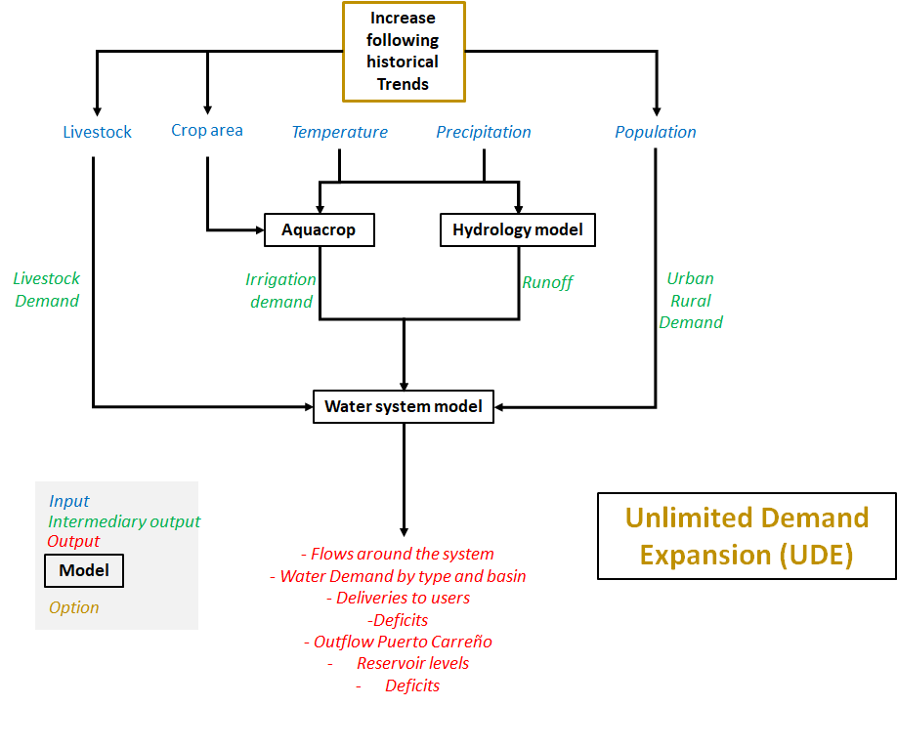

Figure 37. The model system input and flow for the UDE scenario.

As mentioned, the UDE scenario has dispatch orders based on the principle of first-come first-served (FCFS), which allocates water to whichever user is able to access it first.

The water demand in the UDE is built on a trend analysis, which uses past expansion or contraction to project expected changes into the future. This is done for each of the 27 sub-hydrozones (catchments) in the model individually and the graphs below give examples of how that appears in selected sub-hydrozones.

Future rice and palm projects are estimated using linear regression from past *r* tends with confidence and probability intervals. The independent variable (X) was defined as years, and the dependent variable (Y) as production in hectares. Using the least squares method, the trend line equation was calculated for each type of production in each watershed.

A coefficient of determination (R2) is used to evaluate the goodness of fit of the models, and the equations were then used to simulate future agricultural production scenarios up to the year 2040. (**Figure 38**).

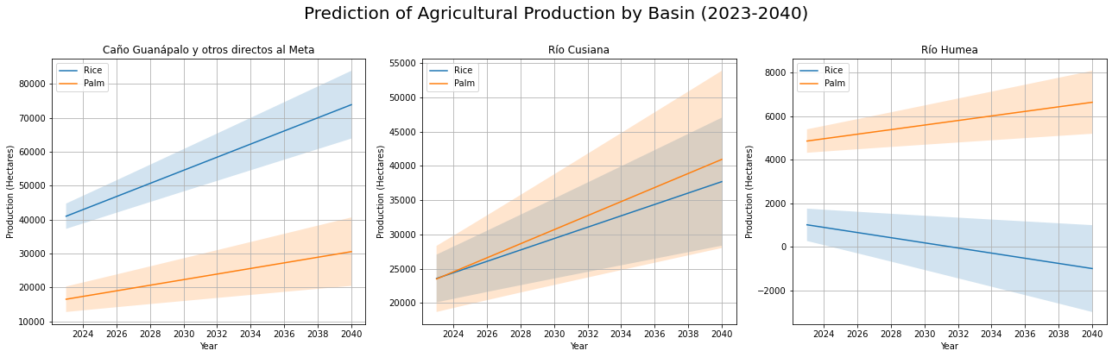

*Figure 38. Example of projected agricultural area for rice and palm oil (2023-2040) in selected sub-basins of the Meta River.*

**Table 16** below shows the final results for the area projections in the UDE scenario for rice and oil palm by catchment. The project suggests that the area under rice production will increase by 70 percent (from 246,000 ha to 417,000 ha) and oil palm by a similar 76 percent (from 205,000 ha to 360,000 ha) in the Meta Basin. In rice production, 12 catchments are projected to have a net gain in rice area, while the rest lose area or have none currently. Rice is the inly land in this model that suffers from negative growth year to year. This is due to the annual production cycle that is very sensitive to weather conditions.

In oil palm, by contrast, all of the catchments are projected to increase area with the largest increase being around Ria Tua (36,000 ha increase), Rio Cusiana (22,000 ha increase) and the catchment in between the Humea and Upia with an increase in area of approximately 20,000 ha.

*Table 16. Rice and Oil palm area projections to 2040.*

|  |  |  |  |  |  |
| --- | --- | --- | --- | --- | --- |
|  |  | Rice (ha) | | Oil Palm (ha) | |
| ID | **Catchment** | **2022** | **2040** | **2022** | **2040** |
| 1 | Río Garagoa | - | - | - | - |
| 2 | Caño Guanápalo y otros directos al Meta | 39,369 | 73,854 | 14,290 | 30,562 |
| 3 | Río Pauto | 41,570 | 96,111 | 117 | 258 |
| 4 | Directos al Río Meta entre ríos Cusiana y Carare | 535 | 1,264 | 2,840 | 6,944 |
| 5 | Directos Bajo Meta entre ríos Casanare y Orinoco | 99 | 175 | 1,170 | 3,065 |
| 6 | Río Melúa | 3,956 | 3,324 | 2,155 | 2,559 |
| 7 | Río Upía | 4,094 | 1,958 | 9,682 | 17,783 |
| 8 | Río Túa y otros directos al Meta | 19,660 | 38,240 | 30,926 | 66,575 |
| 9 | Río Cravo Sur | 22,192 | 47,798 | 4,257 | 6,997 |
| 10 | Directos al Meta entre ríos Cusiana y Cravo Sur | 5,724 | 13,397 | 7,335 | 15,741 |
| 11 | Río Cusiana | 18,219 | 37,695 | 17,711 | 40,936 |
| 12 | Río Yucao | 5,448 | 4,716 | 2,347 | 3,043 |
| 13 | Río Guatiquía | 8,230 | 915 | 3,965 | 5,804 |
| 14 | Río Humea | 1,820 | 0 | 4,157 | 6,643 |
| 15 | Río Guacavía | 3,523 | 2,157 | 6,223 | 9,443 |
| 16 | Río Guavio | 135 | 0 | 1,046 | 1,097 |
| 17 | Rio Metica (Guamal - Humadea) | 7,467 | 2,611 | 46,428 | 59,630 |
| 18 | Río Guayuriba | 2,453 | 0 | 7,034 | 8,273 |
| 19 | Directos Rio Metica entre ríos Guayuriba y Yucao | 4,359 | 3,693 | 2,205 | 2,713 |
| 20 | Directos al Río Meta entre ríos Humea y Upia (mi) | 6,243 | 0 | 23,045 | 43,429 |
| 21 | Río Lengupá | - | - | - | - |
| 22 | Caño Cumaral | 206 | 9 | 3,267 | 4,053 |
| 23 | Río Manacacias | 3,558 | 4,540 | 13,625 | 23,131 |
| 24 | Directos al Río Meta entre ríos Pauto y Carare | 17,258 | 40,328 | 6 | 15 |
| 25 | Río Negro | 5,142 | 0 | 836 | 1,463 |
| 26 | Lago de Tota | - | - | - | - |
| 27 | Casanare | 24,805 | 50,765 | 0 | 19 |
|  | **Total (ha)** | **246,065** | **417,134** | **204,668** | **360,176** |

For swine and poultry production, the same trend analysis was used to estimate future populations and thus water demand. On the other hand, considering the available data on cattle, and its relevance for the region, an exponential growth model was used to make the projection to 2040, considering an annual growth rate of 1.5%. (**Figure 39**)

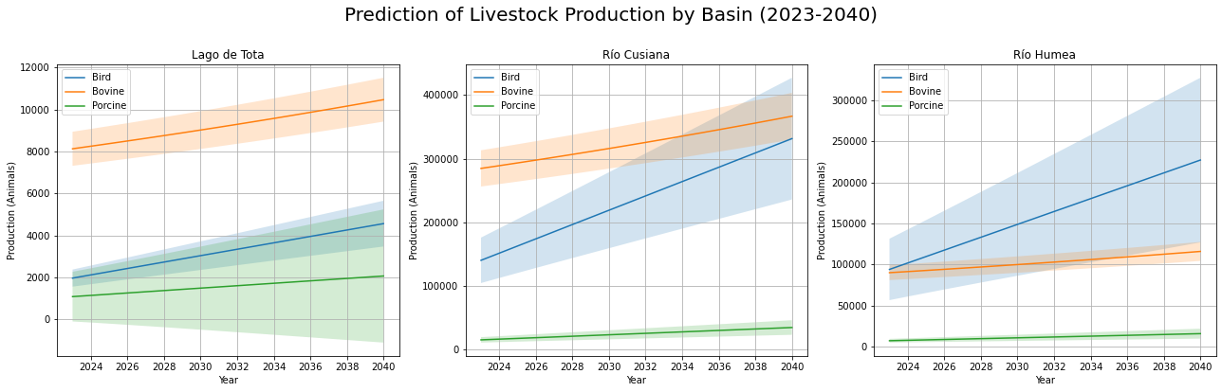

*Figure 39. Projected livestock populations (2023-2040) in selected sub-basins of the Meta River.*

**Table 17** shows the projected expansion results for 2040 in chicken, cattle, and pigs. Following current trends, the chicken population is projected to more than double from 14 million to 34 million, an increase of 147 percent.

The percentage growth in herd size for cattle is 31 (recall they are projected at a 1.5 percent cumulative annual growth) going from 4.8 million in 2022 to 6.3 million head in 2040. Meanwhile the pig herd is estimated to increase from 1 million to 1.7 million (57 percent).

In the unlimited demand scenario, agricultural and ranching expansion is limited by the prescribed agricultural frontier which eliminates access to protected areas and other conservation areas (**Figure 40**). The projected expansion, however, is eventually not constrained by land area since there is an excess under the scenario.



*Figure 40. The agricultural frontier potentially sets limits on expansion*

*Table 17. Projected populations for Chicken, Cattle and Pigs through 2040, by Sub-hydrozone (catchment) – sorted by Catchment ID.*

|  |  |  |  |  |  |  |  |
| --- | --- | --- | --- | --- | --- | --- | --- |
|  |  | Chicken | | Cattle | | Pigs | |
| ID | **Catchment** | **2022** | **2040** | **2022** | **2040** | **2022** | **2040** |
| 1 | Río Garagoa | 2,293,130 | 5,774,323 | 214,304 | 280,169 | 132,124 | 302,142 |
| 2 | Caño Guanápalo y otros directos al Meta | 18,949 | 41,085 | 277,423 | 362,687 | 10,938 | 22,960 |
| 3 | Río Pauto | 39,389 | 81,299 | 379,560 | 496,215 | 14,771 | 32,202 |
| 4 | Directos al Río Meta entre ríos Cusiana y Carare | 3,355 | 5,954 | 30,485 | 39,854 | 8,089 | 9,014 |
| 5 | Directos Bajo Meta entre ríos Casanare y Orinoco | 8,917 | 16,225 | 34,836 | 45,542 | 986 | 2,520 |
| 6 | Río Melúa | 1,875 | 3,144 | 55,885 | 73,060 | 139,842 | 159,413 |
| 7 | Río Upía | 65,897 | 107,135 | 88,273 | 115,403 | 4,174 | 9,018 |
| 8 | Río Túa y otros directos al Meta | 57,173 | 220,303 | 252,586 | 330,215 | 18,280 | 30,990 |
| 9 | Río Cravo Sur | 23,438 | 52,064 | 265,635 | 347,275 | 14,180 | 31,685 |
| 10 | Directos al Meta entre ríos Cusiana y Cravo Sur | 4,785 | 10,067 | 64,206 | 83,940 | 2,717 | 5,828 |
| 11 | Río Cusiana | 146,226 | 331,427 | 280,455 | 366,650 | 16,587 | 34,685 |
| 12 | Río Yucao | 2,230 | 1,394 | 69,059 | 90,284 | 192,908 | 219,500 |
| 13 | Río Guatiquía | 3,055,713 | 9,311,199 | 155,013 | 202,655 | 37,247 | 71,658 |
| 14 | Río Humea | 146,715 | 227,190 | 88,610 | 115,844 | 8,409 | 15,631 |
| 15 | Río Guacavía | 848,402 | 2,136,236 | 80,032 | 104,629 | 24,824 | 39,165 |
| 16 | Río Guavio | 128,357 | 315,075 | 116,281 | 152,018 | 7,843 | 24,467 |
| 17 | Rio Metica (Guamal - Humadea) | 1,522,910 | 2,422,436 | 199,063 | 260,244 | 26,304 | 36,151 |
| 18 | Río Guayuriba | 4,912,937 | 12,434,720 | 137,764 | 180,105 | 78,844 | 178,807 |
| 19 | Directos Rio Metica entre ríos Guayuriba y Yucao | 2,581 | 3,038 | 58,594 | 76,602 | 151,540 | 172,694 |
| 20 | Directos al Río Meta entre ríos Humea y Upia (mi) | 184,250 | 189,428 | 87,365 | 114,216 | 2,399 | 4,542 |
| 21 | Río Lengupá | 59,732 | 130,734 | 92,547 | 120,990 | 8,680 | 23,137 |
| 22 | Caño Cumaral | 1,384 | 11,204 | 34,723 | 45,395 | 2,850 | 4,280 |
| 23 | Río Manacacias | 5,439 | 29,515 | 174,404 | 228,006 | 71,094 | 81,704 |
| 24 | Directos al Río Meta entre ríos Pauto y Carare | 19,031 | 40,837 | 209,637 | 274,067 | 8,274 | 15,580 |
| 25 | Río Negro | 310,685 | 463,983 | 61,402 | 80,274 | 32,099 | 36,930 |
| 26 | Lago de Tota | 1,986 | 4,558 | 8,010 | 10,472 | 283 | 2,059 |
| 27 | Casanare | 215,458 | 471,333 | 1,271,062 | 1,661,712 | 46,492 | 104,076 |
|  | **Total** | **14,080,944** | **34,835,906** | **4,787,217** | **6,258,523** | **1,062,775** | **1,670,838** |

*Livestock data for Casanare response unit includes animals from both Casanare and Arauca departments, assigned in proportion to the area of the Hydrozone within the Meta Basin (it does not correspond to the Casanare department herd). Also note that livestock population for the Meta basin are different from the Orinoquía totals.

### Scenario III. Demand Sensitivity analysis

Demand Sensitivity (DS) analysis (roughly equivalent to a stress test) seeks to analyze how the behavior of a system changes due to gradual changes in some of its key variables. In this case, water demand is one of the essential variables as it defines the extractions necessary to satisfy specific uses.

The analysis of the model's performance in the sensitivity analysis allows the identification of maximum ‘allowable’ demands at the sub-basin level through the gradual growth of the cultivated area, in this example, up to the point at which deficits appear.

Holding all else equal, the sensitivity analysis conducted here seeks to find the percentage of increase in the cultivated area that generates the appearance of a deficit in the sub-basins. In this scenario, production areas are uniformly increased by 20 percent up to a maximum of 200 percent area growth, and with the UDE area projections as a limiting upper bound.

### Scenario IV. Selected Future

There are too many policy and market mixes to examine within this project timeline. However, it is important to understand that there is a mix of public policy and technology adoption that will help manage water demand over time. Here we use Speculative Future (SF) scenario to demonstrate what a mixed approach would look like.

These selections are not representative of stakeholder views but rather are selected simply to demonstrate the impact of change on the water system. Note that because several significant variables are being adjusted simultaneously, it is not possible to uniquely attribute impact to any single one, rather the change represents the collective impact and general discussions and speculation can be made.

In this scenario the model is run with the following adjustments:

* The dispatch orders are prioritized to ensure compliance with Colombian legislation and proxies a scenario of enforcement.
* The land use expansion is limited by the Demand Sensitivity scenario.
* The rice demand is reduced to zero by adjusting the planting dates to proxy a complete transfer to dryland rice production (no removals from the system for irrigation).
* The land use expansion is constrained by land suitability, protected and conservation areas, and irrigable areas.

# owf model Results

The results are presented in two sections: first, the overall climate stress test absent of any scenarios; and secondly, the incorporation of changes in water demand through adjustments in land use.

## Results: Climate Stress Test

Each stress test composite scenario of precipitation, temperature and water demand is represented in two ways that offer complimentary perspectives on system performance: a step and a trend.

The step is where changes in climate and demand do not occur over time but instead occur over the entirety of the time series, and a trend is when changes in climate and demand occur linearly over time. The step change is used to simulate steady state conditions in a future climate (e.g., a 2-degree warmer world).

Due to the stochastic nature of the weather generator outputs, the calculation of several performance metrics requires many years of simulation over a stationary condition (i.e., in terms of both demand and weather forcing) in order to ensure the estimated value of the metric converges to a reasonably representative value.

This is accounted with step change scenarios, which are used in the vulnerability assessment. Each step change scenario can be considered to represent the performance of the system as a snapshot in time under stationary conditions of climate and demand. Summary statistics across all ten realizations for each step change scenario are used to estimate performance metrics, and thus are derived from nearly 1,000 years of simulated data.

Results of the climate stress test are commonly illustrated using a set of climate response functions showing the system response (e.g., change in performance) as a function of change in either precipitation or temperature. Results can also be shown as a surface that is a function of both temperature and precipitation.

### Response to changes in precipitation

Response functions that are said to be ‘univariate’ show the system response (e.g., change in delivery reliability) that would result from change of a single factor of stress (e.g., change in temperature). When not indicated otherwise, it is assumed that all other factors of stress (e.g., precipitation) are baseline values (no change).

**Figure 41** presents the Univariate Climate Response Function for the Meta River outlet in Puerto Carreño The x-axis shows the range of precipitation changes that has been considered (with a step change of 10%). The y-axis shows the estimated value at the outlet of the Meta River. The solid black line shows the case where precipitation changes without temperature increases. Currently, the average flow of the Meta River in the outlet is 4,865 m3/s and corresponds to the black line where P%=0. The lines in different shades of yellow and red represent increases in temperature of 1°C. The histogram below the top graph indicates the distribution of GCM projections of precipitation change. In this case, the largest number of projections indicate a change of between -5% and +5% centered on zero (no change).

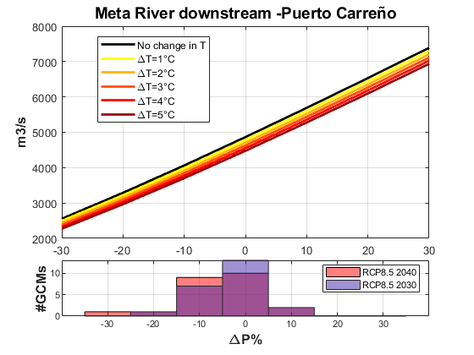

*Figure 41.* *Univariate climate response function for the Meta River outlet in Puerto Carreño in response to changes in temperature.*

The same results are shown in **Figure 42** but this time as a function of mean temperature change while each line indicates a separate change in mean precipitation. Note that here the GCMs distribution is highest for 1 degree warmer for 2030 and 2 degrees warmer for 2040.

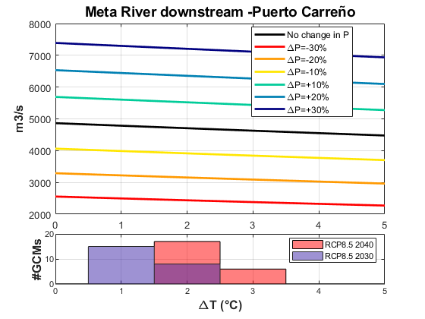

*Figure 42*. *Univariate climate response function for the Meta River flow in m3/s at the outlet in Puerto Carreño according to changes in precipitation.*

The results can also be shown as a function of joint changes in temperature and precipitation. This bi-variate response function is a way to more clearly identify the vulnerabilities caused by climate change, which of course, will affect precipitation and temperature simultaneously. An example of a bi-variate response function is illustrated for a representative performance metric in Figure 35. In this figure, mean annual flow and maximum deficit are plotted in a surface plot with a change in precipitation on the x-axis and a change in temperature on the y-axis. Given a performance metric threshold above which performance is acceptable and below which performance is unacceptable, the surface plot is often colored to identify the precipitation and temperature change combinations that result in future acceptable/unacceptable performance.

The univariate and bi-variate repones functions are useful visualization tools highlighting the climate and demand conditions for which the system is vulnerable. However, i) the likelihood of these conditions is unknown at this stage, and ii) how the change in system vulnerabilities and/or performance could manifest over time is not explicit either. To address these two points, one can map performance metrics against Global Circulation Model (GCM) temperature and precipitation projections. The mean value across a 30-year moving window is taken for each GCM projection.

For the present analysis, 33 GCM are considered, as shown in **Figure 43**, each with its precipitation and temperature change projections for the different C02 concentration pathways. We used these projections to fit a bivariate Gaussian probability distribution function that helps delineate the climate change area within the bivariate response function. This type of analysis allows one to focus the changes in precipitation and temperature within the plausible ranges according to the projections of the models.

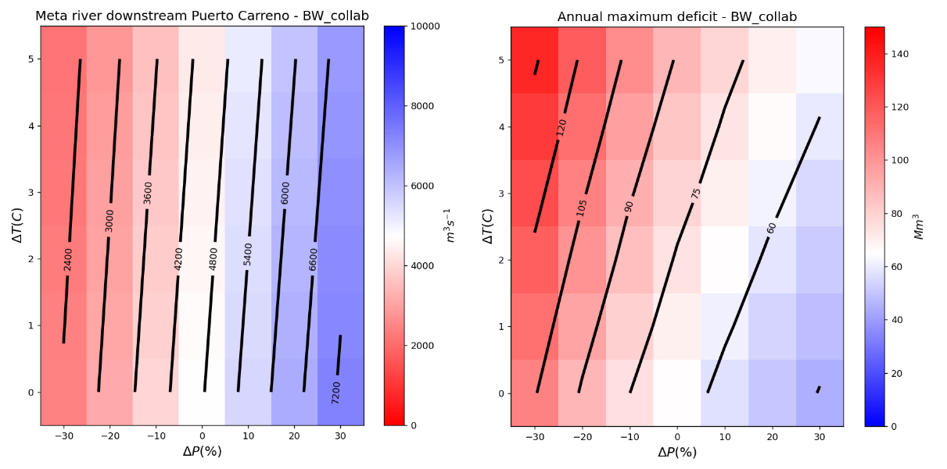

*Figure 43*. *Bivariate Climate Response Function for Meta River outflow (in Puerto Carreño) (m3/s). This matrix shows changes in the streamflow as a function of variations in precipitation and temperature. White color shows the current climate, Red is less water, blue is more water.*

After fitting the bivariate Gaussian probability distribution function, joint combinations of changes in precipitation and temperature are randomly sampled to obtain a 1,000 sample to build the non-exceedance probability curve. We run this type of analysis for different climate change scenarios or projection years.

For example, **Figure 44** shows the projection of a bivariate Gaussian probability distribution function on the climate response function for the flow at the outlet of the Meta River in Puerto Carreño.

Probability distribution functions are built for the RCP 8.5 scenario in 2030 and 2070. An average temperature rise of 1.0°C is expected for 2030 and 2.0°C for 2070, but with a wide range of variability. Precipitation will decrease by approximately 5% by 2030 and 8% by 2070. For both precipitation and temperature, a significant potential deviation reflects the different values adopted by multiple GCMS.

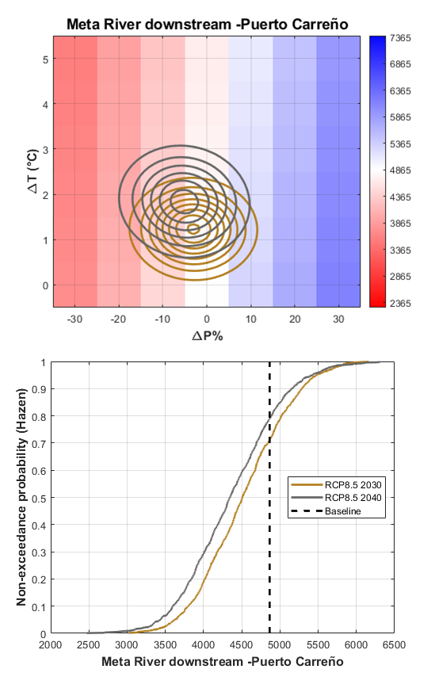

*Figure 44*. *Projection of a bivariate Gaussian probability distribution (Contours) on the climate response function for the Meta River Outlet. Contours in brown represent the climate projections 2030 and gray for 2040 under the RCP8.5 scenario. The center of each ellipse is the average change while each elliptical border represents 1, 2 ,3 … standard deviation from the average*

As time progresses, there will be a gradual change in the precipitation and temperature conditions until reaching the values expected by the GCMs for years of particular relevance or interest. In our case, the mean value across a 30-year moving window is taken for each GCM projection. The bivariate response function is used to interpolate the values of the metric of interest as time evolves. Since there are multiple GCMs, the average of the ensemble of the models for the desired scenario will be taken as the expected value, also building the confidence intervals with 95% reliability.

Finally, **Figure 45** presents an example of how results from step change scenarios can be mapped against GCM projections to show how system performance is likely to change over time. In this case, we present the temporal evolution of the mean flow in the meta river outlet in Puerto Carreño.

We used 32 GCM considering the RCP4.5 and RCP8.5 C02 pathways. Lines represent the ensemble mean of GCM projections, while the shaded areas show the 95% confidence interval for each path. Both paths suggest that the streamflow in the Meta River will be lower in the next few decades.

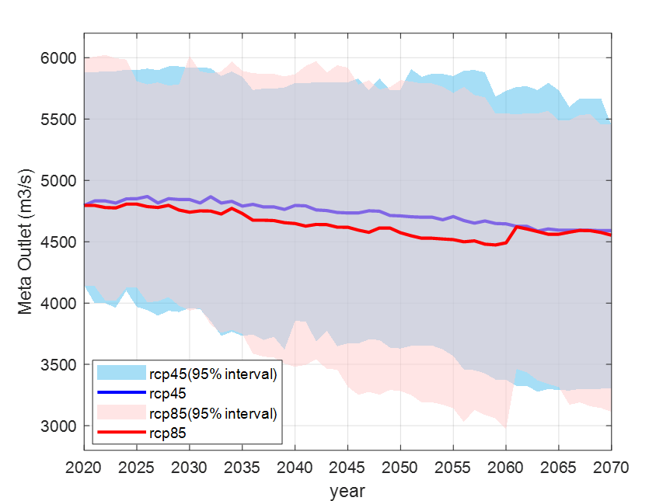

*Figure 45*. *Projection of the Meta River outflows under climate change considering RCP 4.5 (in blue) and 8.5 (red) trajectories. The thick lines correspond to the value obtained yearly from the assembly of 33 climate change models. The shaded areas correspond to the 95% confidence interval for each trajectory analyzed. All calculations were prepared for a 30-year moving average.*

The complete analysis of each of the previous graphs is known as vulnerability assessment analysis. It defines the response function of a given metric within the model to precipitation, temperature, and demand changes. Given that the model has hundreds of variables that can be analyzed, the next step will be defining performance metrics consistent with the key process in the system model.

## Results: Water Demand Scenarios

### Scenario I. Climate Change

As an example, **Figure 46** shows the deficit response function to precipitation and temperature changes. The deficit is more significant when precipitation decreases and temperature increases due to the greater water requirement for crops and the reduction of runoff in the basin.

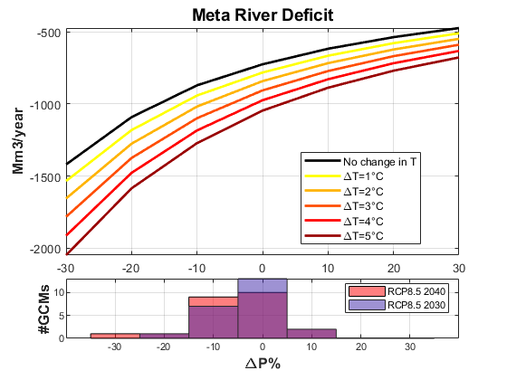

*Figure 46*. *Univariate Climate Response Function for Average annual Deficit (Mm3/year). This plot shows changes in the annual deficit as a function of variations in precipitation and temperature. black color shows no changes in temperature, Red is more temperature.*

Under current conditions (no changes in P and T), the average deficit is 724 Mm3/year; however, assuming a scenario P=-10% and T=2°C, the average deficit can increase to 1,017 Mm3/year, which represents an increase of approximately 40% due to climate change alone.

A similar analysis can be carried out on the average maximum deficit, whose value currently is 24,302 Mm3/year, and under climate change conditions, by 2040, it could reach 31,980 Mm3/year (a 33% increase **Figure 47**).

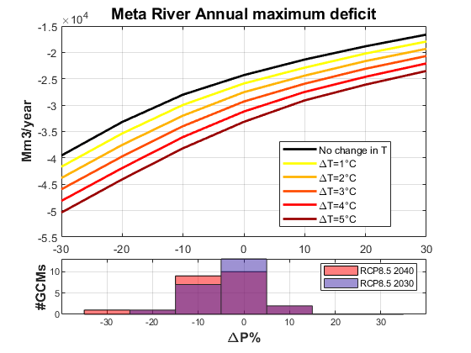

*Figure 47.* *Univariate Climate Response Function for Maximum annual Deficit (Mm3/year). This plot shows changes in the annual deficit as a function of variations in precipitation and temperature. black color shows no changes in temperature, Red is more temperature.*

The most significant average and maximum deficits are found in the Metica and Directos river basins between Humea and Upía (Dir_btw_Hu_Up). Both watersheds are characterized by having high oil palm production, and it is also assumed that all palm is irrigated. In most basins, there is always a deficit, which is aggravated by climate change conditions.

The most outstanding result is the maximum deficit, an order of magnitude greater than the average deficit. The Meta River basin may experience extreme conditions due to natural variability with severe consequences for the regional water system (**Figure 48**).

On the other hand, currently, several basins have flows below the environmental flow, with some recurrence. The basins of the Upía, Guavio, Garagoa, and Melua rivers have the highest recurrence. Climate change could aggravate the regional situation, and based on the relationship between demand and available supply, most basins are at high and very high levels of water use during the dry season.

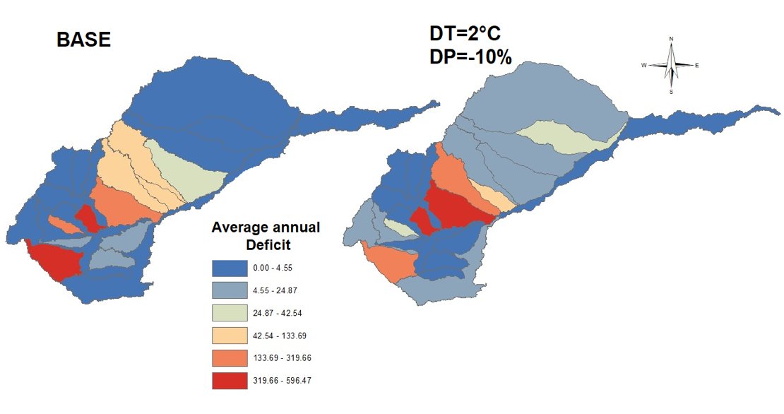

*Figure 48*. *Comparison of the deficit between the baseline and its value in 2040 considering only climate change. The color scale shows in blue the basins with lower deficits and in yellow and red scale those basins with high deficits. Climate change, in general, increases the average deficit in each of the hydrographic subzones.*

Based on the results from the Climate Stress test, in this scenario, the base condition is compared to a future where temperature increases by 20 and precipitation decreases by 10 %. The sub-catchment level performance results for 2040 under a base scenario and a DT=2°C and DP=-10% (CC) are also presented in detail in the collective results **Table 18** below.

### Scenario II. Unlimited Demand Expansion

The following scenario builds on the BASE and the CC and adds agricultural expansion which continues on the trajectory it has been on for the past two decades, as well as population growth, which together increase the demand in the system. In this case the model is attempting to replicate what will occur if we continue on in a “business-as-usual” situation but with the additional effect of climate change.

Table 18 below reports the performance metrics for each of the sub-basins under the differing scenarios for BASE, CC, and UDE+CC.

A key result is that while the CC scenario increases the deficits by approximately 40% the expansion of livestock, population and agriculture under the UDE doubles the deficits from the CC and triples the deficits of the current (BASE) conditions.

Table 18. Performance metrics for the Base, Climate Change (CC), and Unlimited Demand Expansion (UDE+CC) scenarios.

|  |  |  |  |  |  |  |  |  |  |  |  |  |
| --- | --- | --- | --- | --- | --- | --- | --- | --- | --- | --- | --- | --- |
| **Performance Metric** | **Annual average deficit** | | | **Annual maximum deficit** | | | **Frequency Q<Qenv** | | | **IUA February** | | |
| **(Mm3/year)** | | | **(Mm3/year)** | | | **(%)** | | | **(%)** | | |
| **Catchment \ Scenario** | **Base** | **CC** | ***UDE+CC*** | **Base** | **CC** | ***UDE+CC*** | **Base** | **CC** | ***UDE+CC*** | **Base** | **CC** | ***UDE+CC*** |
| Metica | 345 | 457 | 320 | 10,160 | 11,858 | 8,875 | 0% | 0% | 0% | 120% | 220% | 170% |
| Guayuriba | 0 | 2 | 15 | 119 | 208 | 806 | 0% | 0% | 0% | 50% | 60% | 80% |
| Negro | 1 | 3 | 1 | 370 | 507 | 232 | 0% | 0% | 0% | 40% | 50% | 30% |
| Guatiquia | 0 | 2 | 16 | 156 | 388 | 1,450 | 0% | 0% | 0% | 20% | 20% | 50% |
| Guacavia | 38 | 53 | 42 | 1,866 | 2,082 | 1,849 | 0% | 0% | 0% | 110% | 120% | 100% |
| Humea | 0 | 1 | 3 | 35 | 205 | 515 | 0% | 0% | 0% | 10% | 10% | 10% |
| Dir_btw_Hu_Up | 263 | 320 | 597 | 7,966 | 8,886 | 14,453 | 0% | 0% | 0% | 530% | 600% | 1,010% |
| Guavio | 0 | 0 | 0 | 0 | 0 | 0 | 0% | 0% | 0% | 30% | 30% | 60% |
| Garagoa | 0 | 0 | 0 | 0 | 0 | 54 | 0% | 0% | 10% | 50% | 60% | 130% |
| Lengupa | 0 | 0 | 0 | 0 | 0 | 0 | 0% | 0% | 0% | 0% | 0% | 0% |
| Dir_btw_GuDam_Up* | 0 | 0 | 0 | 0 | 0 | 54 | 0% | 0% | 10% | 50% | 60% | 130% |
| Lago de Tota | 0 | 0 | 0 | 0 | 0 | 0 | 0% | 0% | 0% | 0% | 0% | 0% |
| Upia | 0 | 0 | 0 | 0 | 0 | 0 | 10% | 10% | 20% | 110% | 150% | 370% |
| Dir_btw_Gb_Yu | 0 | 0 | 0 | 0 | 0 | 0 | 0% | 0% | 0% | 30% | 40% | 40% |
| Yucao | 1 | 4 | 5 | 358 | 556 | 766 | 0% | 0% | 0% | 40% | 50% | 50% |
| Manacacias | 0 | 0 | 12 | 0 | 0 | 1,082 | 0% | 0% | 10% | 30% | 40% | 100% |
| Cumaral | 0 | 0 | 0 | 14 | 19 | 14 | 0% | 0% | 0% | 20% | 10% | 10% |
| Melua | 1 | 1 | 1 | 96 | 111 | 86 | 0% | 0% | 0% | 80% | 140% | 110% |
| Tua | 35 | 84 | 500 | 2,892 | 4,045 | 14,202 | 0% | 0% | 0% | 60% | 90% | 200% |
| Cusiana | 9 | 31 | 248 | 1,167 | 2,025 | 7,034 | 0% | 0% | 0% | 60% | 80% | 180% |
| Dir_btw_Cu_CS | 10 | 20 | 134 | 962 | 1,154 | 3,819 | 0% | 0% | 0% | 100% | 130% | 330% |
| Cravo Sur | 16 | 28 | 52 | 1,371 | 1,851 | 3,574 | 0% | 0% | 0% | 140% | 130% | 150% |
| Guanapalo | 3 | 9 | 9 | 951 | 1,698 | 1,694 | 0% | 0% | 0% | 30% | 40% | 40% |
| Pauto | 0 | 1 | 25 | 0 | 281 | 2,722 | 0% | 0% | 0% | 10% | 10% | 10% |
| Dir_btw_P_Ca | 0 | 3 | 43 | 114 | 380 | 3,448 | 0% | 0% | 0% | 10% | 10% | 0% |
| Dir_btw_Cu_Ca | 0 | 0 | 0 | 0 | 0 | 0 | 0% | 0% | 0% | 10% | 10% | 60% |
| Casanare |  |  |  |  |  |  |  |  |  |  |  |  |
| **META RIVER** | **724** | **1,017** | **2,301** | **24,302** | **31,980** | **68,339** | **0%** | **0%** | **1%** | **31%** | **62%** | **158%** |

An extremely important result is the significant factor change in deficits when comparing annual average deficits to annual maximum deficits. Although many of the results are shown below as average, the maximum deficits should also be part of the planning process.

These deficits are widespread throughout the Basin but are extreme in the sub-basin that have concentration of both all components (population, livestock and agriculture). **Figure 49** shows the spatial distribution of deficits for the three scenarios.

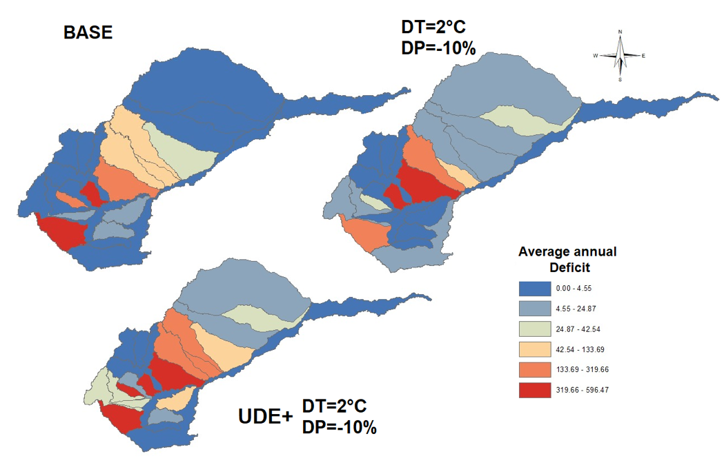

*Figure 49*. *Spatial comparison of the deficit between the baseline and its value in 2040 (BASE - top left); considering only climate change (CC - top right), and climate change with unlimited demand expansion (UDE+CC bottom center). Dark blue denotes less deficits and red the highest.*

These results demonstrate a clear impact of increasing water supply deficits under climate change, which is then exacerbated by the UDE scenario wherein the demand continues to increase following a similar pattern (trend) as the past two decades.

Basins suffering the most drastic deficits include Metica, Upia, Tua, and Cravo Sur. The linking catchments between the Humea and Upia (Dir_btw_Hu_Up) and between the Cusiana and Cravo Sur (Dir_btw_Cu_CS) also suffer significant deficits under both scenarios (CC and UDE+CC).

### Scenario III. Demand Sensitivity

The results below in **Table 19** show that the majority of sub-basins cannot withstand an unlimited expansion in agricultural demand. If land use is to be managed based on the ability of the water system to satisfy demand, there must be a careful control of expansion. The total area projected for rice in the UDE scenario is 4,236,000 ha from 1,313,000 today, while oil palm projected to increase to 3,601,000 from the current 2,163,000 ha. Once the DS scenario is applied, however, where crop area is limited to the point at which deficits annual deficits appear, the total areas are significantly reduced. For rice the available area, while adding nearly 1,000 ha from the BASE, is halved from the projected increase in the UDE. The allowable increase in oil palm in DS over the BASE is insignificant (60 ha), while the reduction from the UDE is almost 1,400 ha.

*Table 19. Projected agricultural areas (‘00 ha) for UDE and DS scenarios with percentage change.*

|  |  |  |  |  |  |  |  |  |
| --- | --- | --- | --- | --- | --- | --- | --- | --- |
| Scenario | BASE | | UDE | | DS | | Percent change (UDE to DS) | |
| Catchment \ Product | **Rice** | **Oil Palm** | **Rice** | **Oil Palm** | **Rice** | **Oil Palm** | **Rice** | **Oil Palm** |
| Metica | 59 | 798 | 26 | 596 | 29 | 298 | 13% | -50% |
| Guayuriba | 11 | 68 | 0 | 83 | 15 | 95 |  | 15% |
| Negro | 57 | 28 | 0 | 15 | 79 | 39 |  | 158% |
| Guatiquia | 19 | 16 | 9 | 58 | 35 | 28 | 287% | -51% |
| Guacavia | 12 | 110 | 22 | 94 | 19 | 175 | -12% | 86% |
| Humea | 54 | 40 | 0 | 66 | 96 | 72 |  | 8% |
| Dir_btw_Hu_Up | 60 | 258 | 0 | 434 | 30 | 129 |  | -70% |
| Guavio | 0 | 0 | 0 | 11 | 0 | 0 |  | -100% |
| Garagoa | 0 | 0 | 0 | 0 | 0 | 0 |  |  |
| Lengupa | 0 | 0 | 0 | 0 | 0 | 0 |  |  |
| Dir_btw_GuDam_Up* | 0 | 0 | 2 | 31 | 0 | 0 | -100% | -100% |
| Lago de Tota | 0 | 0 | 0 | 0 | 0 | 0 |  |  |
| Upia | 48 | 72 | 20 | 178 | 105 | 159 | 427% | -11% |
| Dir_btw_Gb_Yu | 6 | 23 | 37 | 27 | 18 | 63 | -52% | 134% |
| Yucao | 9 | 28 | 47 | 30 | 15 | 45 | -68% | 51% |
| Manacacias | 1 | 77 | 45 | 231 | 1 | 169 | -97% | -27% |
| Cumaral | 0 | 0 | 0 | 41 | 0 | 0 |  | -100% |
| Melua | 0 | 0 | 33 | 26 | 0 | 0 | -100% | -100% |
| Tua | 52 | 280 | 382 | 666 | 72 | 393 | -81% | -41% |
| Cusiana | 116 | 177 | 377 | 409 | 116 | 177 | -69% | -57% |
| Dir_btw_Cu_CS | 12 | 61 | 134 | 157 | 26 | 135 | -81% | -14% |
| Cravo Sur | 153 | 56 | 478 | 70 | 275 | 100 | -43% | 44% |
| Guanapalo | 233 | 72 | 739 | 306 | 420 | 130 | -43% | -57% |
| Pauto | 263 | 0 | 961 | 3 | 473 | 0 | -51% | -100% |
| Dir_btw_P_Ca | 105 | 0 | 403 | 0 | 188 | 0 | -53% | -100% |
| Dir_btw_Cu_Ca | 0 | 9 | 13 | 69 | 0 | 25 | -100% | -64% |
| Casanare | 44 | 0 | 508 | 0 | 106 | 0 | -79% | -100% |
| META RIVER | **1,313** | **2,173** | **4,236** | **3,601** | **2,120** | **2,234** |  |  |

These overall changes, however, mask a relocation of and variable reduction in production area by catchment. For rice, percentage variation in production area from UDE to DS ranges from a decline of 100 percent to an increase of 427 percent (note that percentage change is always affected by the starting area). Of the 18 catchments that undergo area change only three increase area, while 15 suffer decreases from the UDE scenario.

In oil palm, 22 of the 27 catchments change area, with six gaining area and 21 losing production area. The range of area change in this case is from minus 100 percent to positive 158 percent.

This result clearly shows that managing land expansion based on water supply and demand requires the limiting of production area, but even more complicated the potential need for relocation of production, which comes at a significant cost. The measurement of ‘winners’ and ‘losers’ (those catchments that gain or lose production area) is not spatially homogenous, although there is an overall decline, because each catchment system is unique.

Furthermore, this study does not take into account the economic costs of relocation that will constrain the change. Importantly, the areas considered to be of medium or high land use suitability for both oil palm and rice are sufficient in the Basin (there is enough land to support expansion and relocation) to reduce the spatial restrictions. However, that does not account for infrastructure and market variables in the calculations of profitability and thus likelihood of area change. Add to this the perennial nature of oil palm production and the costs of adjustments soon become significant.

Therefore, it is important that appropriate water saving technology be examined and incorporated into development policies rather than, or perhaps in addition to, expecting a movement of crop area between catchments. To that end we use the next scenario, call the Speculative Future, to demonstrate that a collective set of systemic changes are able to reduce water deficits in the system.

### Scenario IV. Selected Future

The Selected Future (SF) scenario reduces the annual average deficit from 2,300 Mm3/year for the UDE+CC scenario 277 Mm3/year, which is also 1/3 of the current BASE scenario (**Table 20**).

This is possibly due to the change of water demand in rice. The area of rice production in the SF scenario reaches almost 6,000 ha, which would compensate for some of the production loss in a transfer to all dryland vs a mix of dryland and irrigated. However, this scenario does not see an increase in oil palm production area over the simulated timeline.

In addition, the restrictions on land use suitability may contribute to the lack of increased production area in oil palm as much of the expansion in previous scenarios takes place in regions that are now more restricted (e.g., Metica, Tua, and Upia).

Table 20. Annual average deficits at the hydrographic subzone and Basin levels for the four scenarios.

|  |  |  |  |  |
| --- | --- | --- | --- | --- |
| Performance Metric | Annual average deficit (Mm3/year) | | | |
| Catchment / response unit | Base | CC | *UDE+CC* | ***SF*** |
| Metica | 344.92 | 457.03 | 319.66 | **132.12** |
| Guayuriba | 0.44 | 1.59 | 15.13 | **0.22** |
| Negro | 1.09 | 2.48 | 0.67 | **0.67** |
| Guatiquia | 0.31 | 1.58 | 15.64 | **0.00** |
| Guacavia | 38.42 | 52.75 | 41.82 | **12.16** |
| Humea | 0.09 | 0.78 | 2.71 | **0.00** |
| Dir_btw_Hu_Up | 263.04 | 319.88 | 596.47 | **121.31** |
| Guavio | 0.00 | 0.00 | 0.00 | **0.00** |
| Garagoa | 0.00 | 0.00 | 0.27 | **0.00** |
| Lengupa | 0.00 | 0.00 | 0.00 | **0.00** |
| Dir_btw_GuDam_Up* | 0.00 | 0.00 | 0.27 | **0.00** |
| Lago de Tota | 0.00 | 0.00 | 0.00 | **0.00** |
| Upia | 0.00 | 0.00 | 0.00 | **0.00** |
| Dir_btw_Gb_Yu | 0.00 | 0.00 | 0.00 | **0.00** |
| Yucao | 1.34 | 3.64 | 4.55 | **0.72** |
| Manacacias | 0.00 | 0.00 | 11.86 | **0.00** |
| Cumaral | 0.12 | 0.16 | 0.11 | **0.00** |
| Melua | 0.79 | 1.11 | 0.84 | **0.00** |
| Tua | 35.17 | 83.95 | 499.93 | **6.31** |
| Cusiana | 8.99 | 31.39 | 248.26 | **0.00** |
| Dir_btw_Cu_CS | 10.24 | 19.47 | 133.69 | **2.31** |
| Cravo Sur | 15.52 | 28.29 | 51.90 | **1.17** |
| Guanapalo | 3.24 | 8.77 | 8.73 | **0.75** |
| Pauto | 0.00 | 1.10 | 24.87 | **0.00** |
| Dir_btw_P_Ca | 0.41 | 2.75 | 42.53 | **0.00** |
| Dir_btw_Cu_Ca | 0.00 | 0.00 | 0.00 | **0.00** |
| META RIVER | **724.00** | **1,017.30** | **2,301.08** | **277.72** |

Preliminary conclusions from these results suggest that water supply deficits will increase under climate change alone from a base scenario, but be exacerbated if agricultural expansion and thus water demand continues to increase in a similar trend as for the past two decades.

Furthermore, it is possible to constrain deficits through a combination of land use planning and other investment and policy tools. It is unavoidable that careful planning and directed expansion are needed to mitigate the effect of agricultural growth. **Figure 50** below shows the spatial impacts of the four scenarios, including the SF effect and demonstrating the potential management of water deficits.

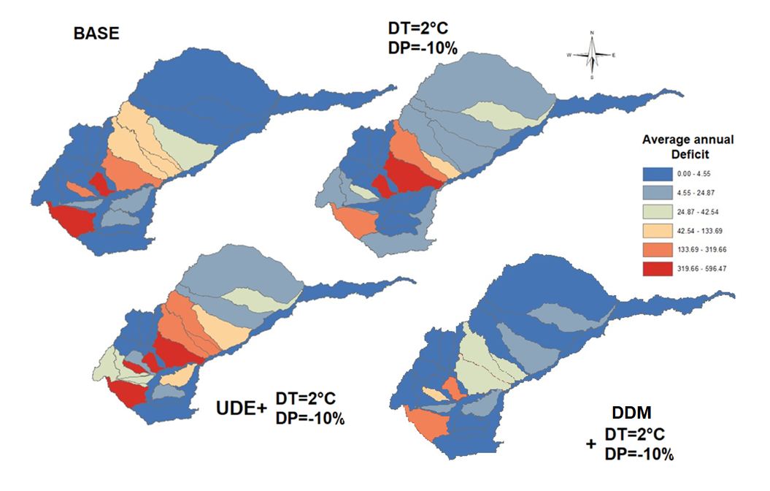

*Figure 50*. *Spatial representation of the average annual deficits for the four scenarios.*

# Conclusions

Current water system designs and design processes are ill-suited to address deep uncertainties related to climate variability and change.  Water systems are increasingly exhibiting fragility to extreme weather events and changing climate conditions.  Feedback loops between land use, land use change and water systems are also becoming increasingly important, exacerbating water stress and amplifying the impacts of climate change. As change intensifies and uncertainties increase, the overarching goal in water system management must shift to designing and managing for resilience – the ability of the water system to maintain its function and characteristic services under stress and disruption.

Incorporating resilience into water-related investments strengthens the robustness of the water system and water-dependent systems (e.g. agriculture) to forecast events and residual risks, while enabling adaptation to incremental change and recovery from increasingly extreme events. Building resilience reduces the risks of system failure over time, thereby reducing the likelihood of disruptions to economies and of needless losses of lives and livelihoods. Moreover, along with investment in risk reduction measures, resilient designs can minimize the costs of recovery when extreme events occur.

The Resilient Basins by Design project responds to growing global demand and urgency for approaches to diagnose, design and manage water systems for resilience. Water is a central development challenge, as a growing population and economy is overwhelming stressed river and groundwater basins and increasing exposure to and costs of water disasters.

Exacerbating current challenges and water stresses, the effects of climate change will most immediately and acutely be expressed through water, including changes in precipitation and extreme events that will surpass current water system capabilities. Vital to future water security and to the security of all water-dependent sectors, is our ability to understand and manage for water resilience at basin scale, including the water system and interdependent farms, industries, cities and economies.

The objective of this consultancy is to improve the knowledge available to understand, design and encourage the adoption of climate smart agricultural practices. The work focuses on using water as a master variable to evaluate possible future scenarios for the Orinoquía region as the demand for agricultural production increases.

The results chart a path forward based on quantitative modeling, as well as demonstrating the effects of climate change and expansion of agriculture and livestock production on the water system. The results are based on quantitative modeling but the overall project required a significant effort in stakeholder engagement, covering more than 40 workshops and a formal survey of opinions.

The key results from this research include:

* Stakeholders anticipate significant changes are imminent in the region and there is a resigned expectation that the impacts will mostly be negative for the environment.
* There is an appetite for engagement and information on the part of stakeholders based on the concern for the future of the region.
* Regardless of any policy or project activity the exogenous effects of climate change will add stress to the regional water system and create deficits.
* Continued growth in livestock production and, more importantly, rice and oil palm, based on historical trends – i.e. growth patterns continue as they have for the past 20 years – will induce stress and the water system in selected basins will experience significant deficits by 2040.
* A combination of policy, enforcement and careful management of irrigation can be used to reduce water deficits created by climate change and the expansion of agriculture and livestock production.

This document shows the results of a complex water system model created to evaluate the impacts of change on the system. It bears mentioning that this model is only the beginning and the results shown herein are a demonstration of the system rather than the final results.

Furthermore, the project has demonstrated the deep interest and engagement on the part of stakeholders throughout the region – e.g., even though Vichada was less represented spatially their commitment and interest was equally as strong – and so the connection between modelling teams and local researchers, government and the private sector should be strengthened so that relevant questions can be asked and answered in the coming years.

# References

Alley, W. 1985. Water balance models in one-month-ahead streamflow forecasting. *Water Resources Research*, 21(4):597–606.

Alley, W. 1984. On the treatment of evapotranspiration, soil moisture accounting, and aquifer recharge in monthly water balance models. *Water Resources Research*, 20 (8):1137–1149.

Allen R., L. Pereira, D. Raes, M. Smith. 1998. *Crop evapotranspiration. Guidelines for computing crop water requirements*. FAO irrigation and drainage paper 56, FAO, Rome.

Arias-Castellanos, J. 2015. Hidropolítica y Gobernanza como Estrategias para la Construcción de un Modelo de Desarrollo Diferente de los Llanos. In Caro-Caro et al (eds). *Visión de Visiones del Desarrollo Sostenible de los Llanos Orientales. Las Voces de los Territorios*. Convenio de Cooperación Ecopetrol-Unillanos N° 5211714 AC 02. Instituto de Ciencias Ambientales de la OrinoquíaColombiana. Unillanos. Villavicencio. Pgs 144-152.

Arias-Vanegas, J. 2004. *Ganadería, paisajes, territorio y región. Una historia ecológica y social de la Orinoquíacolombiana*. Instituto de Investigación de Recursos Biológicos Alexander von Humboldt. Bogotá, Colombia. 139 pgs.

Arrieta-Castro, M., A. Donado-Rodríguez, G. Acuña, F. Canales, R. Teegavarapu and B. Kaźmierczak. 2020. Analysis of streamflow variability and trends in the meta river, Colombia. *Water* 12(1451).

Becerra, R., E Herrera, G. Andrade Pérez, E. Uribe, G. Rudas, A Durán, and L. Castro. 2009. *La Mejor Orinoquíaque Podemos Construir: Elementos para la Sostenibilidad Ambiental del Desarollo*. Corporinoquia. 144 pgs. <https://repositorio.uniandes.edu.co/handle/1992/46593>

Becerra, I., L. Castro, C. Cortes, C. Del Valle, A. Díaz, A. Flórez, M. Fonseca, …and. J. Viveros. 2020. *Plan de ordenamiento productivo del arroz en Colombia 2020-2038*. Bogotá: UPRA. 424 pgs.

Bojorquez-Tapia, l., E. Hallie, B. Hernandez-Aguilar, and R, Shelton. 2020. Addressing complex, political and intransient sustainability challenges of transdisciplinarity: The case of the MEGADAPT project in Mexico City. *Environmental Development* 38 (2021) 100604.

Bravo Parra, A.M. (2021) *Cadenas sostenibles ante un clima cambiante. La ganadería en Colombia*. Bonn (Germany): Deutsche Gesellschaft für Internationale Zusammenarbeit (GIZ). 142 p. ISBN: 978-958-8945-52-1

Bridhikitti, A., Ketuthong, A. P., Li, R., Li, J., & Liu, G. (2023). How do sustainable development-induced land use change and climate change affect water balance? A case study of the Mun River Basin, NE Thailand. *Water Resources Management*, 37(6-7), 2737-2756.

Bustamante, C. and L. Rojas-Salazar. 2018. Reflexiones sobre transiciones ganaderas bovinas en Colombia, desafíos y oportunidades. *Biodiversidad en la Practica*. 3(1):1-29. Instituto Von Humbolt.

Bustamante, C., F. Osorio, L. Rojas and X. Cáceres. 2013. *Plan Estrategico Macrocuenca del Rio Orinoco Fase I Y II*. Instituto De Investigacion De Recursos Biológicos Alexander Von Humboldt. 321 pgs.

Baur, F. 1951. *Extended-range weather forecasting*. In Compendium of Meteorology. Eds. XXXX pgs. 814–833. Springer Publishing.

Beven, K. and A. Binley. 1992. The Future of Distributed Models: Model Calibration and Uncertainty Prediction. *Hydrol. Process*. 6(3):279–298. doi:10.1002/hyp.3360060305

Broom, D., F. Galindo, E. Murgueitio. 2013. Sustainable, efficient livestock production with high biodiversity and good welfare for animals. *Proc. R. Soc. B Biol. Sci.* 280, 20132025.

Brown, C., F. Boltz, S. Freeman, J. Tront, and D. Rodriguez. 2020. Resilience by design: A deep uncertainty approach for water systems in a changing world. *Water Secur*. 9, 100051. <https://doi.org/10.1016/j.wasec.2019.100051>

Brown, C., Y. Ghile, M. Laverty, and K. Li. 2012. Decision scaling: Linking bottom-up vulnerability analysis with climate projections in the water sector. *Water Resour.* *Res.* 48. <https://doi.org/10.1029/2011WR011212>

Caro-Caro, C., G. Benavides-Ladino, M. Torres-Mora, and S. Parada-Guevara, 2015. *Visión de Visiones del Desarrollo Sostenible de los Llanos Orientales. Las Voces de los Territorios*. Convenio de Cooperación Ecopetrol - Unillanos N° 5211714 AC 02. Instituto de Ciencias Ambientales de la OrinoquíaColombiana. Unillanos. Villavicencio. 252 pgs.

Carvajal L. and E. Roldan, 2007. Calibracion del modelo lluvia-escorrentia agregado gr2m aplicacion: cuencadel rıo aburra. *Dyna*, 74(152): 73–87.

Chapra, S., G. Pelletier, and H. Tao. 2003. QUAL2K. *A modeling framework for simulating river and stream water quality: docQUumentation and user’s manual*. Civil and Environmental Engineering Department, Medford, Tufts University.

CONPES. 2015. *Política para el Desarrollo Integral de la Orinoquia: Altillanura – Fase I*. Consejo Nacional de Política Económica y Social República de Colombia. Departamento Nacional de Planeación. 83 pgs.

CORPES Orinoquia. 1997. *La OrinoquíaColombiana: Vision Monografica segunda edicion.* Consejo Regional de Planificación Económica y Social, Corpes Orinoquia. 137 pgs.

Cormacarena. 2019. Plan De Gestión Ambiental Regional PGAR 2020 – 2031. 145 pgs.

Corporinoquia. 2013. *Plano de Gestion Regional Ambiental (PGAR): 2013- 2025*. Corporinoquia. 319 pgs.

DNP. 2011. *Visión de Desarrollo Territorial Departamental. Visión Arauca 2032: Geoestratégica, innovadora y nuestra*. Departmento Nacional de Planeacion. Imprenta Nacional de Colombia. 214 pgs.

DNP. 2011. *Visión de Desarrollo Territorial Departamental Meta Visión 2032: territorio integrado e innovador*. Departmento Nacional de Planeacion. Imprenta Nacional de Colombia. 175 pgs.

DNP 2021. *Modelo de Ordenamiento Territorial Regional para la Orinoquía (MOTRO)*. USAID. 145 pgs.

DNP. 2022. *Colombia Potencial Mundial de la Vida: Bases de Plan Nacional de Desarollo 2022-2026*. Departamento Nacional de Planeación. Imprenta Nacional de Colombia. 238 pgs.

ECOTON. 2020. *Toxic river: The fight to reclaim water from oil palm plantations in Indonesia*. Report. 7pgs.

FAO. 2013. *Coping with water scarcity. A framework for action for agriculture and food security.* Food and Agriculture Organization of the United Nations. Rome.

FAO. 2022. *Integrated Water Resources Management for Security*. Food and Agriculture Organization of the United Nations. Rome. Retrieved from https://www.fao.org/3/nk446es/nk446es.pdf

Florian-Vergara, C., Salas, H. D., & Builes-Jaramillo, A. (2021). Análisis de la precipitación y la evaporación en el Orinoco colombiano según los modelos climáticos regionales del experimento CORDEX-CORE. TecnoLógicas, 24(52), 242-261.

François, B., A. Bruce, K. Nguyen, D. Park, D. Rheinheimer, U. Taner, S. Wi, H. Khan, A. Dufour, D. Behar, D. Yates, C. Ammann, M. Haasnoot, and C. Brown. 2021. *Long Term Vulnerability Assessment and Adaptation Plan for the San Francisco Public Utilities Commission Water Enterprise – Phase I*. The Water Research Foundation, University of Massachusetts, Amherst, Massachusetts. The Water Research Foundation, 287pp. Available online at <https://www.waterrf.org/resource/long-term-vulnerability-assessment-and-adaptation-plan-san-francisco-public-utilities-0>.

FEDEGAN. 2018. *Ganadería colombiana: Hoja de ruta 2018-2022*. Bogotá, D.C., Colombia: Federación Colombiana de Ganaderos (FEDEGAN). <http://static.fedegan.org.co.s3.amazonaws.com/publicaciones/Hoja_de_ruta_Fedegan.pdf>

Freeman, S., C. Brown, H. Cañada, V. Martinezb, A. Navag, P. Rayc, D. Rodriguez, A. Romoe, J. Tracyc, E. Vázquezd, S. Wia, and F. Boltz. 2020. Resilience by Design in Mexico City: A participatory human-hydrologic systems approach. *Water Security* 9. 100053.

Gassón (2002)). XX

Gleick, P. and C. Iceland. 2018. *Water, Security and Conflict*. World Resources Institute and Pacific Institute. <https://pacinst.org/wp-content/uploads/2018/08/Water-Security-and-Conflict.pdf>

Guo, S., J. Wang, L. Xiong, A. Ying, and D. Li, “A macro-scale and semi-distributed monthly water balance model to predict climate change impacts in China,” Journal of hydrology, vol. 268, no. 1-4, pp. 1–15, 2002.

Hughes, J. and P Guttorp. 1994. A class of stochastic models for relating synoptic atmospheric patterns to regional hydrologic phenomena. *Water Resources Research*, 30(5):1535–1546.

Herrera Velasquez, J. 2015. *Generacion y calibracion de caudales medios mensuales mediante el modelo gr2m, en la cuenca del rio coata*. XX

Hughes, J. and P Guttorp. 1994. A class of stochastic models for relating synoptic atmospheric patterns to regional hydrologic phenomena. *Water Resources Research*, 30(5):1535–1546.

Herrera Velasquez, J. 2015. *Generacion y calibracion de caudales medios mensuales mediante el modelo GR2M, en la cuenca del rio coata*. XX

Hughes, J. and P Guttorp. 1994. A class of stochastic models for relating synoptic atmospheric patterns to regional hydrologic phenomena. *Water Resources Research*, 30(5):1535–1546.

Hurtado-Montoya A. and O. Mesa-Sanchez. 2014. Reanalysis of monthly precipitation fields in Colombian territory. *Dyna*, 81(186):251–258.

IDEAM. 2013. *Zonificación y codificación de uniades hidrográficas e hidrogeológicas de Colombia*. Bogotá, D. C., Colombia. Publicación aprobada por el Comité de Comunicaciones y Publicaciones del IDEAM.

IDEAM. 2022. *Estudio Nacional del Agua 2022*. Instituto de Hidrología, Meteorología y Estudios Ambientales. Bogota. 464 pgs.

Jazim, A. 2006. A monthly six-parameter water balance model and its application at arid and semiarid low yielding catchments. *Journal of King Saud University-Engineering Sciences*, 19(1):65–81.

Kling H. and H. Nachtnebel. 2009. A method for the regional estimation of runoff separation parameters for hydrological modelling. *Journal of Hydrology*, 364(1-2):163–174.

Kirshner, S. (2007) XX

Lobell, D., Deines, J., & Tommaso, S. (2020). Changes in the drought sensitivity of US maize yields . *Nature Food,* 1(11), 729-735.

Mouelhi, S., C. Michel, C. Perrin, and V. Andreassian, “Stepwise development of a two-parameter monthly water balance model,” Journal of Hydrology, vol. 318, no. 1-4, pp. 200–214, 2006.

Martinez G. and H. Gupta. 2010. Toward improved identification of hydrological models: A diagnostic evaluation of the “abcd” monthly water balance model for the conterminous united states. *Water Resources Research*, 46(8): XX

MADR. 2021. *Plan integral de gestión del cambio climático del sector agropecuario*. [Eds.] Grupo de Sostenibilidad y Cambio Climático: Cárdenas Avila, Isabel; Lozano Castro, Nelson Enrique; Márquez Torres, Martha Liliana; Martin, Adriana. Bogotá, D. C., Colombia. Ministerio de Agricultura y Desarrollo Rural.

MADS. 2014. *Guía Técnica para la Formulación de los Planes de Ordenación y Manejo de Cuencas Hidrográficas*. Ministerio De Ambiente y Desarrollo Sostenible Bogotá, D.C.: Colombia.

MADS. 2017. *Guía Metodológica para el Diseño y la Implementación de Procesos de Prevención y Transformación de Conflictos por el Agua: Conceptos y herramientas de diálogo y negociación*. Ministerio De Ambiente y Desarrollo Sostenible. Dirección de Gestión Integral de Recurso Hídrico. Bogota. Colombia. 93pgs.

MADS. 2018. Resolution 2035 of 2018. Ministerio De Ambiente y Desarrollo Sostenible.<https://archivo.minambiente.gov.co/images/normativa/app/resoluciones/e8-res%202035%20de%202018.pdf>

MADS. 2023. Ministerio De Ambiente y Desarrollo Sostenible. <https://www.minambiente.gov.co/gestion-integral-del-recurso-hidrico/caracterizacion-y-manejo-de-conflictos/>

MAVDT. 2010. *Política Nacional para la Gestión Integral del Recurso Hídrico*. Ministerio de Ambiente, Vivienda y Desarrollo Territorial. <https://www.minambiente.gov.co/wp-content/uploads/2021/11/Politica-Nacional-para-la-Gestion-Integral-del-Recurso-Hidrico.pdf>. 124 pgs.

Mejia, J. 2000. Consumo de agua por la palma de aceite y efectos del riego sobre la producción de racimos; una revisión de literatura. *PALMAS*, 21(1):51-58.

Molina-Benavides, R., C. Bustamante, A. Martínez, J. Uribe and J. Redondo. 2020. Caracterización espacial de la ganadería bovina en la Orinoquíacolombiana. *Revista MVZ Córdoba*. 25(3). <https://doi.org/10.21897/rmvz.1720>

Morales-Lizarazo, D. and P. Ungar-Ronderos. 2022. Conflictos ambientales en Colombia: reflexiones sobre sus cambios positivos a partir de una revisión de literatura. *Colombia Forestal,* 25(2):85-103.

Mouelhi, S., Michel, C., Perrin, C., & Andréassian, V. (2006). Stepwise development of a two-parameter monthly water balance model. Journal of Hydrology, 318(1-4), 200-214.

Michelangeli, P., R. Vautard, and B. Legras. 1995. Weather Regimes: recurrence and quasi stationarity. *Journal of the Atmospheric Sciences*, 52(8):1237–1256.

Nandan, R., Woo, D. K., Kumar, P., & Adinarayana, J. (2021). Impact of irrigation scheduling methods on corn yield under climate change. Agricultural Water Management, 255, 106990.

Omondi, P. A., Awange, J. L., Forootan, E., Ogallo, L. A., Barakiza, R., Girmaw, G. B., & Komutunga, E. (2014). Changes in temperature and precipitation extremes over the Greater Horn of Africa region from 1961 to 2010. International Journal of Climatology, 1262-1277.

Palacio, G, González, J, Yepes, F, Carrizosa, J, Palacio, L, Montoya, C y Márquez, G. 2001. *Naturaleza en disputa. Ensayos de historia ambiental en Colombia 1850-1995*. Universidad Nacional de Colombia.

Perfetti, J., A, Hernández, J. Leibovich, J., & A. Balcázar. 2013. *Políticas para el desarrollo de la agricultura en Colombia*. SAC y Fedesarrollo | Bogotá, D.C. 247 pgs.

Pimentel J, C. Rogéliz Prada and T. Walschburger. 2021. Hydrological Modeling for Multifunctional Landscape Planning in the Orinoquía Region of Colombia. *Front. Environ. Sci*. 9:673215. doi: 10.3389/fenvs.2021.673215

Puertas-Orozco, O., Y. Carvajal-Escobar and M. Quintero-Angel. 2011. Estudio de tendencias de la precipitación mensual en la cuenca alta-media del río Cauca, Colombia. *Dyna*, 78:112–120.

Rabiner, L. 1989. *A tutorial on hidden Markov models and selected applications in speech recognition*. Proceedings of the IEEE, 77(2), 257–286.

Rabiner, L., & B. Juang. 1986. An introduction to hidden Markov models. *Lee Ass. Magazine*, 3(1):4–16.

Ray, P., C. Brown. 2015. *Confronting climate uncertainty in water resources planning and project design: the decision tree framework*. World Bank Group, Washington, DC.

Rincon, L. 2019. Aplicacion de los modelos lluvia-escorrenta GR2M y GR4J en la cuenca del r ıo gualı para la gestion de los recursos hídricos. Source

Rudas, G. 2011. *La Mejor Orinoquíaque Podemos Construir. Segundo Foro: Arauca síntesis de conclusiones y recomendaciones*. [www.foronacionalambiental.org.co](http://www.foronacionalambiental.org.co). 12 pgs.

Robbins, P., 2004. *Political ecology: A critical introduction*. John Wiley & Sons.

Robinson, S.-a. (2020). Climate change adaptation in SIDS: A systematic review of the literature pre and post the IPCC Fifth Assessment Report. Wiley Interdisciplinary Reviews: Climate Change, 11(4), e653.

Rodriguez, J. D. (2020). The Extractive Industries and Society. Oil revenues, public procurement and armed conflict: A case study of a, 686-703.

Rodríguez, I., Inturias, M., Frank, V, Robledo, J., Sarti, C., Borel, R., & Melace, A. (2015). Abordando la Justicia Ambiental desde la transformación de conflictos: experiencias con Pueblos Indígenas en América Latina. *Revista de Paz y Conflictos*. 8(2):97-128.

Rozo, C. 2014. *Scenarios of the future expansion of Oil Palm in Colombia: impacts generated by the biofuels sector*. Ph D. Thesis Environmental and Rural Studies, Pontificia Universidad Javeriana, Bogota, Colombia. 234 pgs.

Safitri, L. H. Hermantoro, S. Purboseno, V. Kautsar, S. Saptomo and A. Kurniawan. 2019. Water footprint and crop water usage of Oil Palm (*Eleasis guineensis*) in Central Kalimantan: environmental sustainability indicators for different crop age and soil conditions. *Water*. 11(35) doi:10.3390/w11010035

Steduto, P., Hsiao, T., Raes, D., Fereres. 2009. AquaCrop - The FAO Crop Model to Simulate Yield Response to Water: *I. Concepts and Underlying* *Principles. Agron*. XX

Sposito, G. 2017. Understanding the Budyko Equation. *Water* 9(236). doi:10.3390/w9040236

Taborda, E. 2009. *Reconstruccion historica de los caudales mensuales a lo largo de la red de drenaje de Colombia*. Escuela de Geociencias y Medio Ambiente, 2009.

Tellman, B., J. Bausch, H. Eakin, J. Anderies, M. Mazari-Hiriart, D. Manuel-Navarrete, and C. Redman. 2018. Adaptive pathways and coupled infrastructure: seven centuries of adaptation to water risk and the production of vulnerability in Mexico City. *Ecology and Society* 23(1):1. https://doi.org/10.5751/ES-09712-230101

Thomas Jr, H. 1981. *Improved methods for national water assessment water resources*.

Thornthwaite C. and J. Mather. 1957. *Instructions and tables for computing potential evapotranspiration and the water balance*. Centerton, Tech. Rep. XX

Temez, J. 1977. *Modelo matemático de transformación precipitación – aportación*. Comisión E. Explotación y Garantía. Grupo de Trabajo de Predicciones de Precipitación y Relación entre Precipitaciones y Caudales, Madrid.

Tomlinson, J., J. Arnott, J. Harou. 2020. A water resource simulator in Python. *Environ. Model. Softw.* 126,104635. <https://doi.org/10.1016/j.envsoft.2020.104635>

Torres, G., G. Sarria, F. Varon, M. Coffey, M. Elliott, and G. Martinez. 2010. First Report of Bud Rot Caused by Phytophthora palmivora on African Oil Palm in Colombia. *Plant Dis*. 94(9):1163. <https://doi.org/10.1094/PDIS-94-9-1163A>

Torres, G., G. Sarria, G. Martinez, F. Varon, A. Drenth, and D. Guest. 2015. Bud rot caused by Phytophthora palmivora: A destructive emerging disease of oil palm. *Phytopathology* 106:320-329. DOI:10.1094/PHYTO-09-15-0243-RVW

UNESCO World Water Assessment Programme. 2020. *The United Nations World Water Development Report 3. Water In A Changing World: Facts and Figures*. 16 pgs.

UPRA, 2014. *Metodología de evaluación de tierras 1: 25.000*. Bogotá (Colombia).

UPRA. 2019. *Gestión de información agropecuaria y planificación del desarrollo agropecuario Córdoba*. Córdoba (Colombia).

Vargas-Serna, J., S. Valencia, and J. Villegas. 2022. *Análisis del uso de la tierra en las sabanas de los Llanos Orientales de Colombia, la región de la Orinoquía, desde 1999 hasta 2022.* [Trabajo de grado profesional]. Universidad de Antioquia, Medellín, Colombia. 36 pgs.

Vargas-Pineda, O., J. Trujillo-Gonzalez and M. Torres-Mora. 2020. Supply–demand of water resource of a basin with high anthropic pressure: case study quenane-Quenanito basin in Colombia. *Air, Soil and Water Research*, vol. 13, p. 1178622120917725, 2020.

Van Ausdal, S. 2008. *Un mosaico cambiante: notas sobre una geografía histórica de la ganadería en Colombia, 1850-1950*. in: A. Flórez-Malagón (ed.). Pontificia Universidad Javeriana. Bogotá, Colombia.

Van der Beken A. and J. Byloos. 1977. A monthly water balance model including deep infiltration and canal losses/un mod`ele mensuel du bilan hydrologique inclusive l’infiltration profonde et les pertes des canaux. *Hydrological Sciences Journal*, 22(3):341–351.

Vandewiele, G., C. Xu et al. 1992. Methodology and comparative study of monthly water balance models in Belgium, China and Burma,” *Journal of Hydrology*, 134(1-4):315–347.

Wang, Q., T. Pagano, S. Zhou, H. Hapuarachchi, L. Zhang, and D. Robertson. 2011. Monthly versus daily water balance models in simulating monthly runoff. *Journal of Hydrology*, 404(3-4):166–175.

World Wildlife Fund. 2016. *Orinoco River Basin 2016 Report Card Colombia*. WWF. 6 pgs.

Xiong L. and S. Guo 1999. A two-parameter monthly water balance model and its application. *Journal of Hydrology*, 216(1-2):111–123.

Xu C. and G. Vandewiele. 1995. Parsimonious monthly rainfall-runoff models for humid basins with different input requirements. *Advances in Water Resources*, 18(1):39–48.

Zhang, J., Zhang, S., Cheng, M., Jiang, H., Zhang, X., Peng, C., & Jin, J. (2018). Effect of drought on agronomic traits of rice and wheat: A Meta-Analysis. *Int J Environ Res Public Health*. 15(5):839.

1. <https://www.indexmundi.com/facts/indicators/ER.H2O.INTR.PC/rankings>
2. https://ers.usda.gov/amber-waves/2021/august/us-food-related-water-use-varies-by-food-category-supply-chain-stage-and-dietary-pattern/
3. Translated from “*…fortalecer la gobernanza multinivel, diferencial, inclusiva y justa del agua y el ordenamiento del territorio en torno al agua buscando la consolidación de territorios funcionales con enfoque de adaptabilidad al cambio climático y gestión del riesgo*.”
4. Decision Scaling is a modeling framework that analyzes the sensitivity of investments in water and energy systems to climate changes and other uncertainties without dependence on climate change projections.
5. https://blogs.umass.edu/hydrosystems/resilience-by-design/
6. “TD can be characterized in terms of three dominant discourses: transcending the narrowness of disciplinary worldviews, solving complex problems through trans-sector participation and team-based science, and transgressing reductionist approaches associated with dominant problem framings” (Klein (2014) as stated in Bojorquez-Tapia, et al. (2020)).
7. These applications informed refinement of the approach, concluding a ‘proof of concept’ stage in 2019. Key scientific advances during this phase are chronicled in a special issue of *Water Security* called “Building Resilience through Water” in 2020. <https://www.sciencedirect.com/journal/water-security/special-issue/10X8CGJB574>
8. <https://www.dane.gov.co/>
9. The Orinoco River Basin and the Orinoquía Region are distinct geographic areas. The Orinoco River Basin includes the Departments of Cunidamarca and Boyaca, whereas the Oriniquía Region is limited to the four Departments of Arauca, Casanare, Meta and Vichada. This is important because the Meta River Basin, which is the focus of study for this work, has its headwaters in Cundinamarca and Boyaca and therefore, while we focus on the Orinoquía in the publication, we include portions of those Departments when they are not usually included in the Region.
10. These CAR are: (1) The Corporation for the Sustainable Development of the Special Management Area La Macarena (Cormacarena), designated as the environmental authority of the Department of Meta; (2) The Regional Autonomous Corporation of the Orinoquía (Corporinoquia), which is the environmental authority in the Departments of Casarare, Arauca and Vichada; and (3) the National Natural Parks (PNN), a national environmental authority overseeing the parks within the Orinoco macro-basin.
11. The MADS (2017 pgs 16-22) lays out a comprehensive list of the actors and their roles in national and regional water management.
12. Corporinoquia. 2013. *Plano de Gestion Regional Ambiental (PGAR): 2013- 2025*. Corporinoquia. 319 pgs.
13. This does not account for informal use.
14. These are Guaviare, Inírida, Meta and Vichada rivers (Bustamante et al. 2013).
15. The index states that 1 is a low water use region and 5 the highest water use region
16. See for example the Stockholm International Water Institute <https://siwi.org/shared-waters-partnership/> or the Pacific Institute water conflict chronology <https://www.worldwater.org/water-conflict/>.
17. Lago de Tota, Guatiquía River, Guacavía River, Garagoa River, Negro River, Túa River, others Directly into the Meta, and the Cravo Sur River
18. Banadía River and others directly into to the Arauca River.
19. Translated for this document.
20. A “C” grade in the report indicates a moderate condition, while a “D” indicates poor condition.
21. Arias et al. (2022), however, identified potential methodological inconsistencies of the Third National Communication on Climate Change of Colombia creating some uncertainty about these results.
22. “CORDEX-CORE aims at contributing to the next IPCC report with a homogeneous dataset of high-resolution regional climate information and providing this information for all major inhabited areas of the world.” https://cordex.org/experiment-guidelines/cordex-core/cordex-core-simulations/
23. Data from presentation “*Estrategias para Mejorar la Cadena de Valor de la Carne Bovina en la Orinoquia.*” Hernando Flórez Díaz, MVZ, MSc, PhD. Villavicencio, 3 de agosto de 2022”. These numbers show that Meta and Casanare each have about 7 % of the national herd.
24. The individual departments have total population increases in the past 20 years of: Arauca 87% (668,000 to 1,289,117), Casanare 44% (1,586,700 to 2,283,987), Meta, 61% (1,440,000 to 2,324,613), and Vichada 96 % (130,000 to 254,641).
25. There are some notable recent exceptions. Between 2018-2023, the municipalities of la Maracena (16%), Mapiripan (10%), Puerto Concordia (7%), and Uribe (13%) in Meta have all experienced greater that 5% growth. There are also annual swings in both positive and negative directions for all municipalities in the regions.
26. Only part of the area of these two departments are in the Meta Basin. So not all of the populations are allocated to water demand for the model.
27. <https://ricetoday.irri.org/how-much-water-does-rice-use/>
28. The Instituto de Estudios para el Desarrollo y la Paz (INDEPAZ) has suggested that as of 2013 the palm agroindustry began to receive different tax and fiscal incentives, as well as facilitated access to land and other production factors. (Moreno, 2022).
29. https://news.mongabay.com/2023/11/palm-oil-cultivation-in-colombia-ecuador-peru-and-brazil/
30. Grey water is polluted, Green water is rainfall, and Blue water is water lost to the system through use.
31. Numbers are rounded to the nearest ‘000.
32. That report was itself supplemented by more than 10 previous planning documents, as well as considerable other information.
33. See for example DNP. 2011. *Visión de Desarrollo Territorial Departamental Meta Visión 2032: territorio integrado e innovador*. Imprenta Nacional de Colombia. 175 pgs.
34. In some planning documents (e.g. CONPES 2015) the departments of Guaviare y Guanía are included due to their important socio-political and economic ties to the region even though they are in the Amazon Biome.
35. A key detail of the water system model is that only removals from the system are accounted for, which means that agriculture dependent only on rainfall does not remove water (it receives it prior to the water entering the system) and therefore is not included as a water demand node.
36. Less than 40% missing data (at least 60 % full data series) is the threshold required by the HMM algorithm to define needed states and the Viterbi matrix (the definition of which is “The Viterbi algorithm is a dynamic programming algorithm for obtaining the maximum a posteriori probability estimates of the most likely sequence of hidden states—called the Viterbi path—which results in a sequence of observed events, especially in the context of Markov information sources and Hidden Markov Models (HMM).” https://en.wikipedia.org/wiki/Viterbi_algorithm).
37. The Meta River basin has a reasonable number of stations with complete data series in the Andean region and the foothills (Piedmonte), especially in the department of Meta, which is roughly the southwestern part of the Basin. On the other hand, stations located in the departments of Casanare and Arauca tend to have less complete data sets, which represents a significant challenge in hydroclimatic forecasting, but which we begin to address in our OWF model for the Banadai sub-zone in Arauca.
38. The Bayesian Information Criterion (BIC) is a means of model selection based on a likelihood function in which model complexity is ranked and simpler models with a lower BIC are the selected choice. <https://en.wikipedia.org/wiki/Bayesian_information_criterion>
39. Thiessen polygons are used in the analysis of area influence and proximity. They allocate a point in space to its predefined nearest feature (in, for example, the way that water flows in a watershed).
40. For example, while flooding events are analyzed on an hourly scale, evapotranspiration could be negligible, while in monthly analysis, evapotranspiration could be of particular importance.
41. Recall that in the monthly GR model, X1 is the maximum storage capacity of the production tank (or the water that stays in the system) and X2 is the water exchanged with other basins (or flowing out of the system/basin).
42. It can be true that water is well captured in one part of a basin but also flows out to other basins elsewhere along the river course.
43. The Budkyo equation quantifies the relationship between annual evapotranspiration and long-term-average water and energy balance at the scale of a catchment.
44. When referring to human demand the term ‘freshwater’ is commonly used, as opposed to ‘water’ for animal consumption or crop production.
45. represents only the consumptive water use. As such, $D_{env}$ is not included in equation 18 because it represents a non-consumptive water use, and so appears as a constraint in the model.
46. A ‘dispatch order’ is a defined list of water recipients in either a time or space ranking.
47. Resolution 2320 (November 27th, 2009), which amended Resolution number [1096](https://www.funcionpublica.gov.co/eva/gestornormativo/norma.php?i=38541#0) of 2000 (the Technical Regulation for the Drinking Water and Basic Sanitation sector).

    <https://www.funcionpublica.gov.co/eva/gestornormativo/norma.php?i=38487>
48. *Ministerio de Ambiente, Vivienda y Desarrollo Territorial*
49. Technical Regulation of the Drinking Water and Basic Sanitation Sector – Title D: Collection and management Systems of Domestic Wastewater and Rainwater <https://www.minvivienda.gov.co/sites/default/files/documentos/titulo_d.pdf> <https://comunidad.udistrital.edu.co/javalerof/files/2015/09/titulo_d_version_prueba.pdf>
50. Under adequate conditions, a sow can produce approximately 20 piglets per year, each of which is slaughtered at five to six months of age, meaning that the additional population off-take happens within the model timescale of one year. In contrast, during the annual timescale cows have one calf that, if male, will go to slaughter at between three to four years.
51. In the scenarios presented in this report rice is the only grain crop included. However, the Aquacrop-OSpy modeling framework in the OWF is set up to simulate irrigation demand and crop yield for other crops, should they adopt significant irrigation practices, including, maize, sorghum, soybean, potatoes, and sugar cane.
52. <https://aquacropos.github.io/aquacrop/>
53. https://www.aescol.com/en
54. These two categories do not always line up as there are sub-hydrozones that are not sub-watersheds but that spaces in between where water flows directly into a sub-watershed. These are identified with the term “Dir…” at the beginning.
55. One of the key difficulties in projecting future land use is that while most documentation is done at the Department or Municipal level, the water models function at a sub-basin level which often crosses Municipal lines. Adjustments between spatial dimensions are made and described below in the projections.
56. An important issue for future analysis will be technical efficiency in urban water systems. In addition, changes in rural demand by household can be used to represent one component of informal water demand.